Chicken Pizza
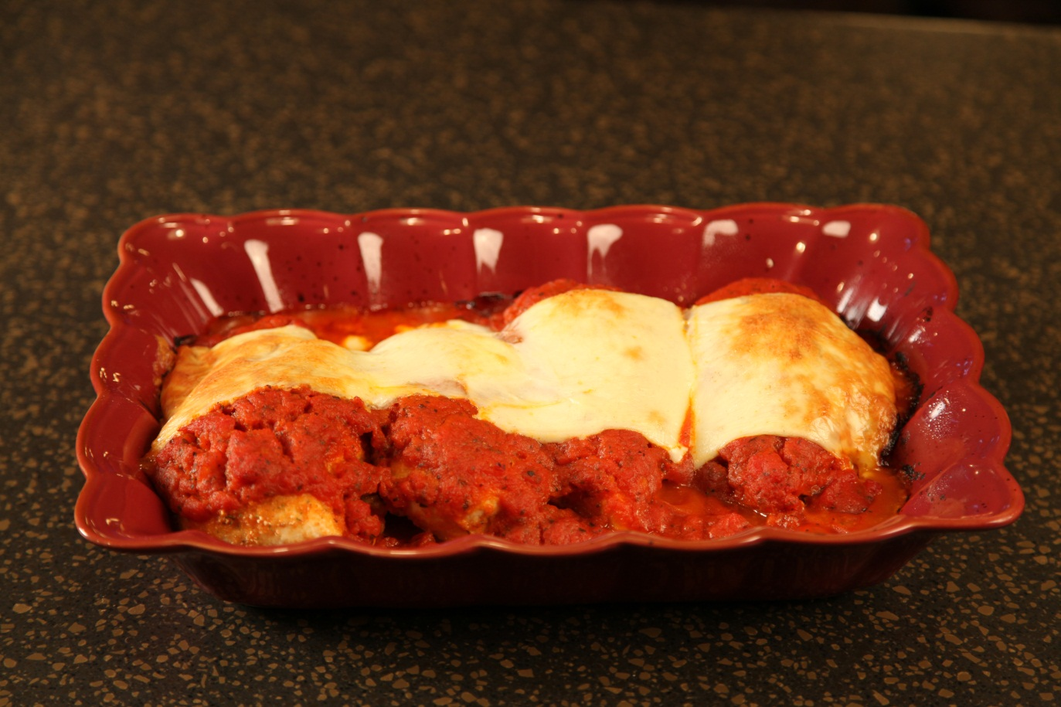

4 |  | Boneless, skinless chicken breasts
1 | cup | Seasoned breadcrumbs
1 | jar | Spaghetti sauce
4 | slices | Mozzarella cheese or Provolone and Mozzarella

Roll chicken breasts in seasoned bread crumbs..

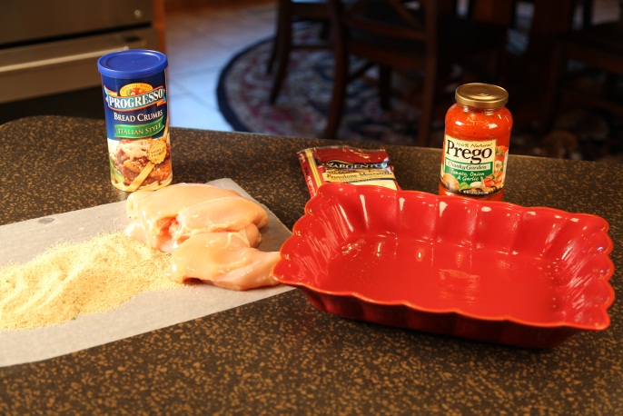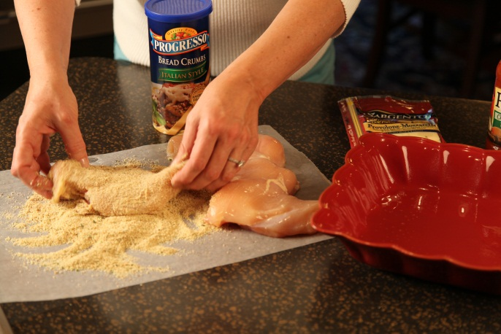

Place in baking dish. Pour spaghetti sauce over top.

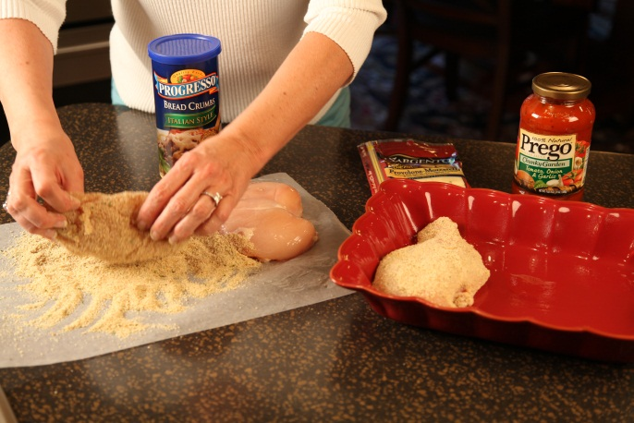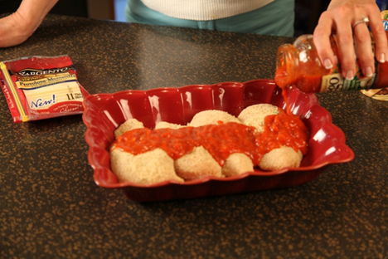

Place mozzarella cheese on top

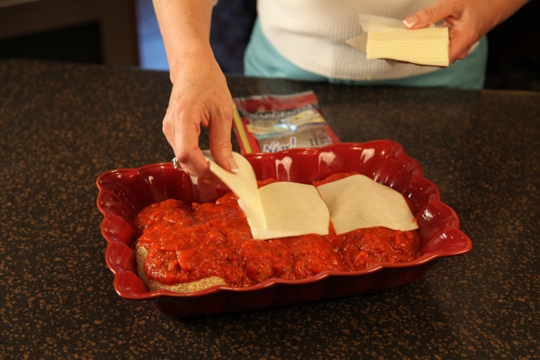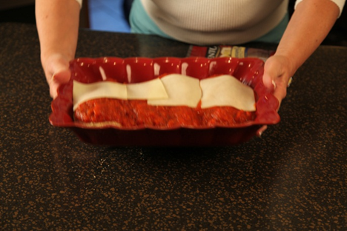

Bake at 375° for 45 minutes until chicken is done and the cheese is melted.

Let’s make life special by sharing great food with our family and friends! Enjoy!

