Cooker Chops
Great recipe for entertaining! Fast, easy and tastes wonderful! No one believes it was prepared in a crock pot.
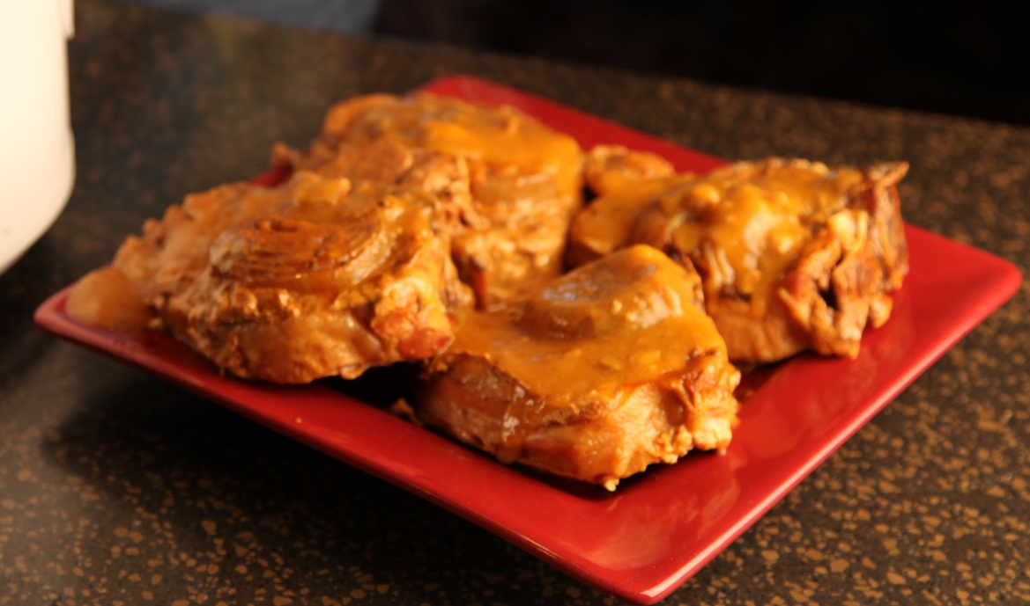
4 |  | 1 1/2" thick pork chops( loin chops with the bone in )
1 | can | Cream of mushroom soup
1/4 | cup | Ketchup
2 | tsp | Worcestershire sauce
1 |  | Onion, sliced
 |  | Instant flour (Wondra)

Put chops in the crock pot and place an onion slice on each chop..
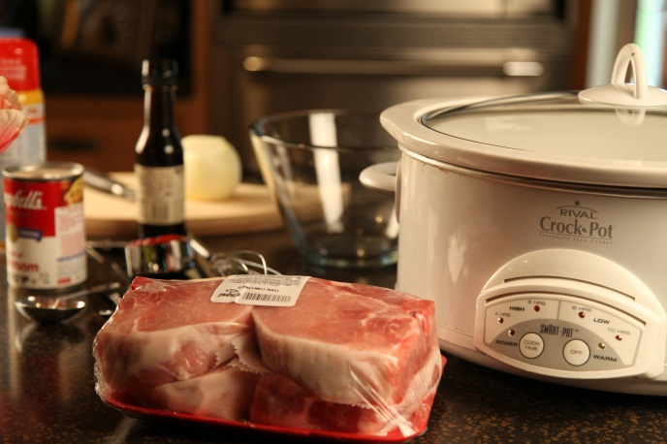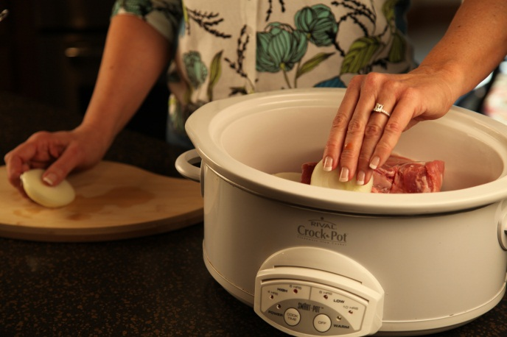
Combine remaining ingredients.
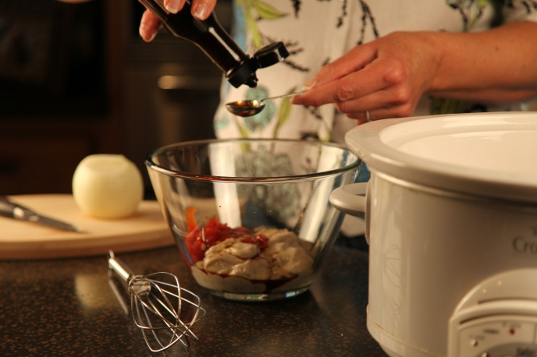
Pour mixture over chops and cover with lid.
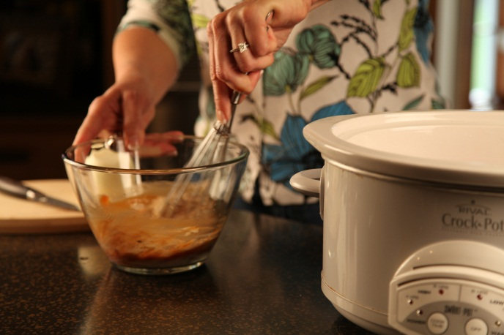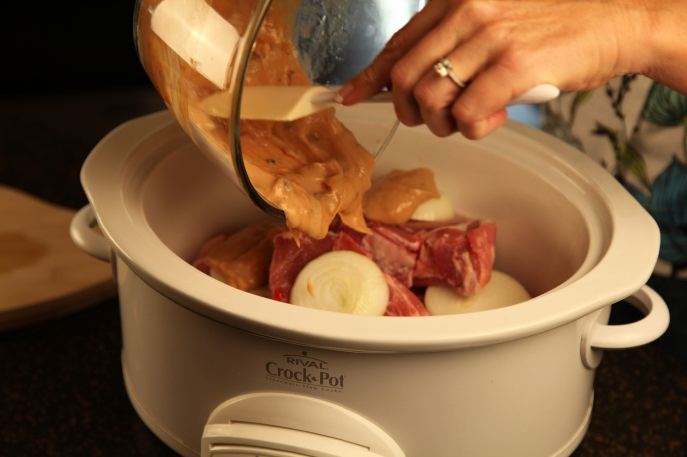

Cook on low 8 to 10 hours or High 3 to 4 hours.

Remove chops. Thicken sauce with Instant flour. Ladle sauce over chops.

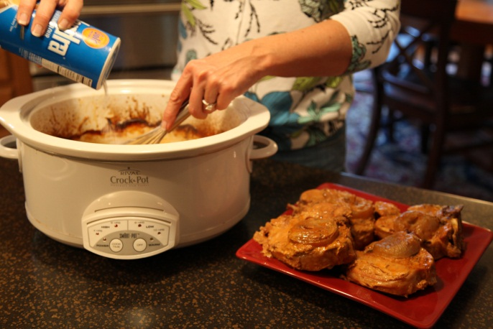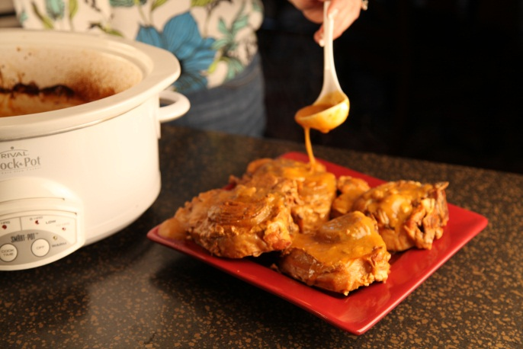
Servings: 4

Let’s make life special by sharing great food with our family and friends! Enjoy!

