Cool Summer Salad
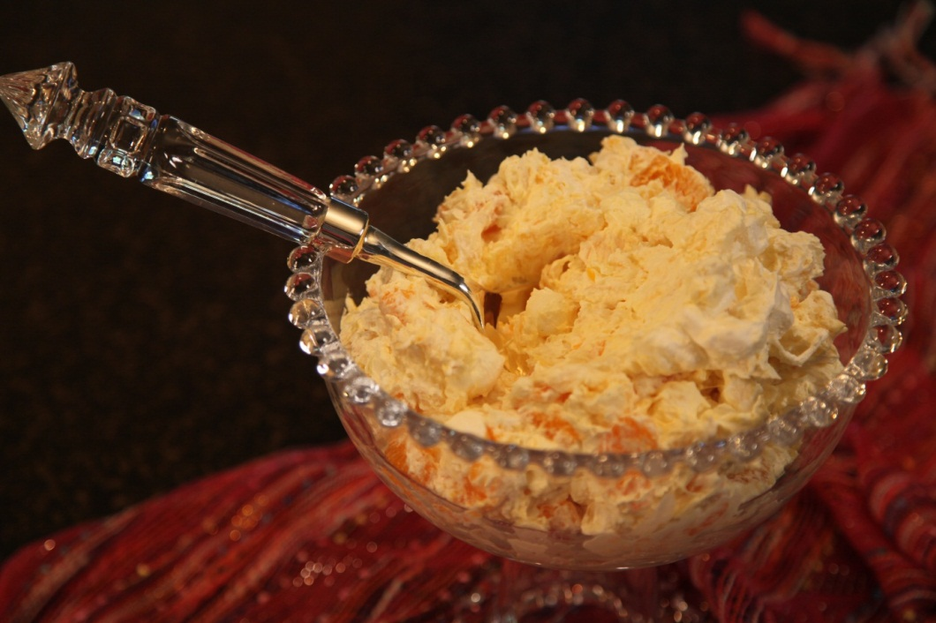
1 | 20 oz can | Crushed pineapple
1 | 3.4 oz pkg. | Instant vanilla pudding
1 | 8 oz | Cool Whip (thawed)
1 | Cup | Miniature marshmallows
1 | 15 oz. can | Mandarin oranges – drained

Mix pineapple with dry pudding mix.
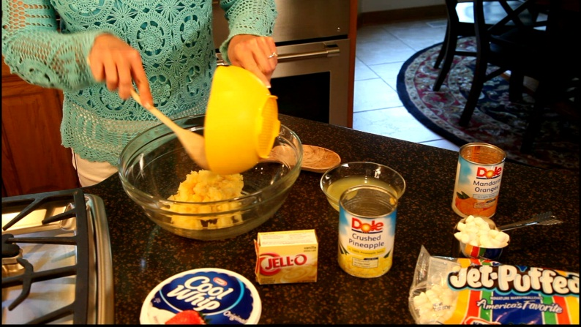
Fold in Cool Whip.
Add oranges and marshmallows.

To serve as a dessert, place Cool Summer Salad in Martini glasses or individual serving bowls.
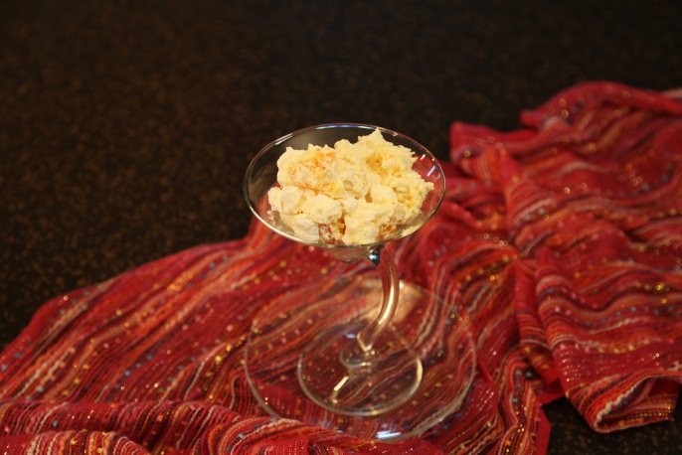
Tip: This may be made ahead and frozen until needed.

Let’s make life special by sharing great food with our family and friends! Enjoy!
Servings: 8

