Cream Cheese Whipped Potatoes
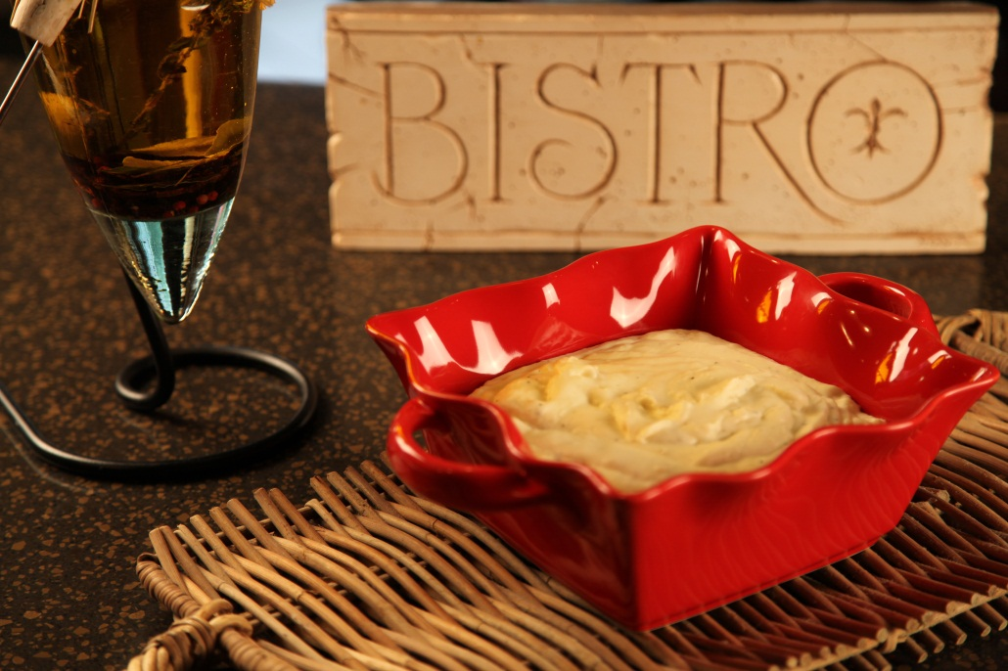
1 |  | Container refrigerated prepared mashed potatoes
1 | 8 oz | Cream cheese

Mix potatoes and cream cheese in a microwave safe bowl.

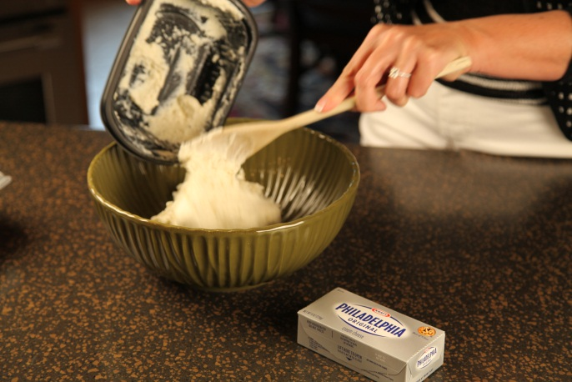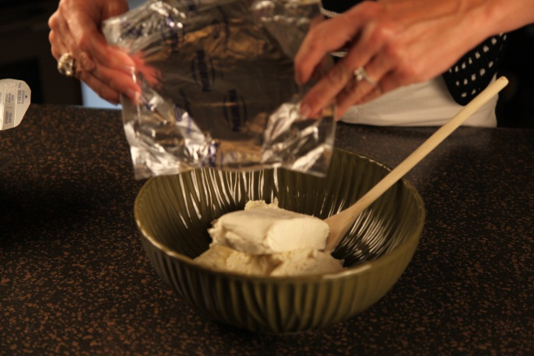

Microwave for 5 minutes, stirring halfway thru cooking time.
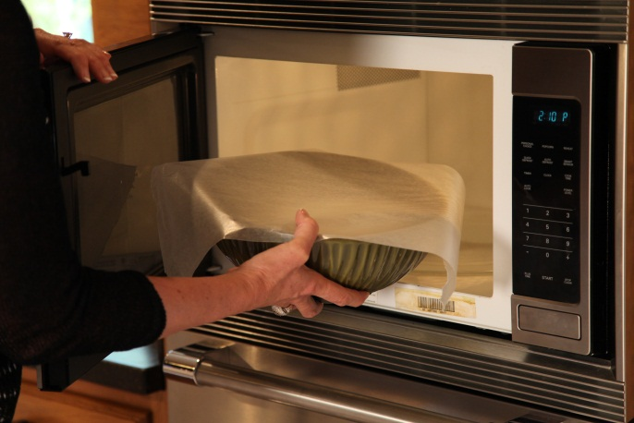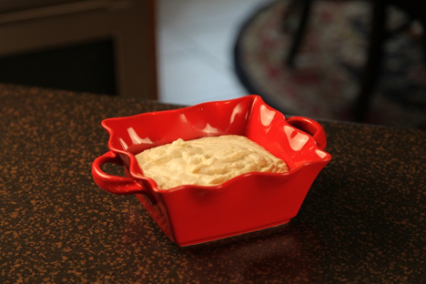

Let’s make life special by sharing great food with our family and friends! Enjoy!

