French Bread Crostini
These are good with any dip - especially my Baked Goat Cheese Marinara.
They are best served warm, but you can easily make them a day ahead and
store in a zip lock bag, then just wrap in aluminum foil and reheat in the oven
for a few minutes before serving. Feel free to add seasonings to these if you
like. Suggestions would be garlic salt, garlic powder, Italian seasoning, or
parsley. You can even top these with shredded parmesan cheese or shredded
Italian cheese as soon as they come out of the oven for additional zing!

12 | slices | French bread
1/4 | cup | Olive oil

Use a serrated knife to slice the French bread and place on a shiny cookie sheet.
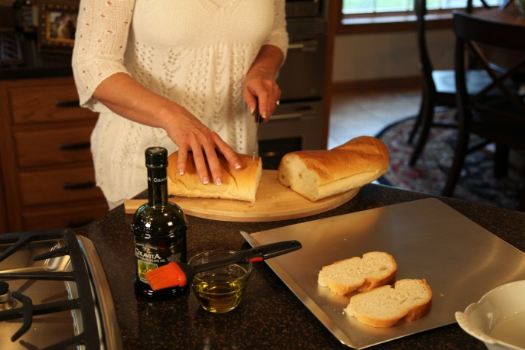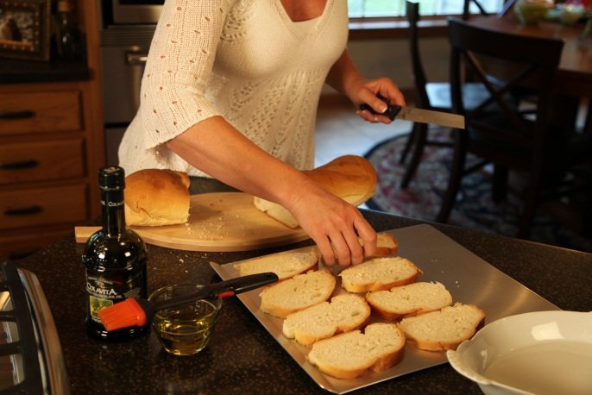

Brush both sides of the bread slices with olive oil.

. 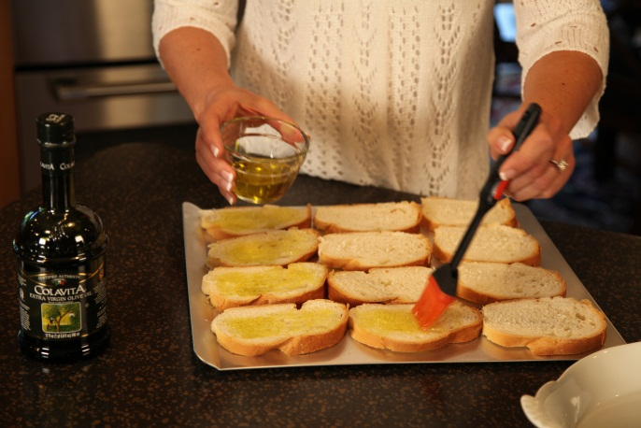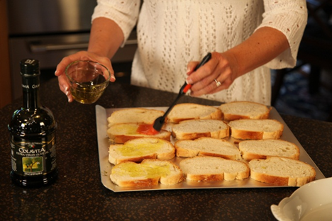

Toast each side under the broiler for 2 to 3 minutes, or until golden. Watch carefully so they don't burn.

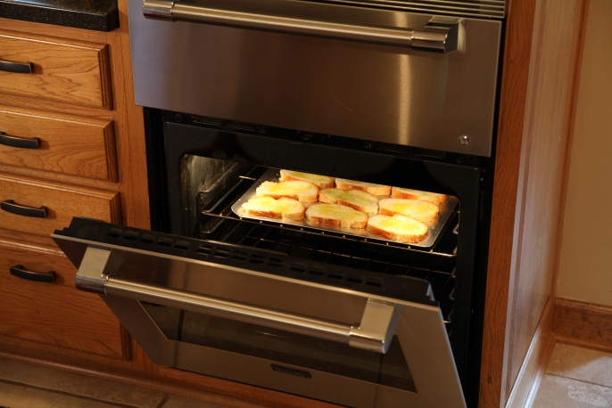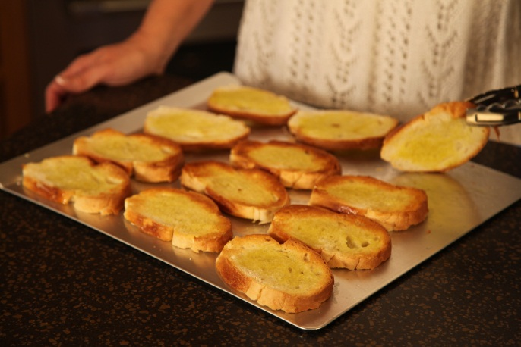

Here you see the baked French Bread Crostini served with my Baked Goat Cheese Marinara:

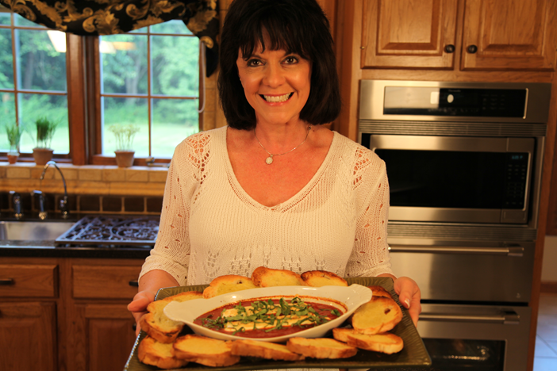

Let’s make life special by sharing great food with our family and friends! Enjoy!

