Fresh Strawberries with Chantilly Cream
This is a simple and delicious dessert. It looks great when served in individual martini glasses. This is also good served as a dip for a dessert buffet.
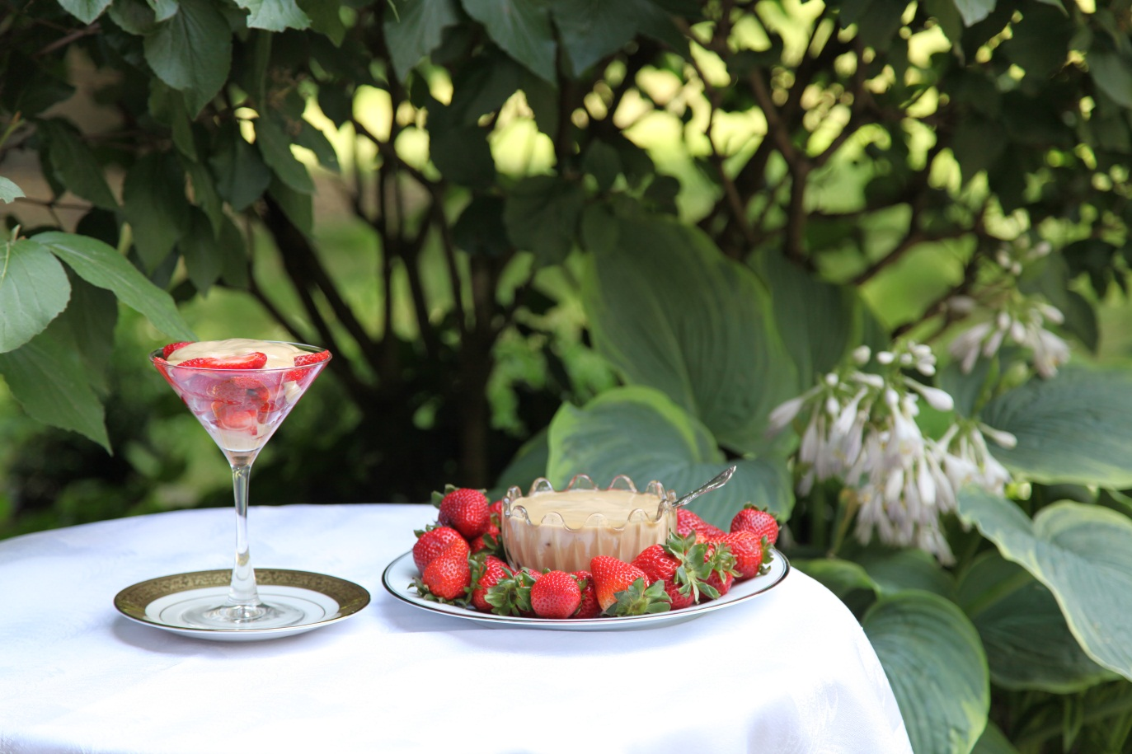

 |  | Fresh strawberries, whole or sliced
16 | oz | Sour cream
1 | cup | Dark brown sugar ( or more in order to get desired caramel color and taste)

Wash fresh strawberries. Leave whole if serving with the dip or slice if serving in individual bowls.
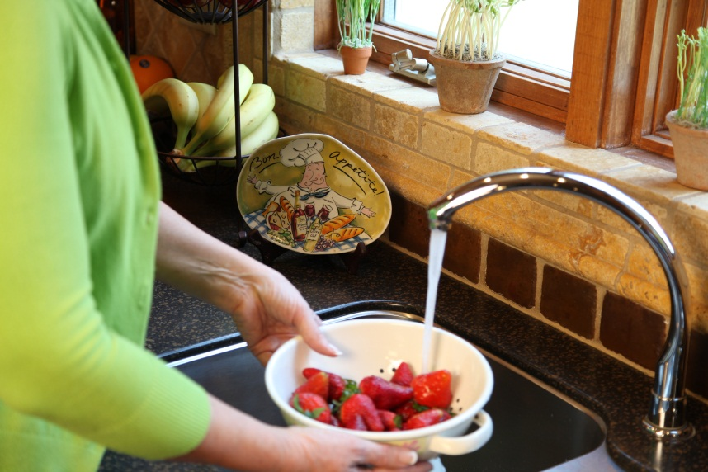

Mix dark brown sugar into the sour cream until it is a dark caramel color.

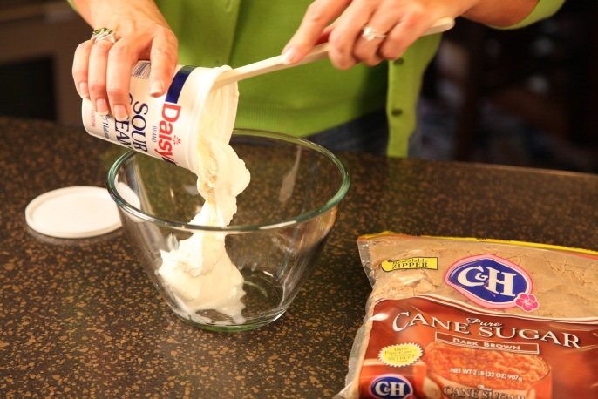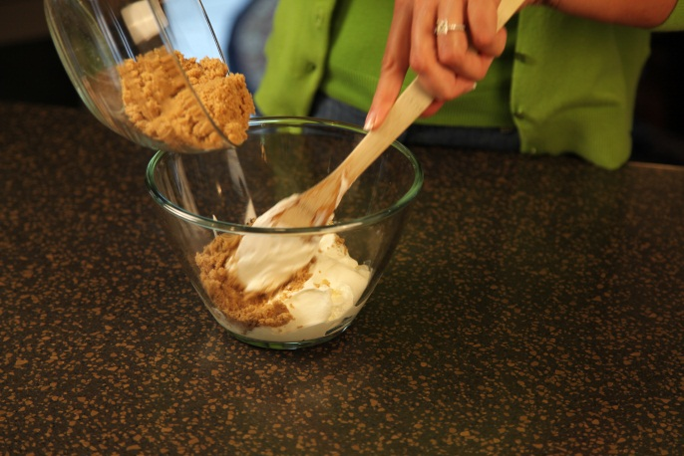

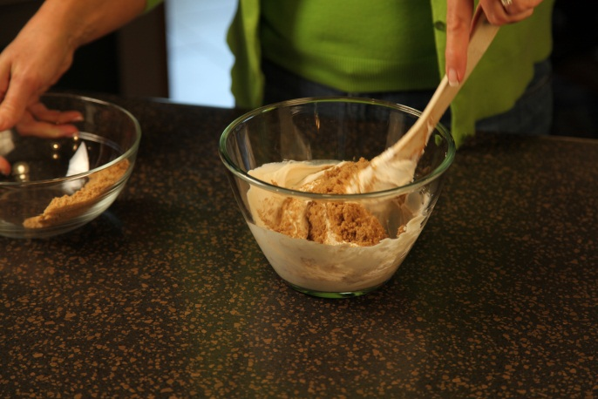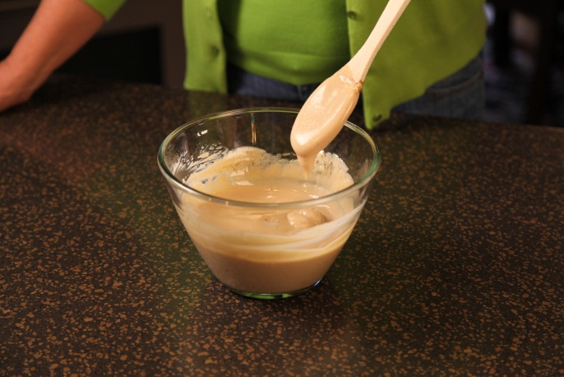

For individual servings, spoon the Chantilly cream over the strawberries.

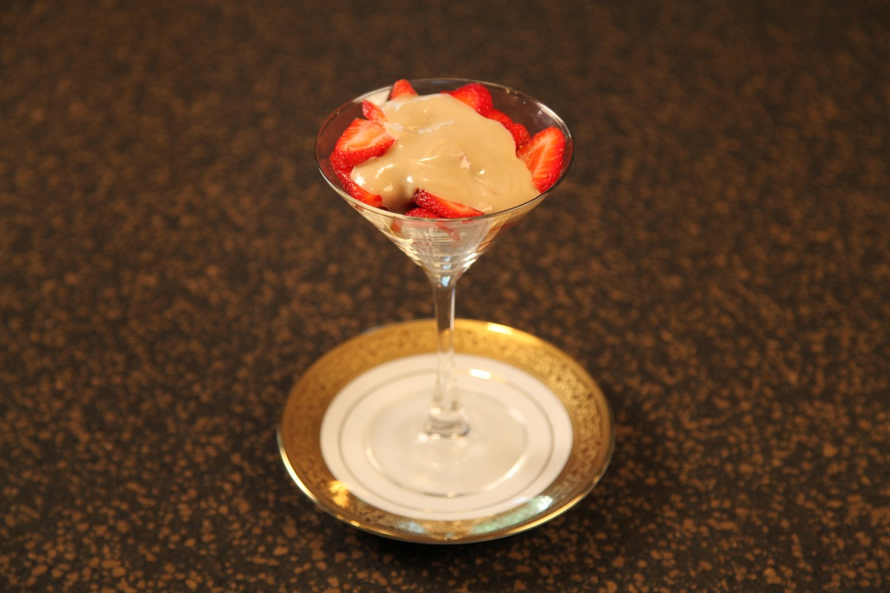

To serve as a dip, place Chantilly Cream in a small crystal bowl and place on a plate. Surround with whole fresh strawberries.

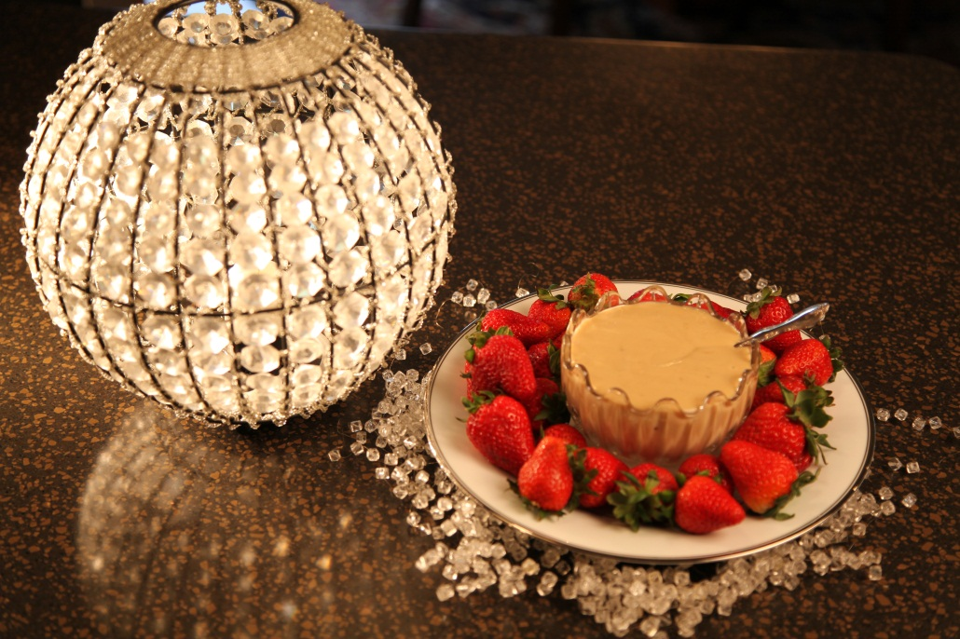

Let’s make life special by sharing great food with our family and friends! Enjoy!

