Italian Beef
“You can have this in the crock pot in less than 5 minutes and at the end of the day you’ll have
delicious Italian Beef ready for dinner. What could be easier!”

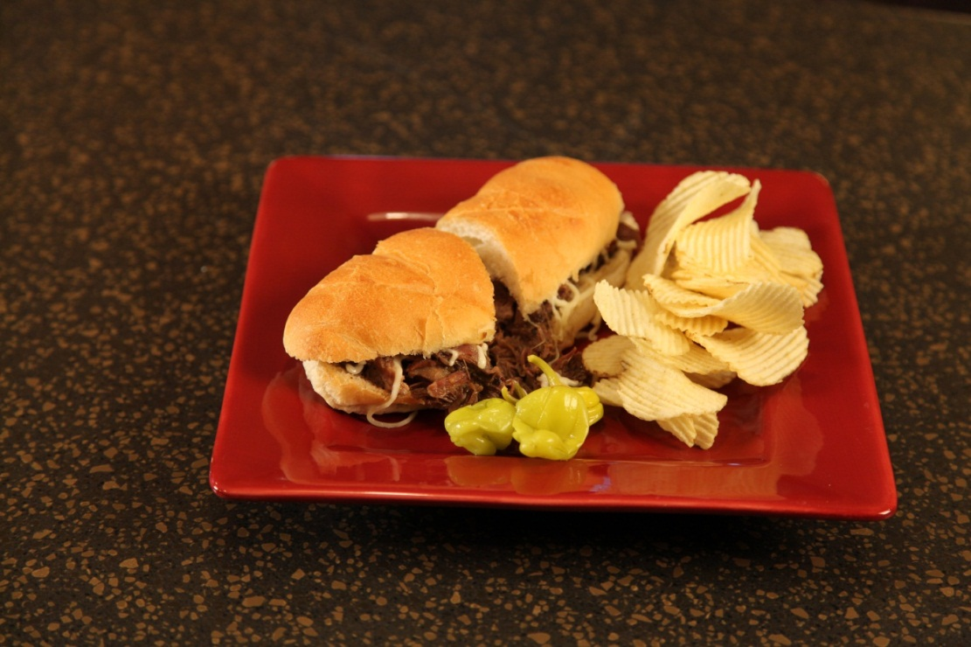
1 | large | beef chuck pot roast (about 3 pounds)
1 | can | Beer
3 | packets | Good Season's Zesty Italian Salad Dressing Mix
 |  | Hoagie Rolls
Shredded Mozzarella cheese
Italian Seasoning
Peperocini peppers (optional)

Place beef pot roast in crock pot. Sprinkle with 3 packets of dry Good Seasons Zesty Italian Salad Dressing Mix.
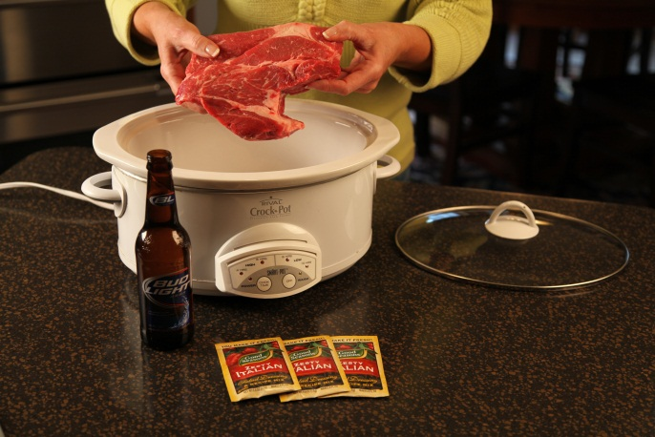 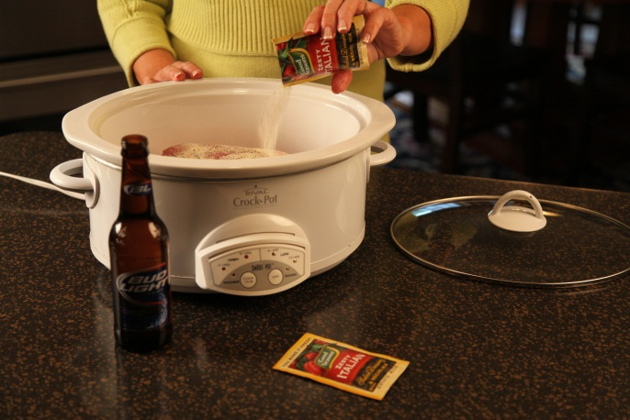Pour one can of beer over roast.

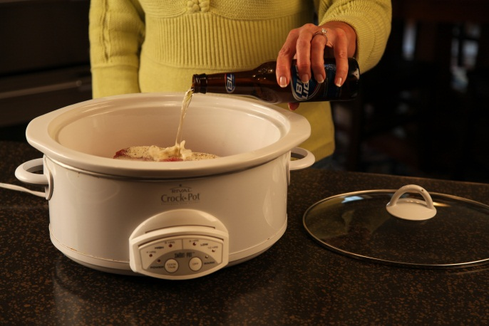

Cook on low all day.
____________________________________________

About one hour before serving, shred the beef in the crock pot using 2 forks.
Sprinkle with Italian Seasoning and stir.

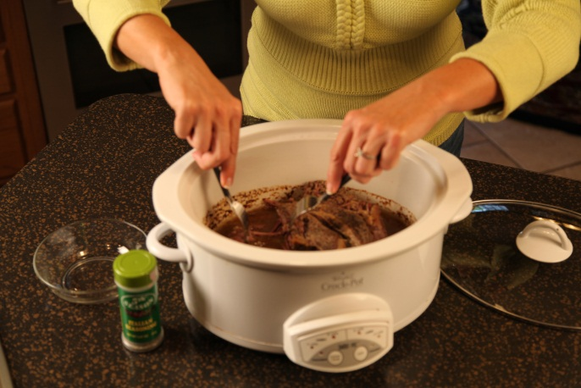

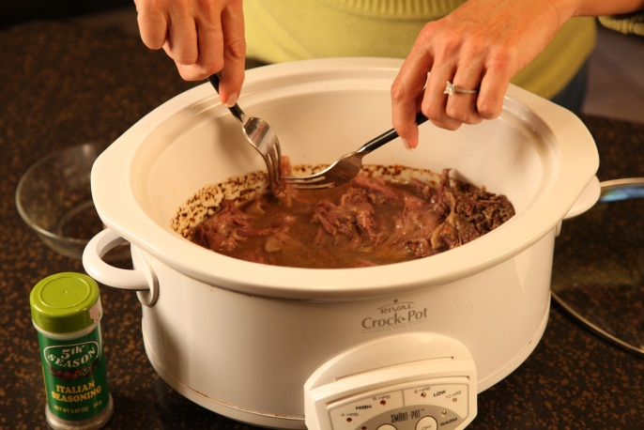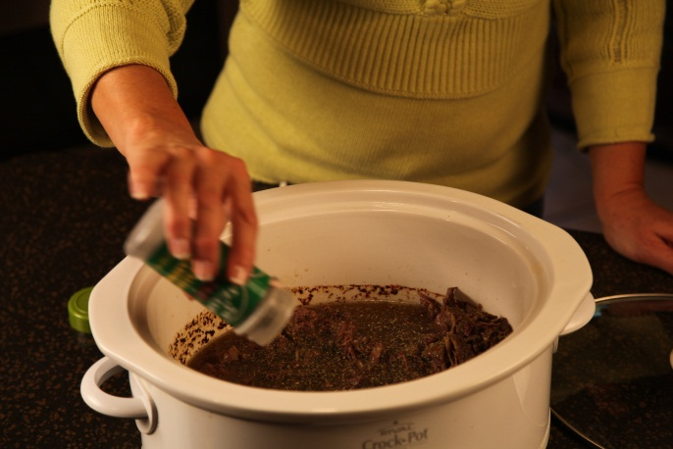

Continue to cook in the sauce.

To serve, put Italian Beef on hoagie roll. Top with shredded Mozzarella cheese. Heat each sandwich 30 seconds in microwave to melt cheese.

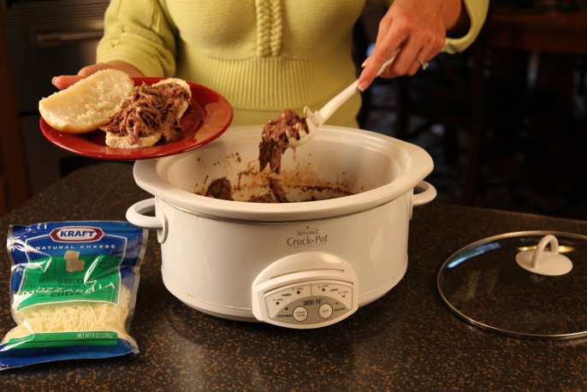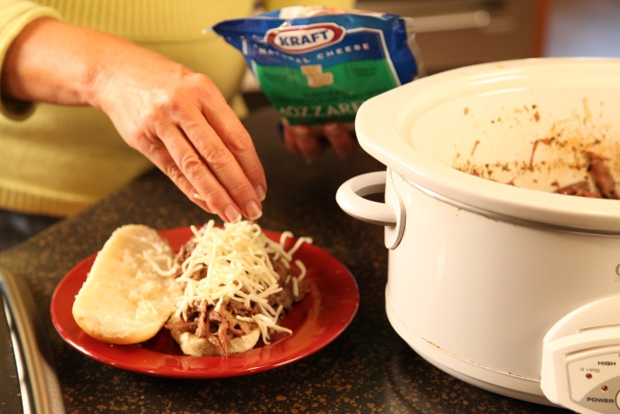

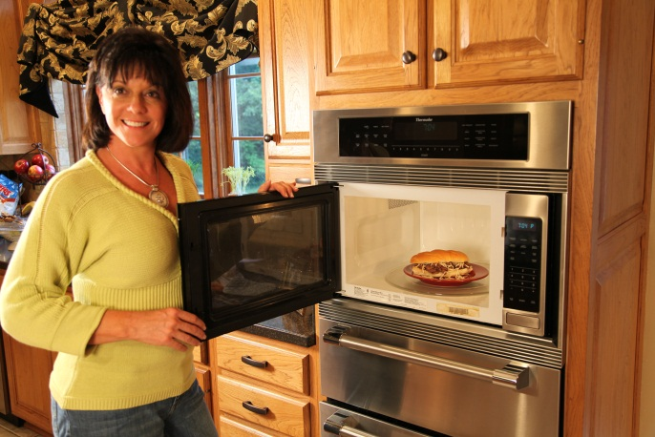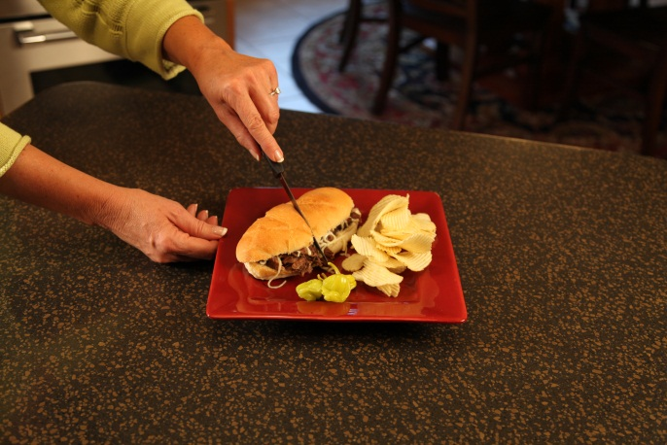

Let’s make life special by sharing great food with our family and friends! Enjoy!

