Mustard Sauce for Meat
This sauce improves in flavor after being refrigerated a day or so ---this makes it a perfect make-ahead accompaniment for roasted or grilled pork or beef. I’ve featured this sauce with my Bourbon Pork Tenderloin, but it would be equally as good with prime rib or grilled rib eyes or even grilled filet mignons.

The flavor is pretty intense, so if you want to tone it down a bit, just use less of the dry mustard. I think the intensity of the flavor is perfect, so I make the recipe exactly as I have given it here.

Here I’m, showing the finished Mustard Sauce served with the Bourbon Pork Tenderloins, which I sliced about 1 inch thick for easy serving:

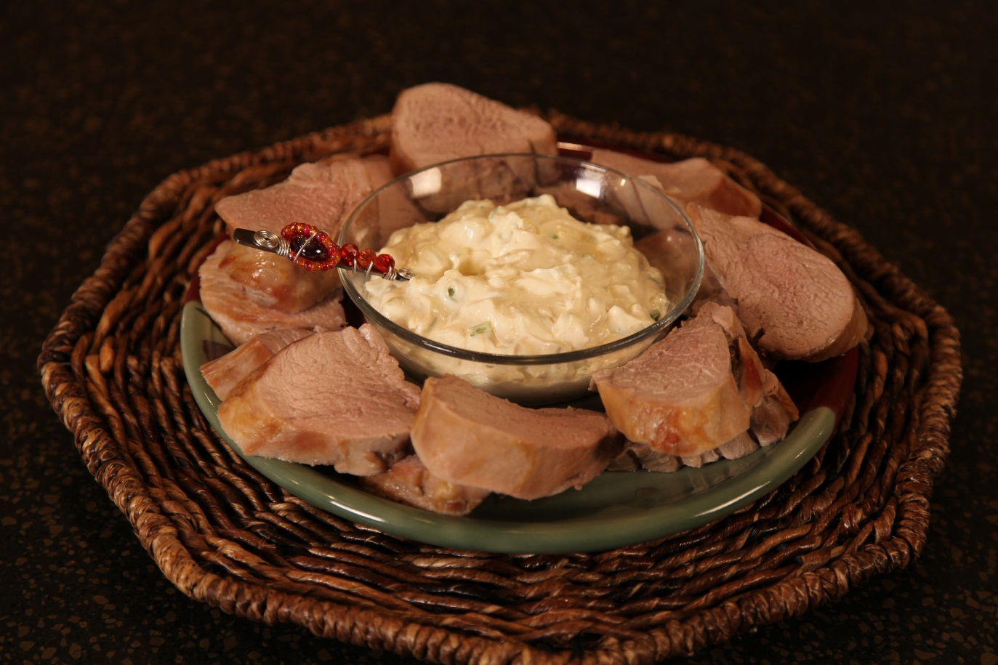
2/3 | cup | Sour cream
2/3 | cup | Mayonnaise
2 | tbs | Dry mustard
4 |  | Green onions, finely chopped ( including the tops)

Combine the sour cream, mayonnaise, dry mustard and chopped green onions. Stir to blend well. Cover and chill.
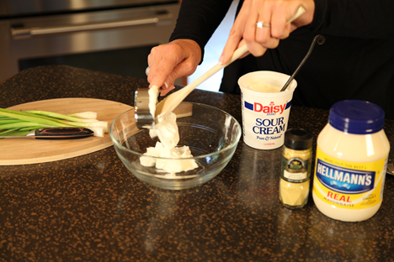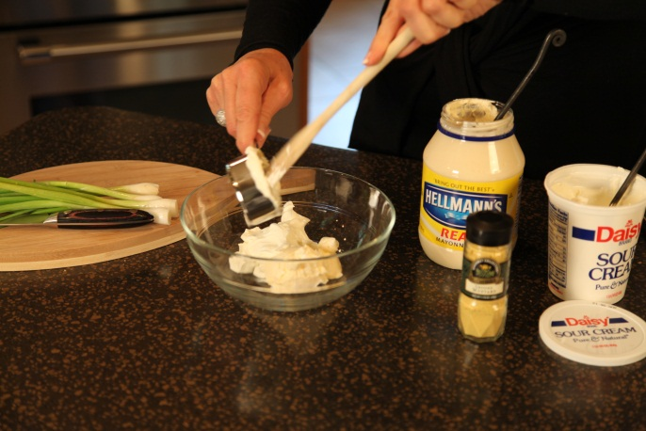
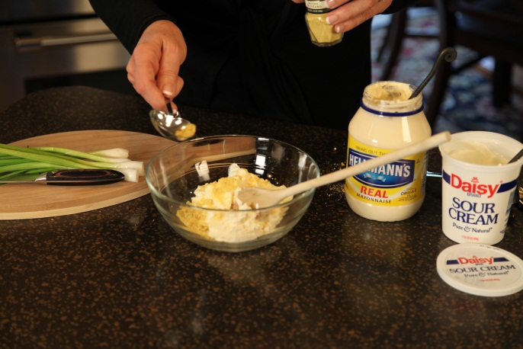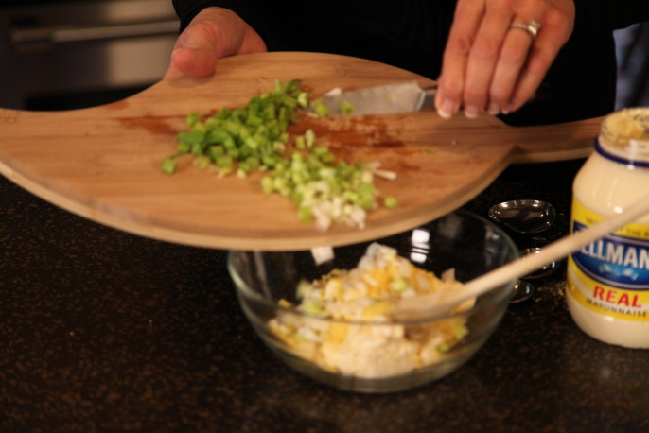
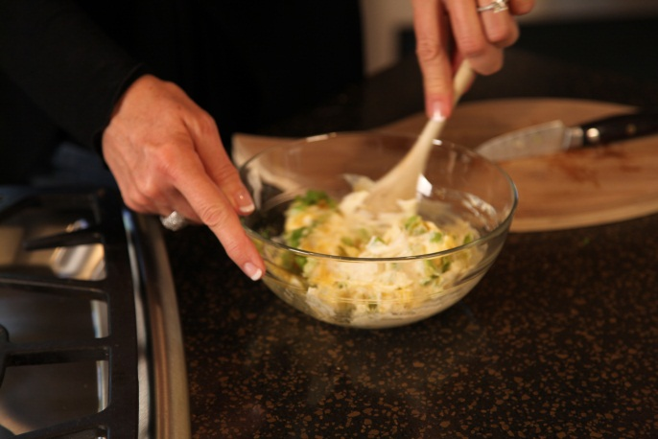

Let’s make life special by sharing great food with our family and friends! Enjoy!

