Orange Cooler
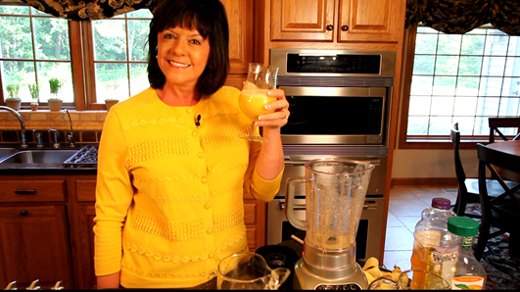
1 | Cup | Fresh Strawberries, sliced OR 2 Bananas
4 | Cups | Orange juice, chilled
1 | Tbs | Honey
1 | Cup | White grape juice, chilled

Place strawberries or bananas, 1 Cup orange juice and honey in blender. Blend on low speed
for 10 seconds.
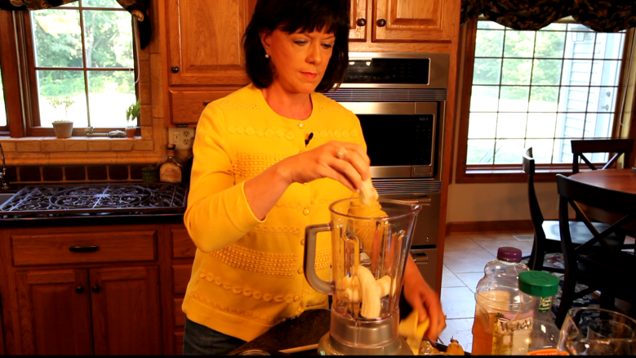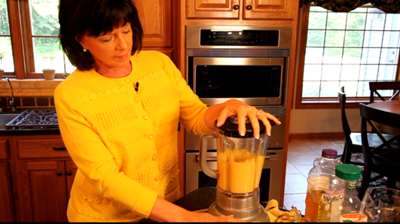
Pour into pitcher and mix in remaining orange juice and white grape juice.
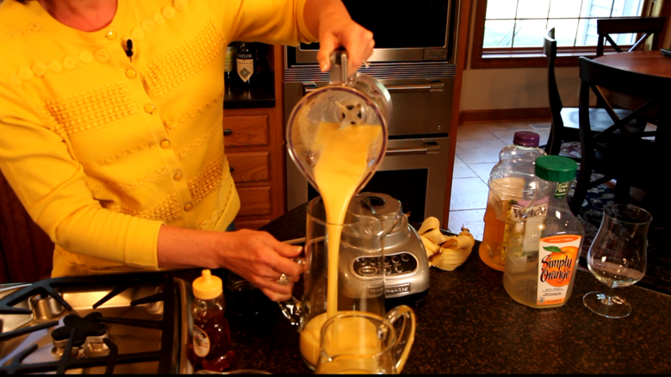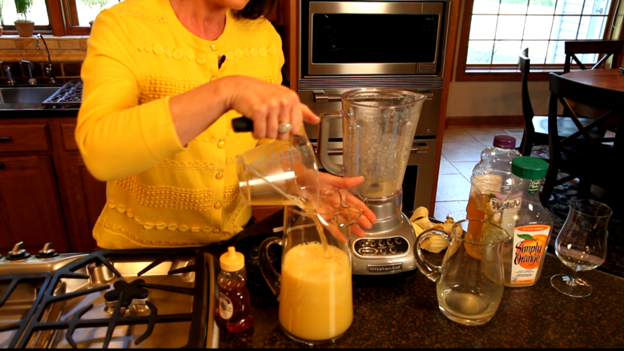

Serve in chilled glasses. Garnish with mint sprig if desired.

