Perfect Baked Potatoes with Baked Potato Bar
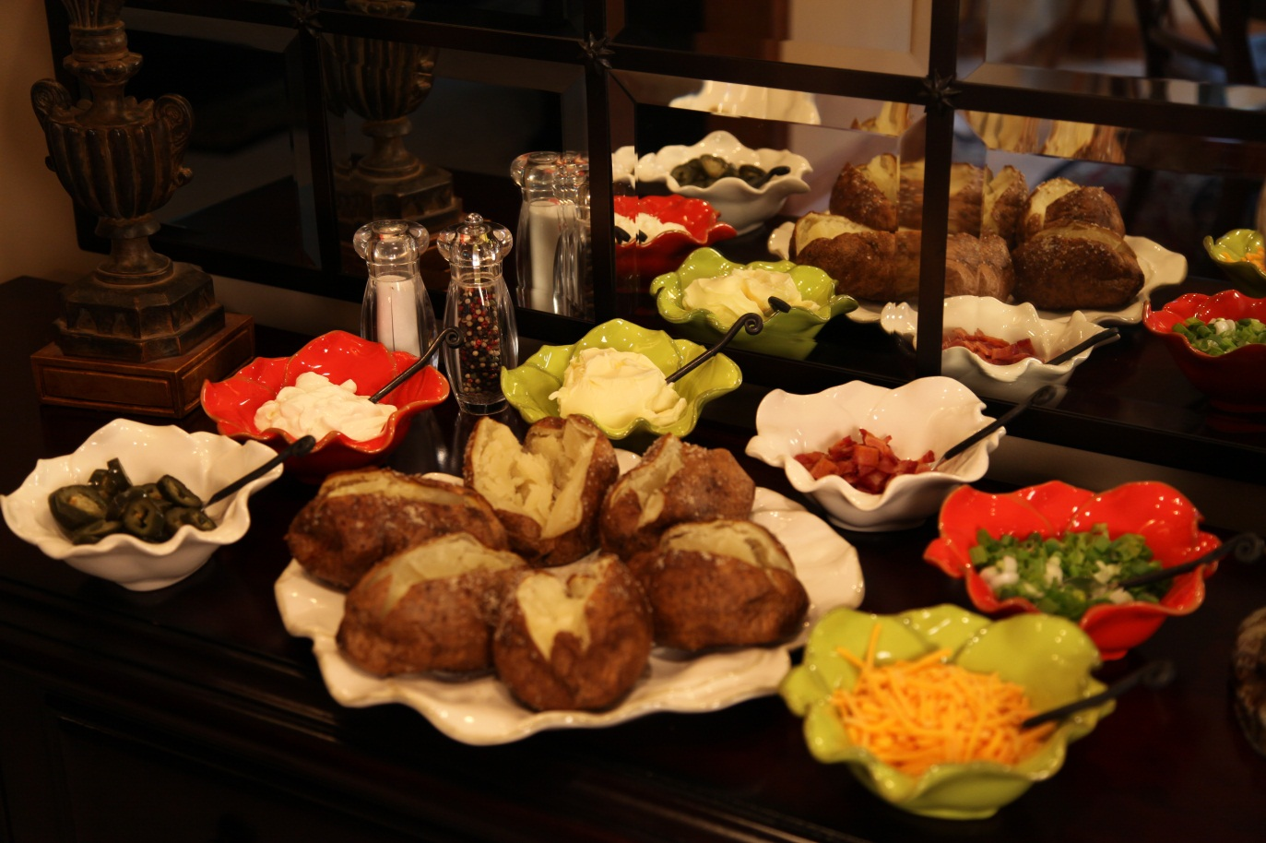

Perfect Baked Potatoes:
Large Idaho Baking Potatoes
Oil
Kosher ( coarse) salt
Options for Baked Potato Bar:
Butter
Sour Cream
Bacon crumbles
Green onion slices ( including tops)
Jalapeno pepper slices
Shredded cheddar cheese
Chili ( in the Fall and Winter)
Canned black beans
Chopped fresh tomatoes
Thawed frozen peas
Salsa
Nacho cheese sauce
Ranch salad dressing
Salt and pepper

Preheat oven to 425°.
Line a cookie sheet with aluminum foil. Scrub baking potatoes and pat dry. Place on foil lined sheet.

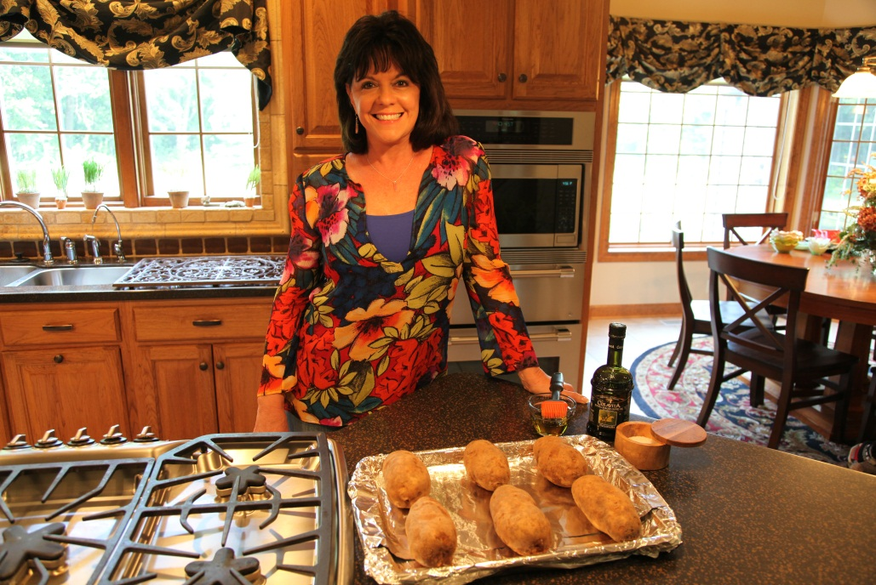

Brush both sides of potatoes with oil and sprinkle both sides with kosher salt.

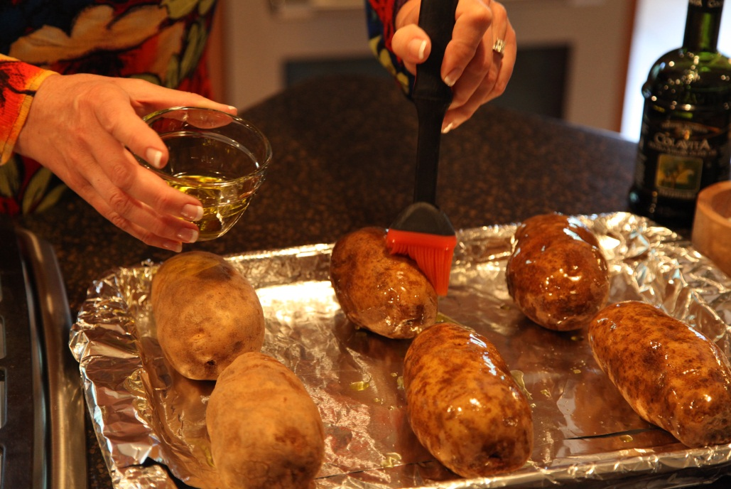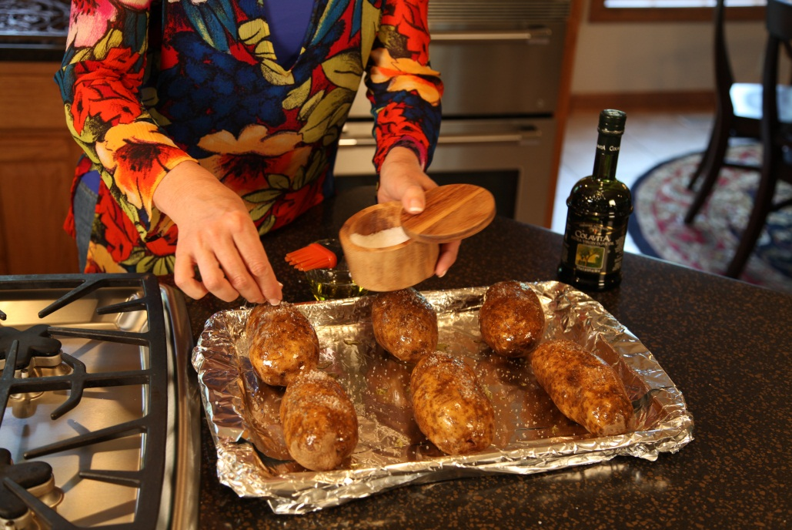

Bake for 1 hour and 15 minutes (for the extra - large potatoes) or until done. Smaller potatoes will
be done in about an hour. Split and serve with options listed above.

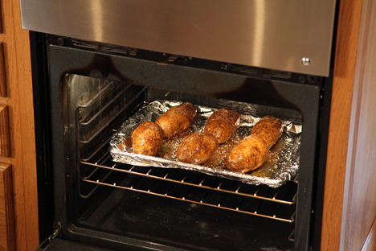

I used butter, sour cream, bacon crumbles ( that I cooked in the microwave ) , sliced green onions, including tops,
Jalapeno pepper slices, shredded cheddar cheese and salt and pepper.

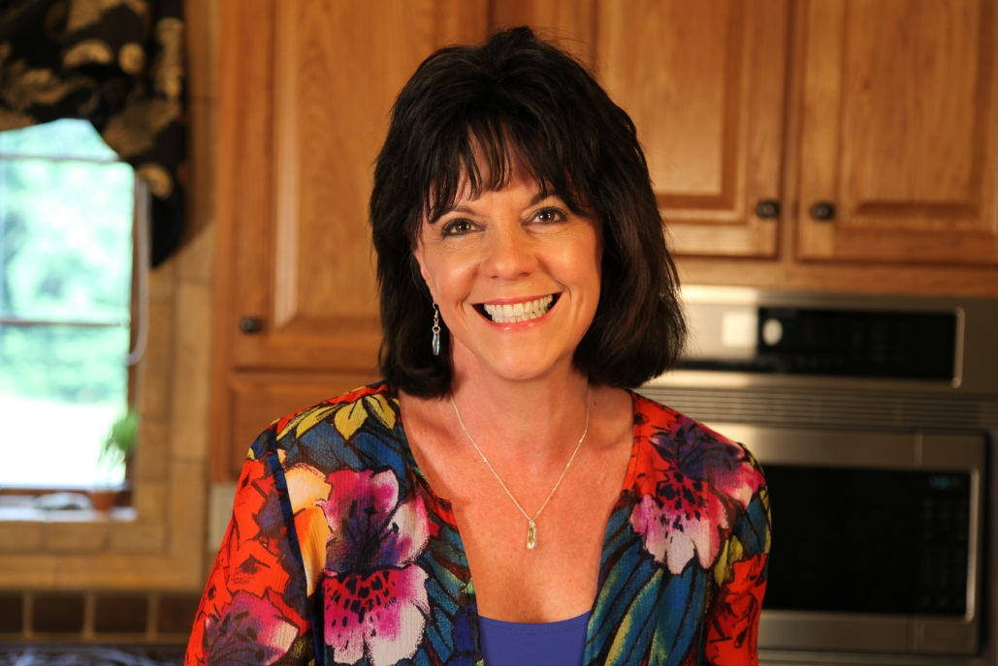

Here you see the buffet set-up. I used a round platter for the baked potatoes and
matching small bows in different bright colors for the condiments.

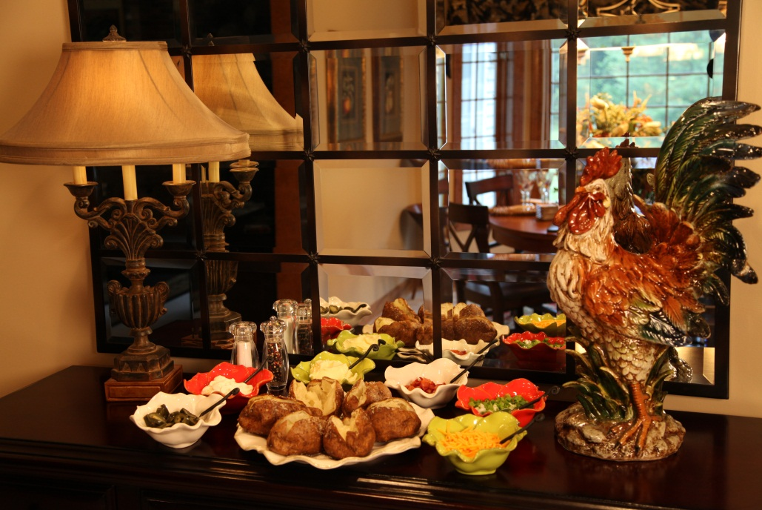

Let’s make life special by sharing great food with our family and friends! Enjoy!

