Pineapple Cream French Toast
This is fantastic!
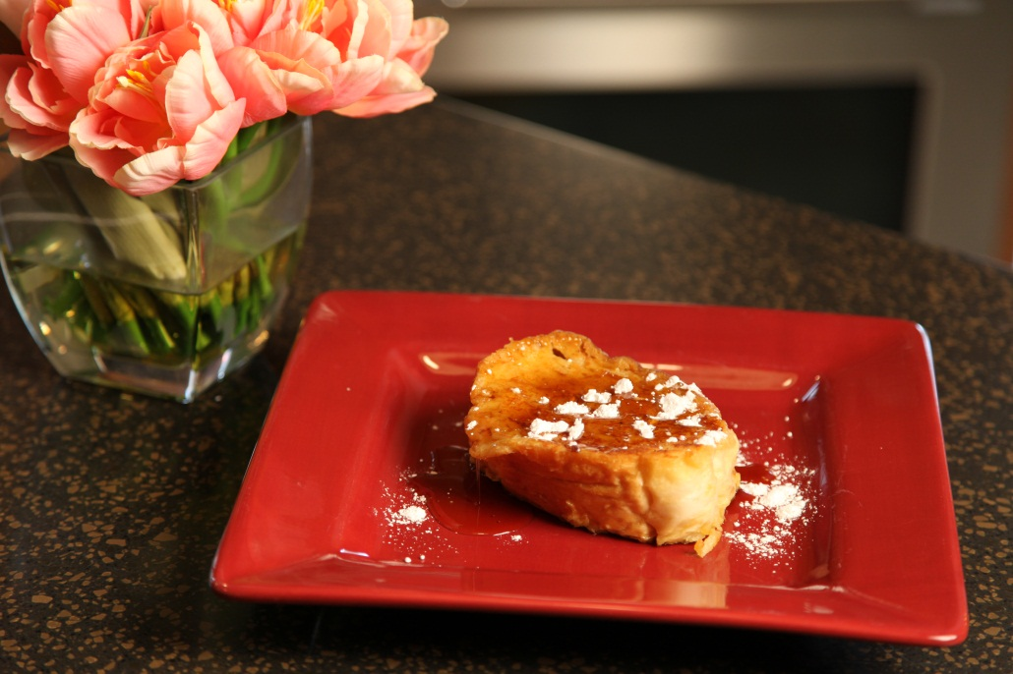
6 |  | thick slices French bread
3 |  | eggs
3/4 | cup | half and half cream
8 oz | can | crushed pineapple, including juice
1/2 | cup | brown sugar
1/2 | cup | melted butter
 |  | powdered sugar for garnish

In a small bowl, whisk eggs, half and half, crushed pineapple with juice and brown sugar.
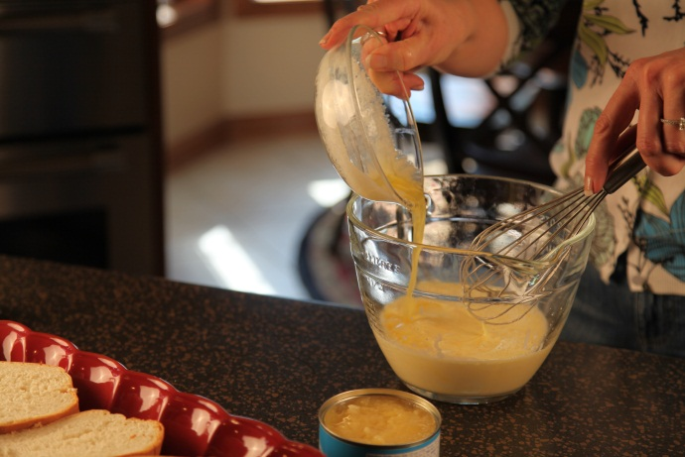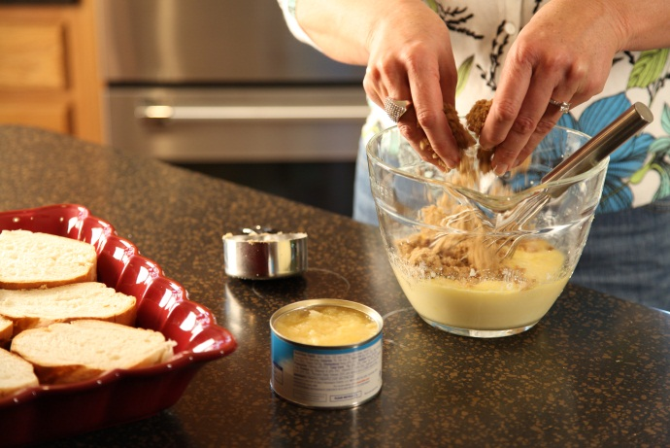
Slice bread with a serrated knife and place bread slices in a single layer in an oblong baking dish.
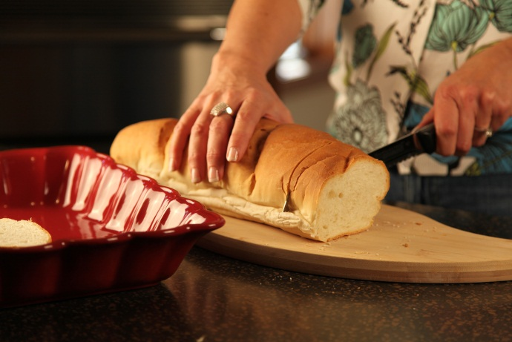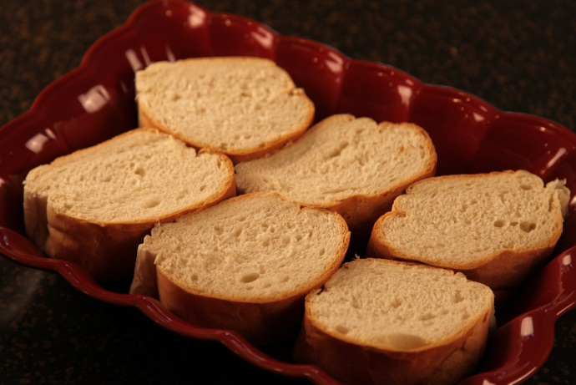
Pour egg mixture over bread. Cover and refrigerate overnight.
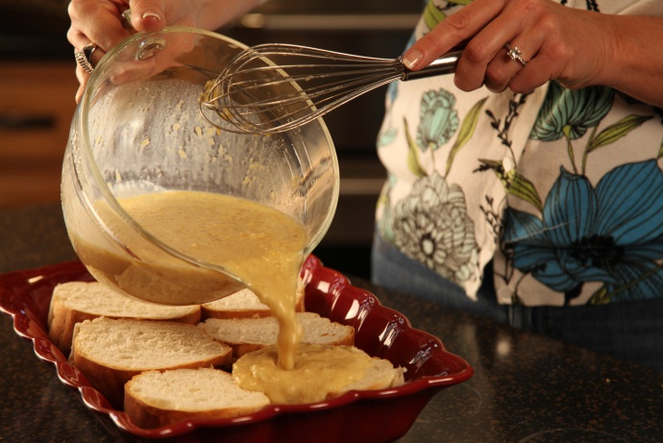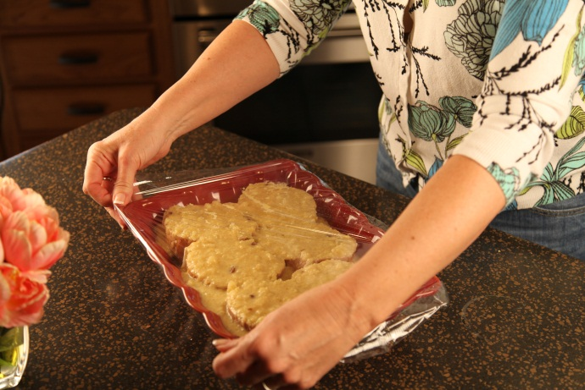

At serving time, melt 2 T of butter on griddle. Add bread slices and cook over medium heat until golden brown on each side.
You may need to add more butter as the French toast cooks.

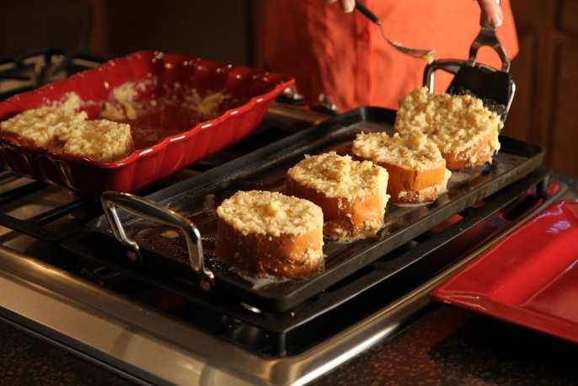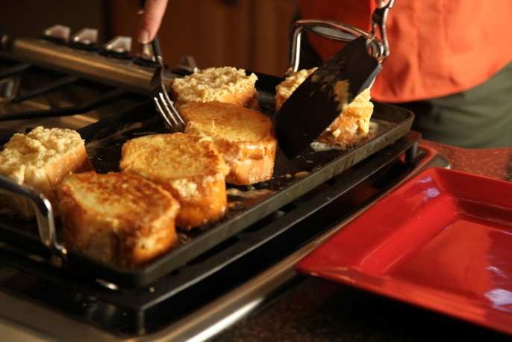

Sprinkle with powdered sugar. Serve with butter and syrup.

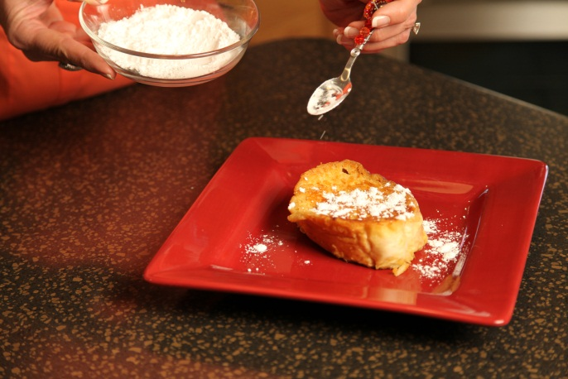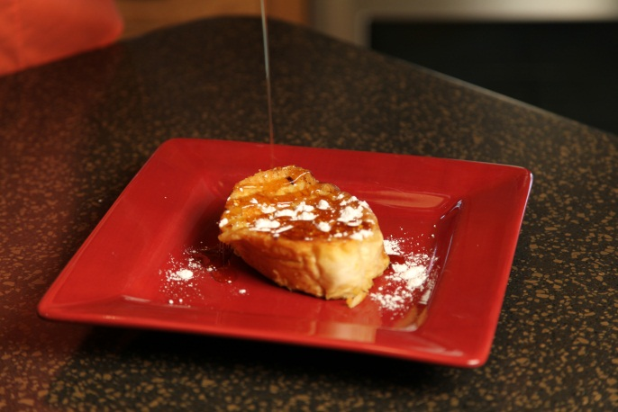

Servings: 6

Let’s make life special by sharing great food with our family and friends! Enjoy!

