Sherbet Punch
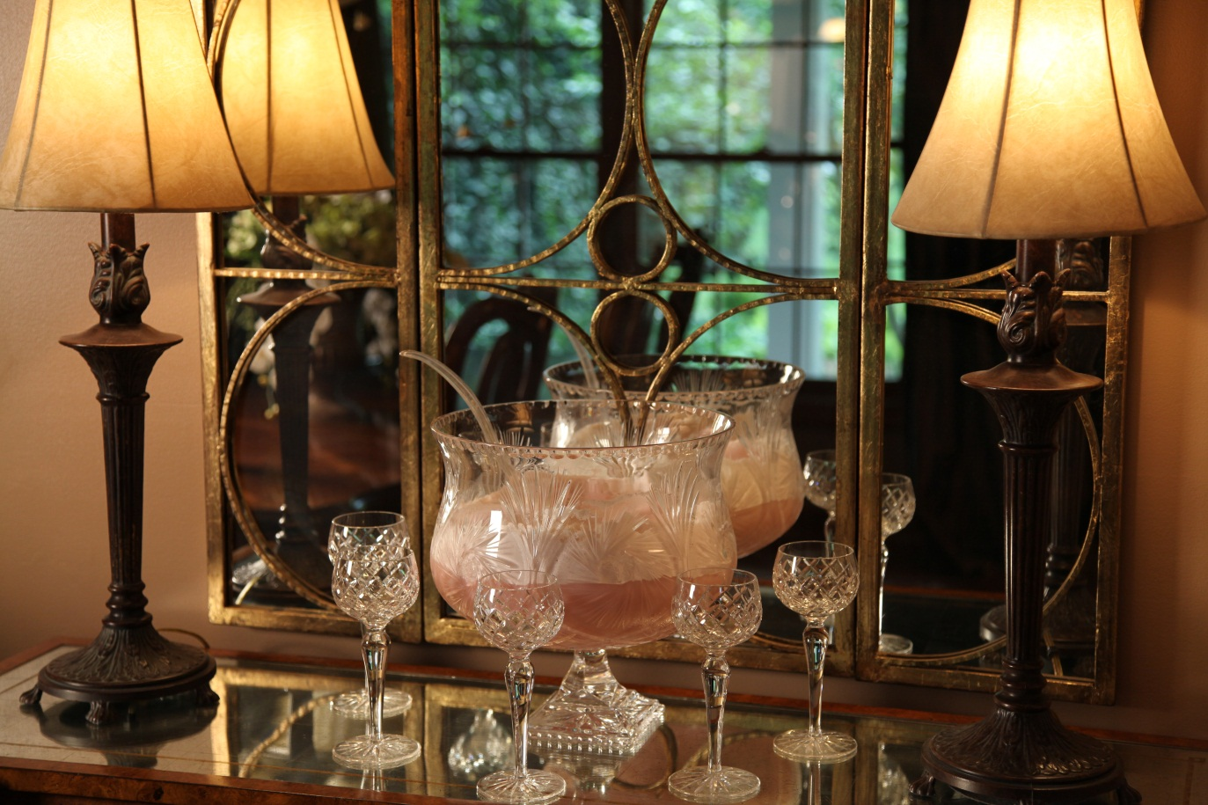

Looking for a quick and delicious punch to serve at a bridal shower or baby shower? This is it! The raspberry sherbet makes a pink punch and the pineapple sherbet makes a yellow punch.
3 | qts | Sherbet ( raspberry or pineapple)
2 | liters | Ginger Ale, chilled

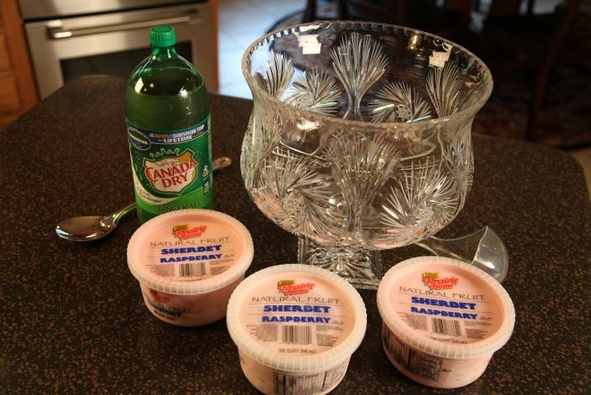

In punch bowl add Raspberry Sherbet. Pour chilled Ginger Ale over sherbet and serve.
Allow about 15 minutes for the sherbet to melt into the ginger ale before serving.

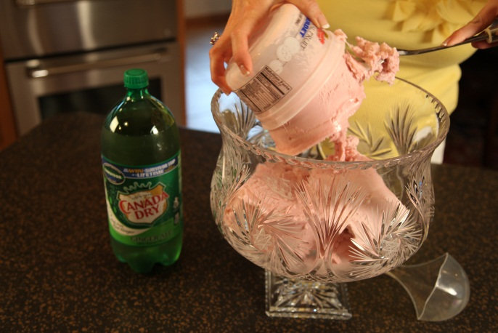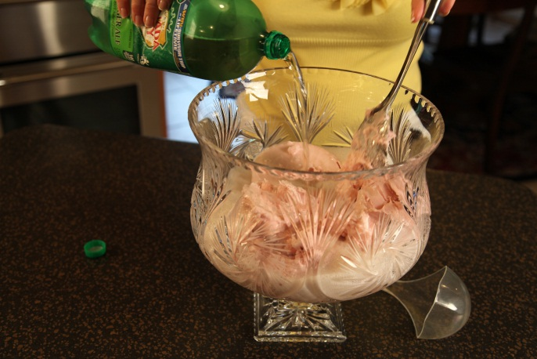

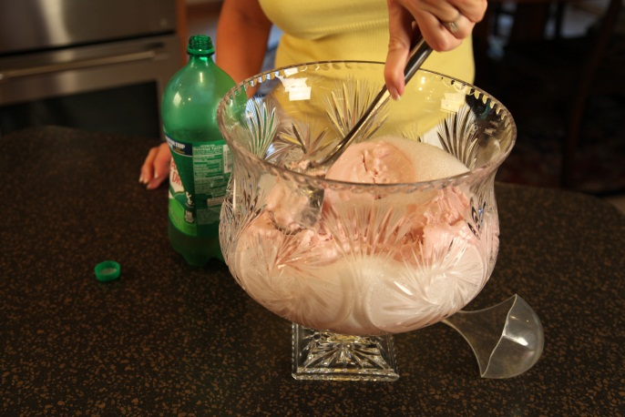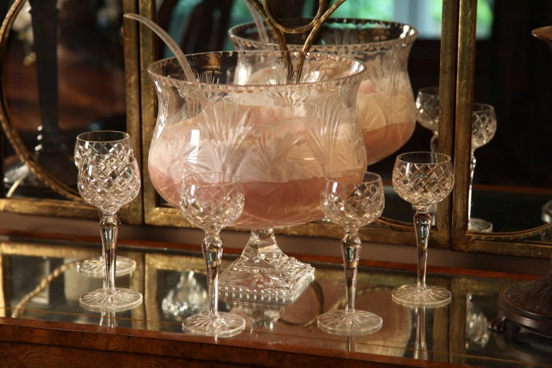

Let’s make life special by sharing great food with our family and friends! Enjoy!

