Southern Sweet Tea

“ I’ve had so many people ask me how to make Southern Sweet Tea! It’s so easy and is perfect
for all of your family meals.”

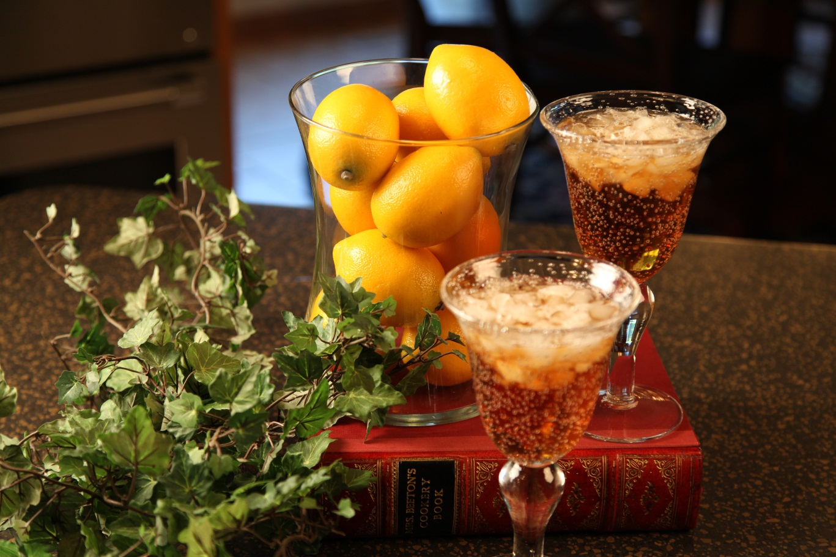

2 |  | Family Size Tea Bags
1 |  | Scant cup of sugar

Microwave about 1 ½ cups of water for 5 minutes, or until boiling. Place 2 Family Size tea bags in
the hot water and cover with a lid, Steep the tea bags in hot water for 5 minutes.
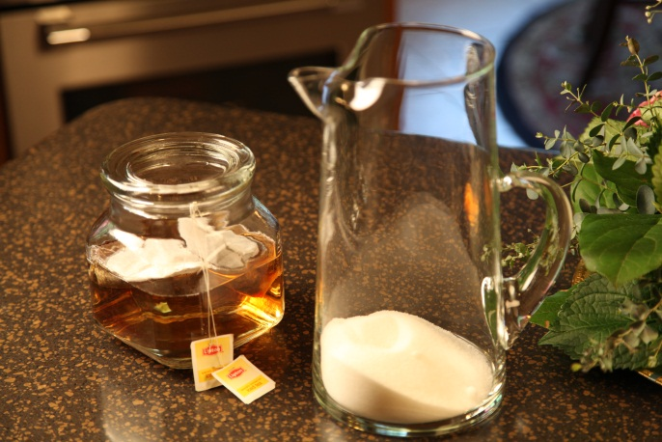

Place a spoon into a glass pitcher. Pour the hot tea brew into the pitcher.

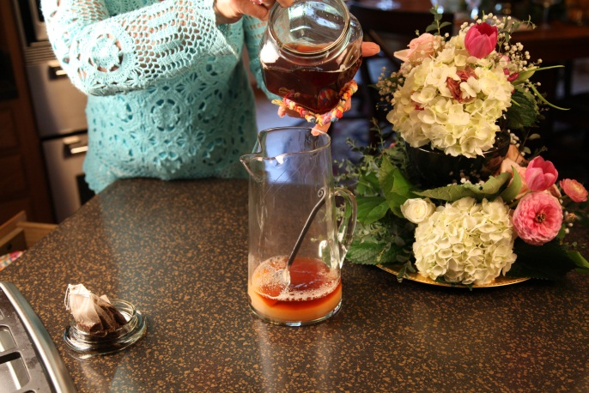

Fill the pitcher with cool water. Serve over crushed ice. Garnish with lemon wedges if desired.

Let’s make life special by sharing great food with our family and friends! Enjoy!

