Pasta on the Porch - Speedy Ziti
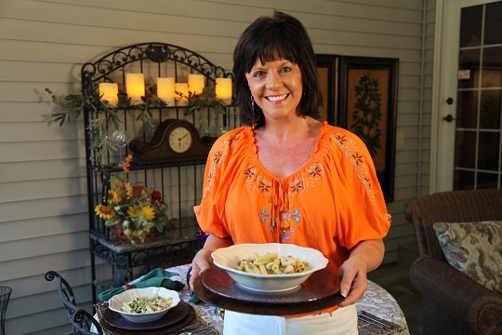

1 | lb | Ziti, Mostaccioli or other medium pasta shape, uncooked
12 | oz | chopped, cooked chicken
2 | tsp | butter or margarine
1 |  | medium onion, chopped
1 | Tbs | Dijon mustard
2 | Tbs | all-purpose flour
2 | cups | low-sodium chicken broth
1/4 | cup | lemon juice
1 | 10 oz | package frozen peas, defrosted and drained
1/4 | cup | fresh parsley, chopped
 |  | Salt and pepper to taste

Prepare pasta according to package directions.
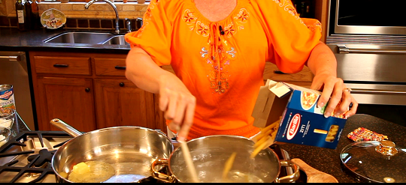

While pasta is cooking, warm the butter or margarine over medium heat in a large skillet. Add onion and cook for 3 mins.

Stir in the Dijon mustard and flour. Using whisk, very gradually whisk in the chicken broth.

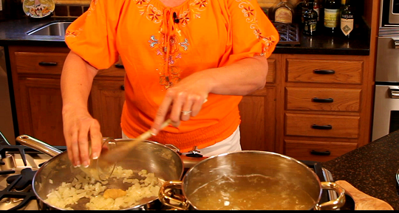

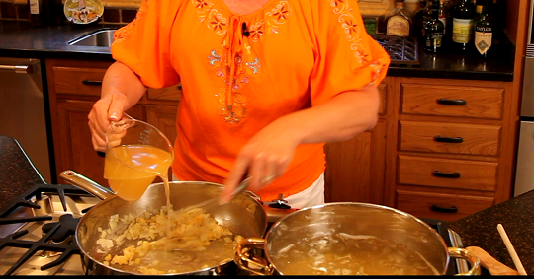

Bring the broth to a boil and stir in the lemon juice, peas and parsley.

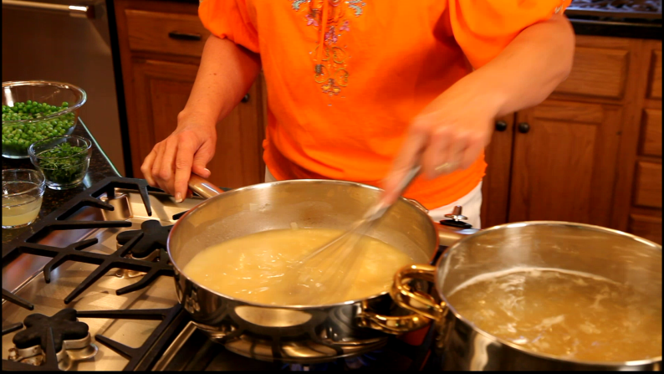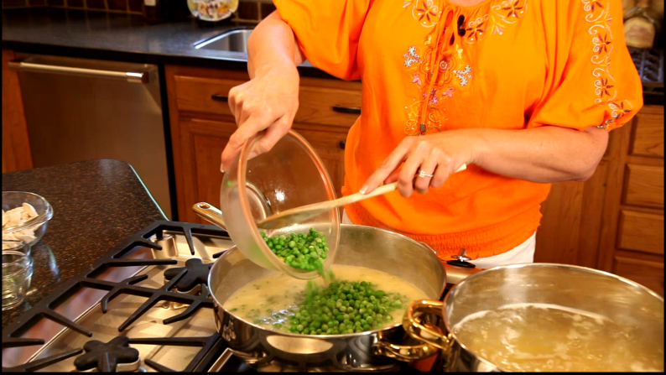

When pasta is done, drain it well. Toss pasta and cooked chicken with sauce, season with salt and pepper and serve.
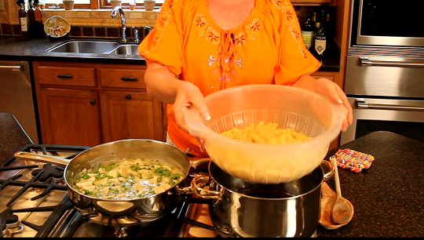

Servings: 4

