Success Secret: Chilling White Wine
Fill the bottom of the ice bucket with about an inch layer of ice cubes.
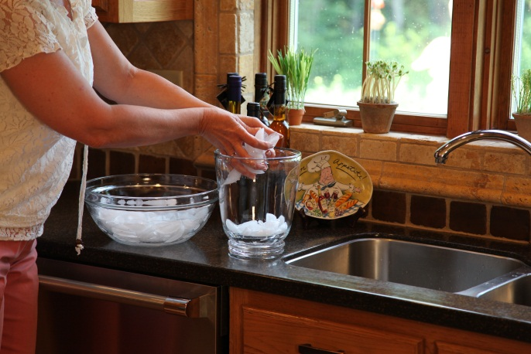

Fill the ice bucket halfway with cold water. The cold water is the success secret - it helps to chill the wine and it makes is easy to get the wine bottle in and out of the ice bucket.

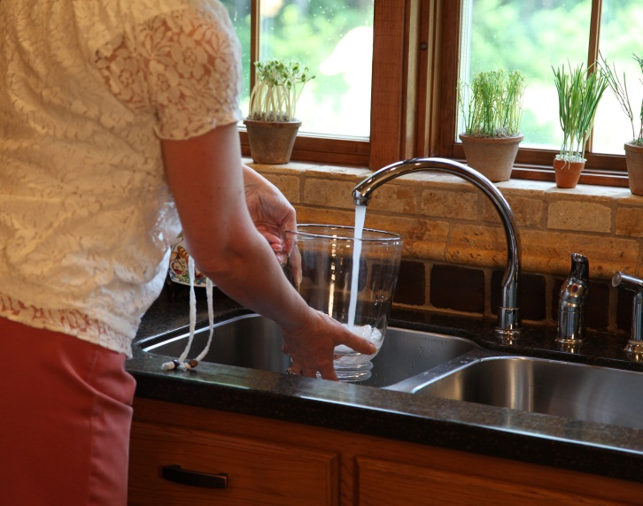

Place the bottle of wine in the ice bucket and position it in the middle of the bucket.

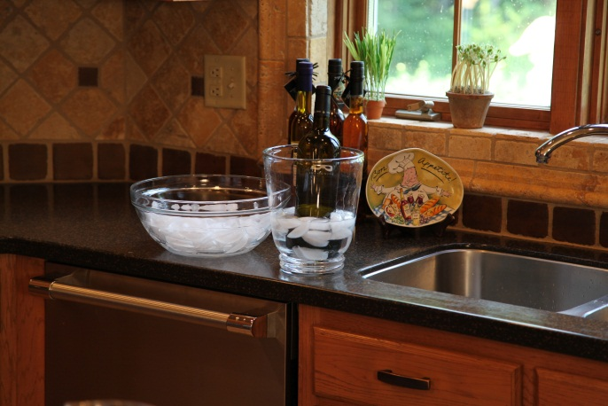

Fill up around the wine bottle with more ice cubes. Fill up to the top of the bottle's label - but
don't pack the ice too tightly.

After about 30 minutes, the wine will be perfectly chilled.

