Sugared Strawberries
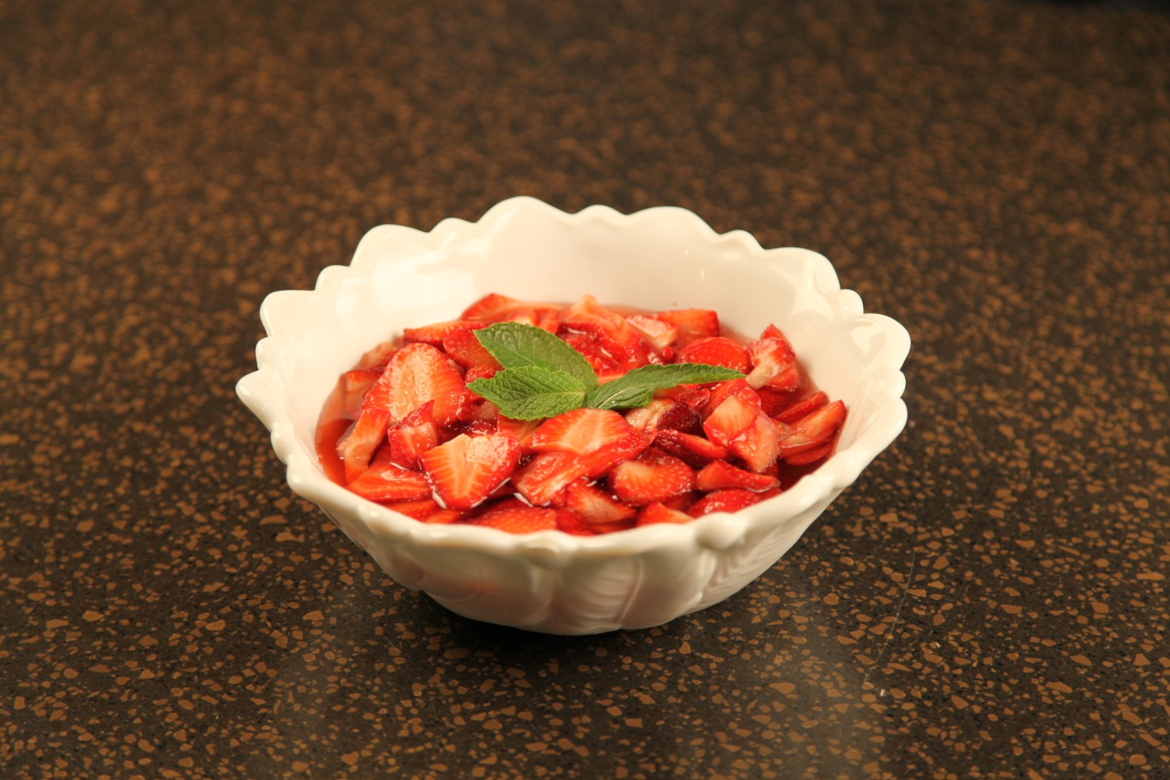

16 | oz | Whole fresh strawberries
3/4 | cup | Granulated sugar

Wash and slice the strawberries removing the leaves and stems.

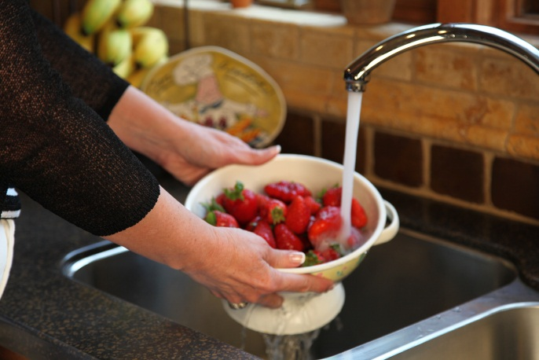

Add the sliced strawberries and the sugar to a bowl.

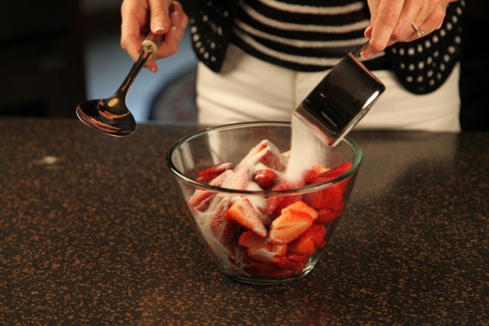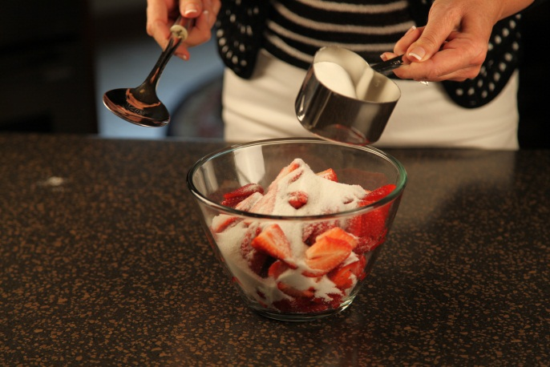

Stir gently to combine well.

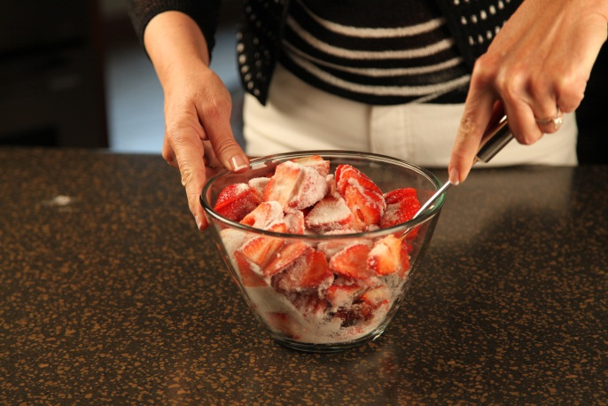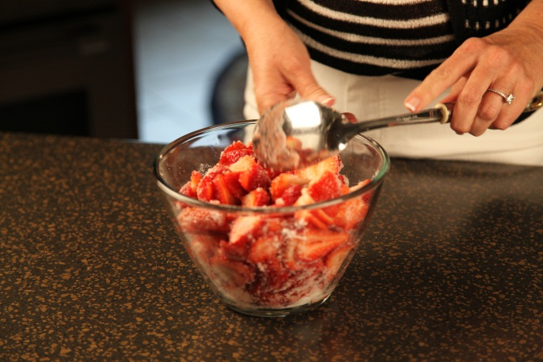

Cover the bowl with plastic wrap and let set a room temperature for about 2 hours, or refrigerate for up to 4 hours. ( I prefer to let the strawberries set out at room temperature because they get very soft when they are refrigerated.)

Stir well before serving. These are good served over shortcake, pound cake or ice cream.
Let’s make life special by sharing great food with our family and friends! Enjoy!

