Vickie's Fried Corn
What can I say about this easy, go-to recipe?? I have been making this for years and everyone absolutely LOVES it! This is an example of taking a perfectly healthy food and making it somewhat unhealthy, but it sure tastes good. The butter and sugar give the corn a sticky sweet goodness that makes for a great side dish for any meal!

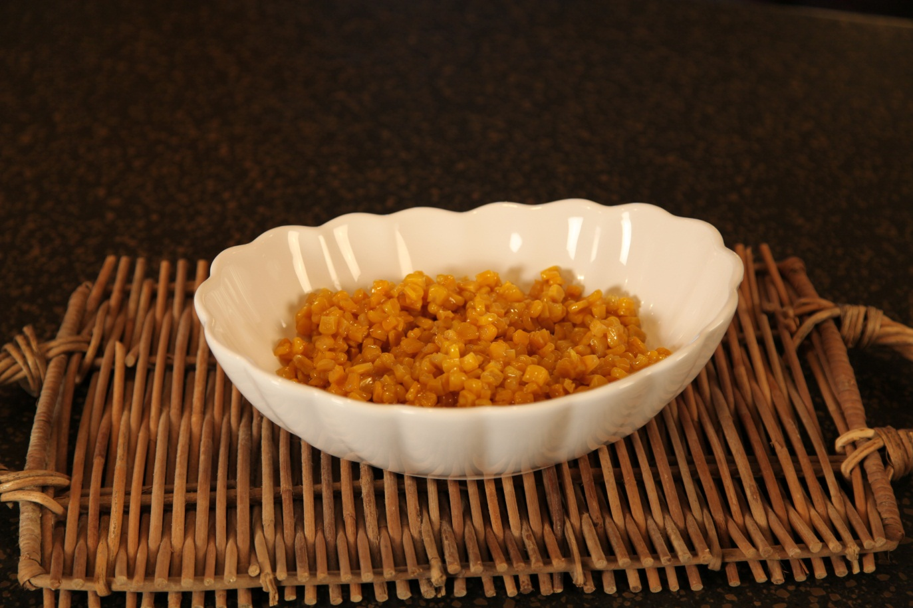
2 | 16 oz | Canned Corn
1/2 | Stick | Butter
½ | Cup | Sugar

Drain one can of corn and use the other can with all of the liquid. Add both cans to a skillet.

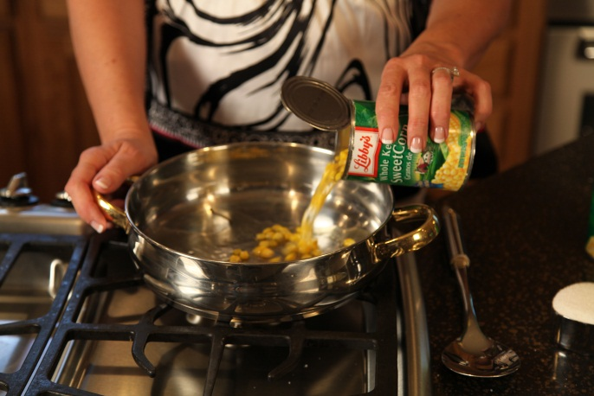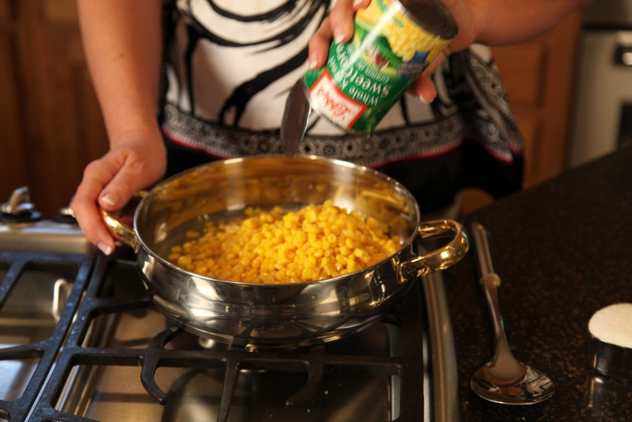
Dot with butter pieces and sprinkle sugar on top.
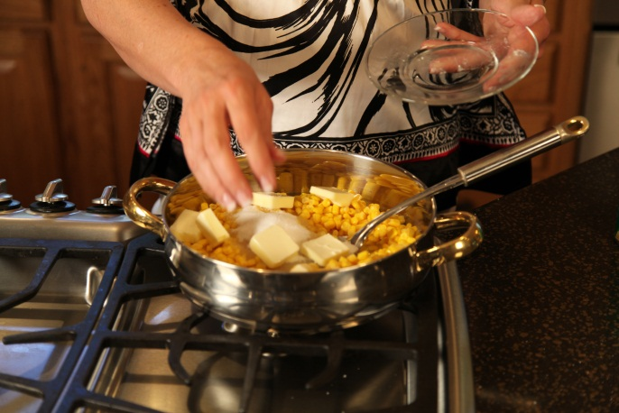

Simmer 30 minutes to develop that sticky goodness!.
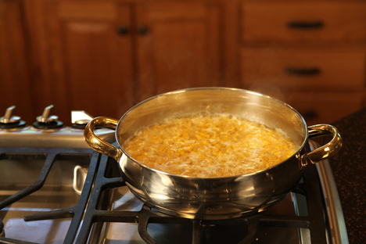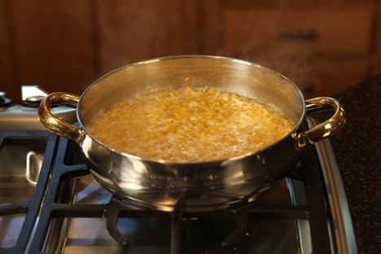
Servings: 6

