Vickie's Lemonade Pie
This recipe was given to me by my Mom many years ago. It tastes just like Key Lime Pie! It is great for easy entertaining!
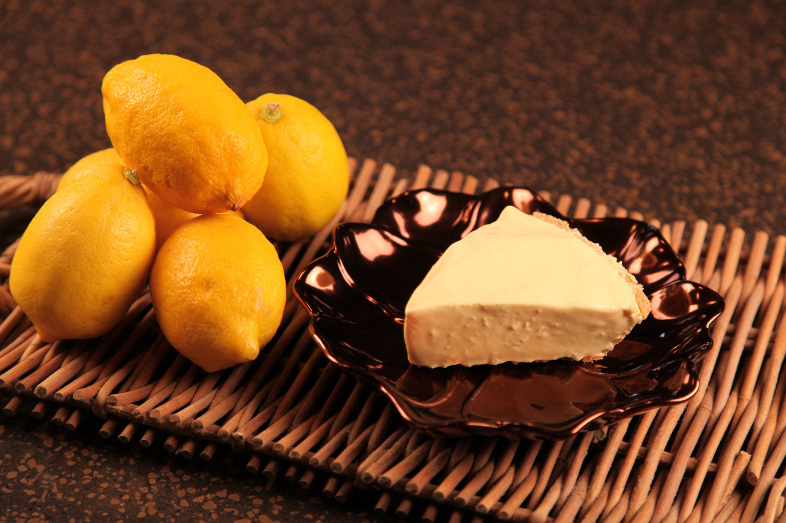

6 oz |  | Frozen lemonade concentrate
8 oz |  | Cool Whip
1 | Can | Sweetened condensed milk
1 |  | Graham cracker crust
 |  | Few drops yellow food coloring

.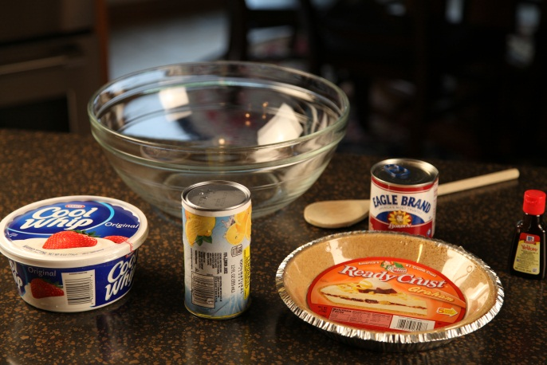
Mix lemonade concentrate and sweetened condensed milk together. I used half of a 12 oz can of lemonade concentrate.
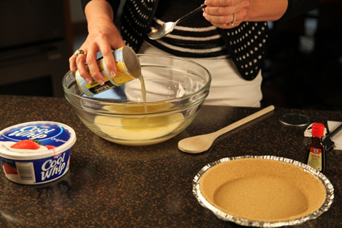

Fold in Cool Whip and a few drops of yellow food coloring.

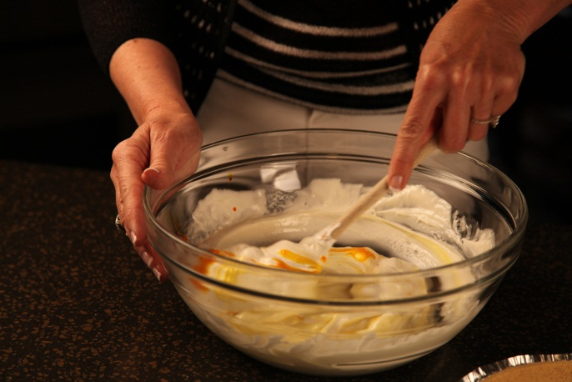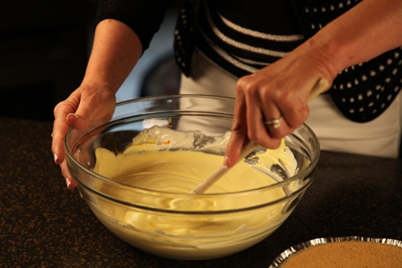

Pour into graham cracker crust and chill.

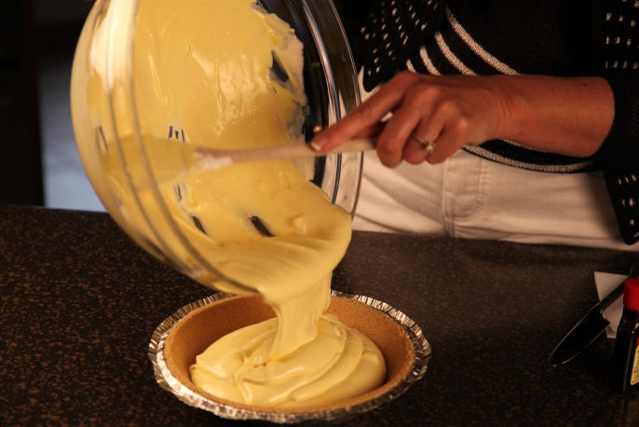

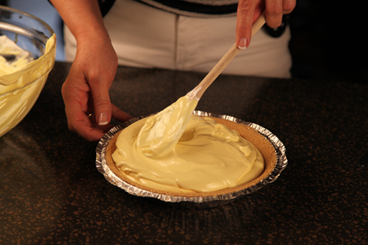

Let’s make life special by sharing great food with our family and friends! Enjoy!

