Baked Goat Cheese Marinara
We had Baked Goat Cheese Marinara at one of our favorite restaurants and I had to recreate it for us at home!
This is just like the restaurant recipe – and it is really quick and easy to make. I like to serve this with my French
Bread Crostini. The crostini can be made a day ahead and then wrapped in aluminum foil and reheated in the oven
when you are ready to serve this. The Goat Cheese Marinara can be assembled ahead of time and refrigerated until
you pop it under the broiler.

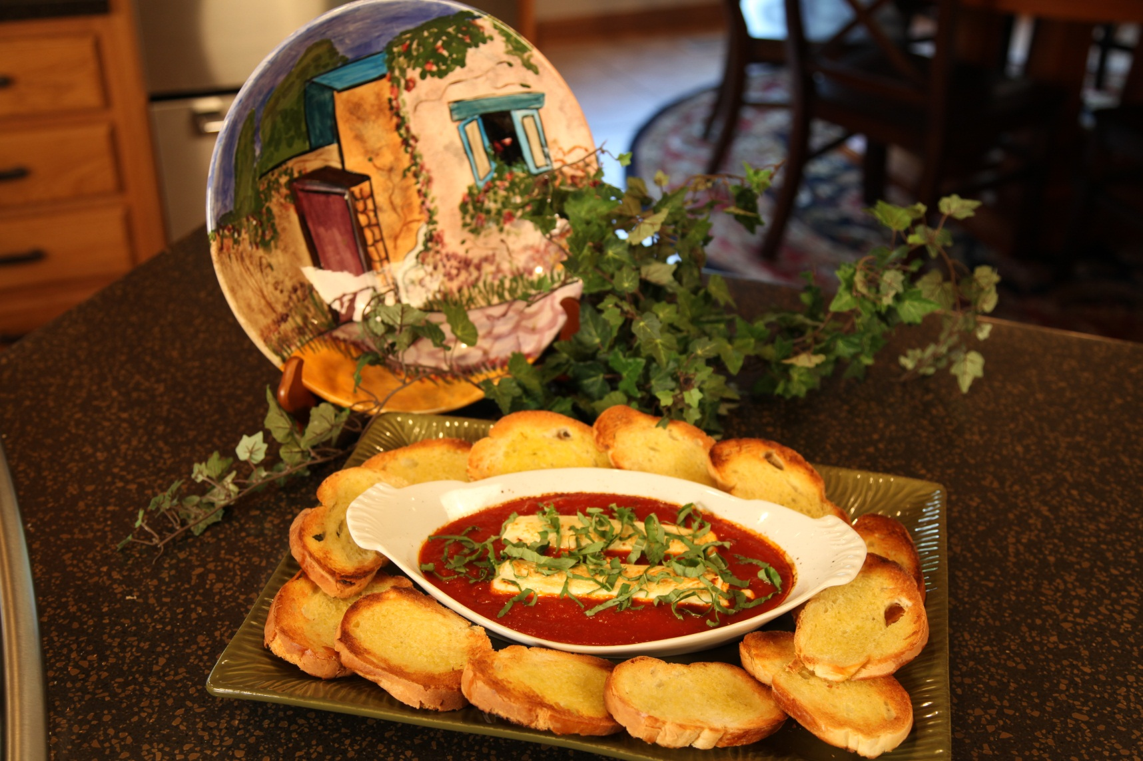

1 1/3 | cups | prepared marinara sauce
6 | oz | goat cheese
2 | tbs | fresh basil, thinly sliced
12 | slices | French bread
 |  | olive oil

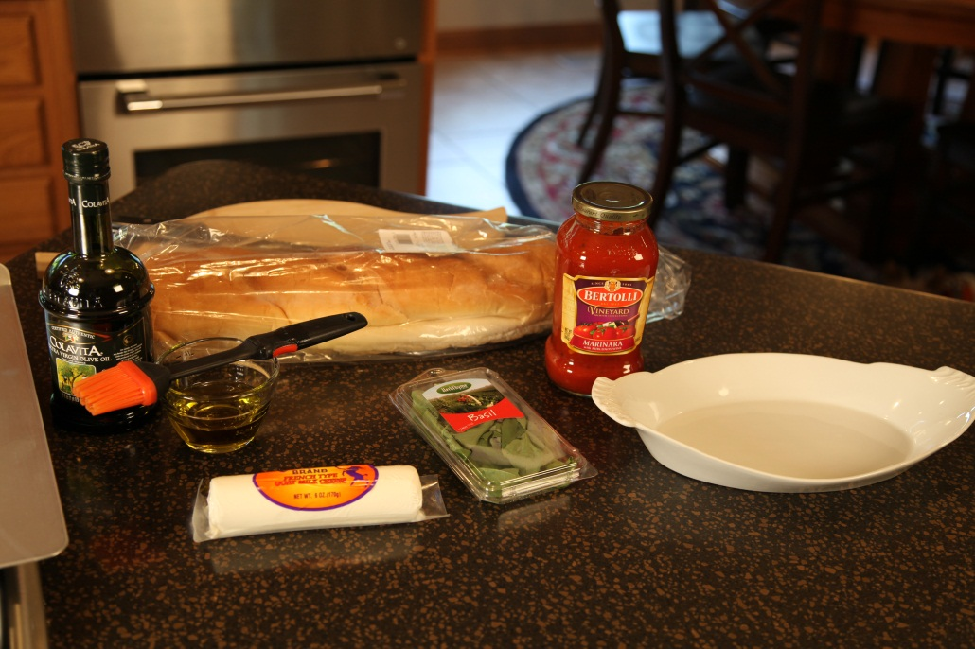

Brush each side of the bread slices with olive oil and place on a sheet pan. Toast each side under the broiler for 2 to 3 minutes, or until golden brown.
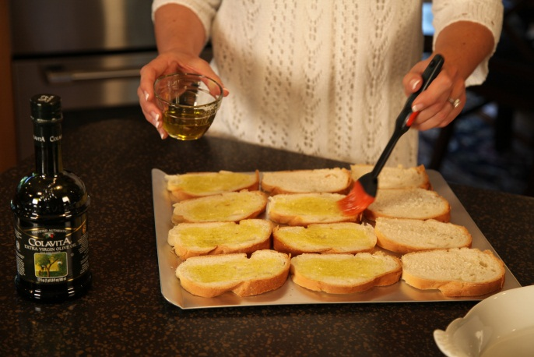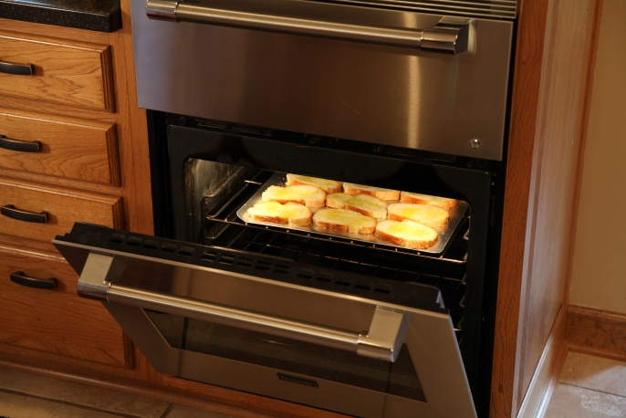

Pour marinara sauce in the bottom of a small baking dish. Slice the goat cheese in half and place in the center of the marinara sauce.

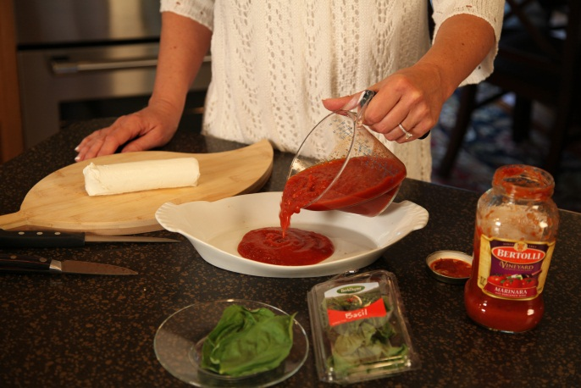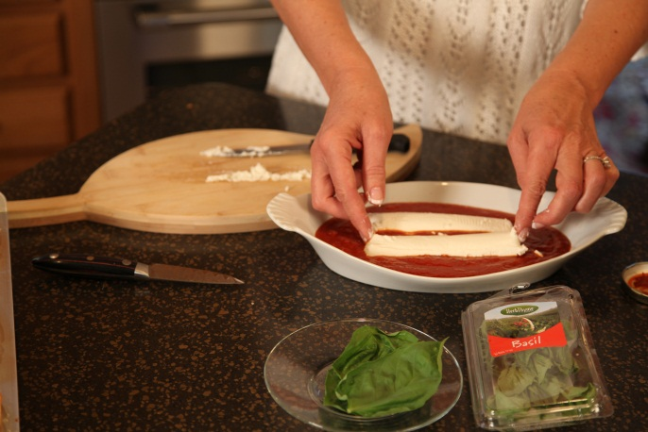

Bake under the broiler for 4 to 6 minutes or until the goat cheese is soft and slightly golden.

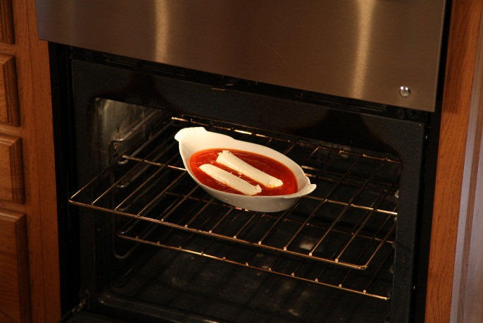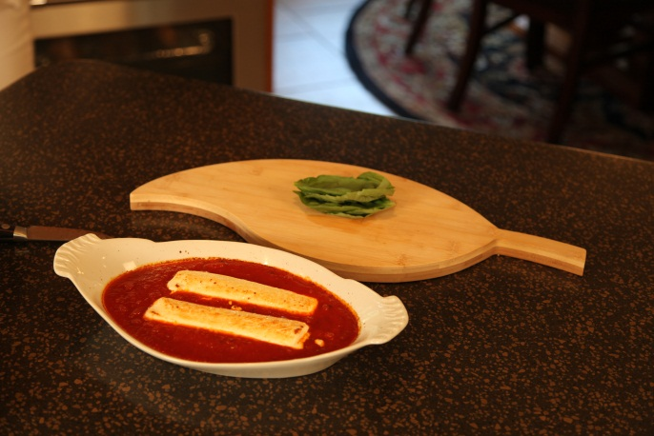

Sprinkle mixture with fresh basil before serving.

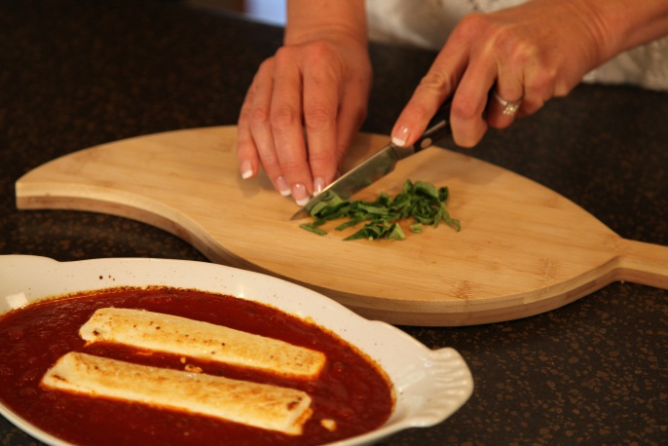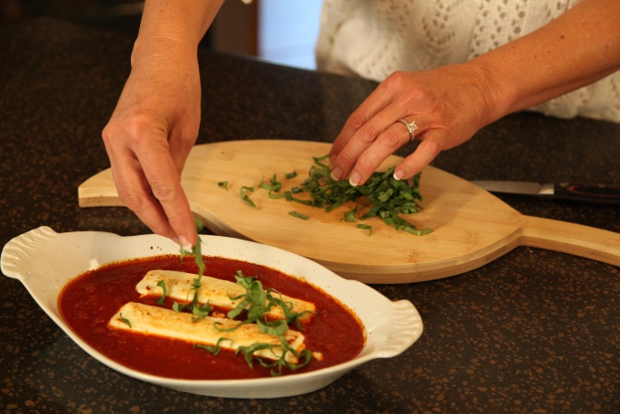

Serves 4 people as an appetizer.

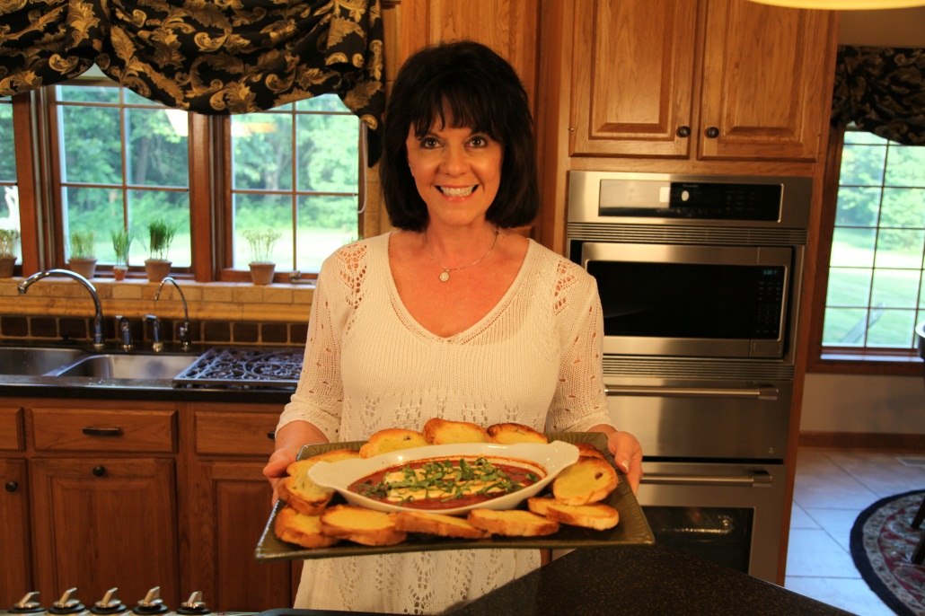

Let’s make life special by sharing great food with our family and friends! Enjoy!

