|  |
| --- |
| Baked Pork Chops and Corn Stuffing |
| C:\Users\Owner\Pictures\Food\Baked Pork Chops With Corn Stuffing\IMG_1486 - Resized.JPG   |  |  |  | | --- | --- | --- | | 1 | can | Cream of Celery Soup | | 4 |  | Boneless pork chops, 3/4" thick | | 1 | box | Cornbread Stove top Stuffing | | 1/2 | cup | whole kernel corn, drained | | 1 |  | Small onion, chopped | | 1/4 | cup | celery, finely chopped | | 1 | tbs | Brown sugar, packed | | 1 | tsp | Spicy brown mustard | |
| Mix stuffing, soup, corn, onion and celery together. Spoon into a greased 9" pie plate.  C:\Users\Owner\Pictures\Food\Baked Pork Chops With Corn Stuffing\IMG_1428.JPG C:\Users\Owner\Pictures\Food\Baked Pork Chops With Corn Stuffing\IMG_1430.JPG  C:\Users\Owner\Pictures\Food\Baked Pork Chops With Corn Stuffing\IMG_1435.JPG C:\Users\Owner\Pictures\Food\Baked Pork Chops With Corn Stuffing\IMG_1439.JPG  Place pork chops on top of the mixture.  C:\Users\Owner\Pictures\Food\Baked Pork Chops With Corn Stuffing\IMG_1446.JPG C:\Users\Owner\Pictures\Food\Baked Pork Chops With Corn Stuffing\IMG_1448.JPG  Mix brown sugar and mustard together and spoon over chops.  Bake at 400° for 30 minutes or until done. |

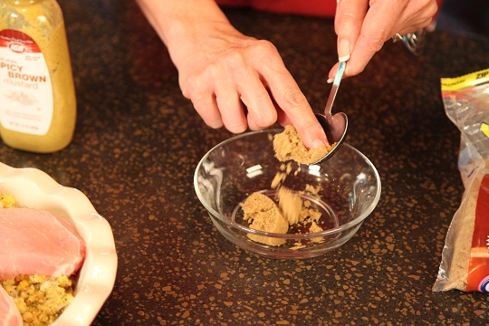 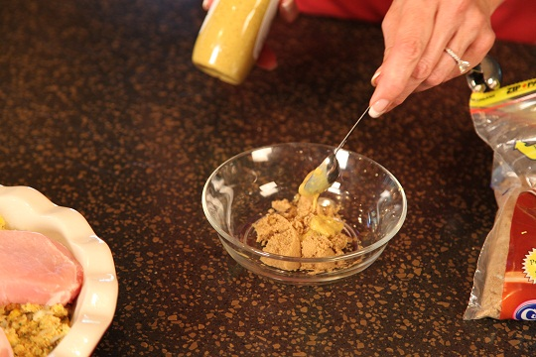

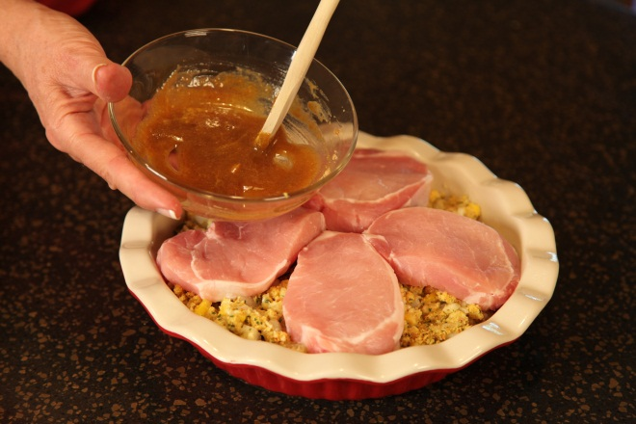 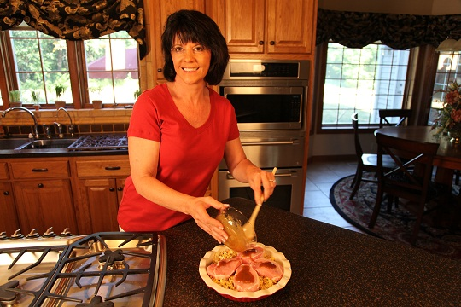

Bake uncovered at 400 degrees for 30 minutes.

Enjoy!