Bourbon Pork Tenderloin with Mustard Sauce
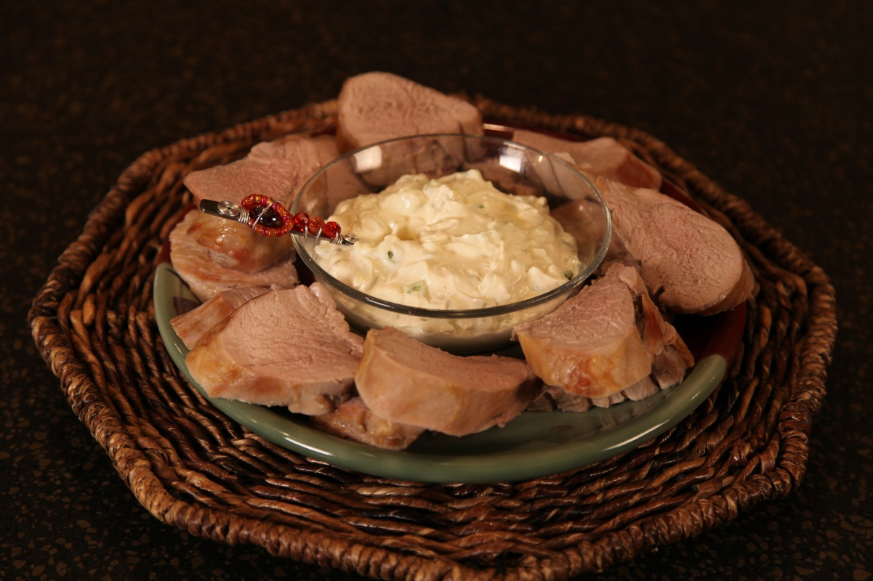

1/4 | cup | soy sauce
1/4 | cup | bourbon
2 | tbs | brown sugar
2 | 1 lb | pork tenderloins
2/3 | cup | sour cream
2/3 | cup | mayonnaise
2 | tbs | dry mustard
4 |  | green onions, finely chopped

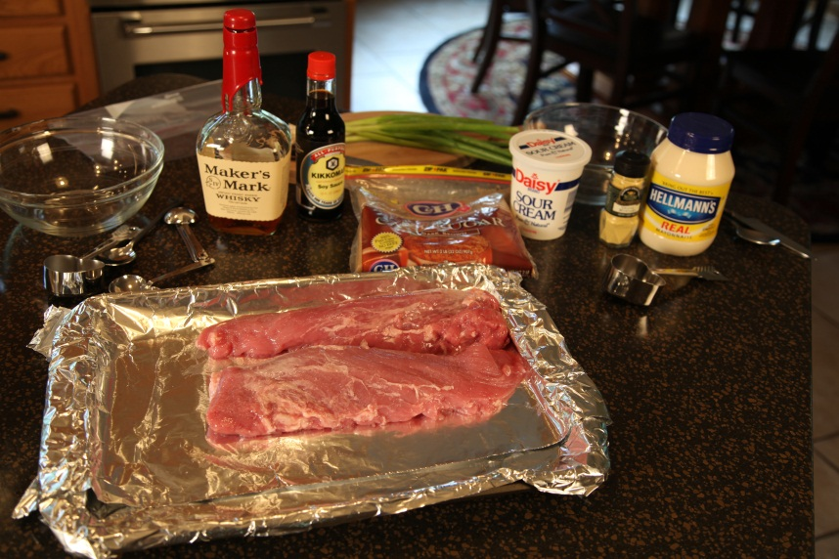

Combine the bourbon, soy sauce and brown sugar in a mixing bowl and stir to combine.
Pour into a large zip lock bag. Add tenderloins; cover or seal, and refrigerate
at least 2 hours, turning meat occasionally.

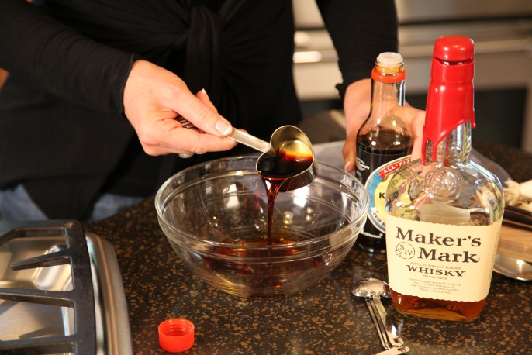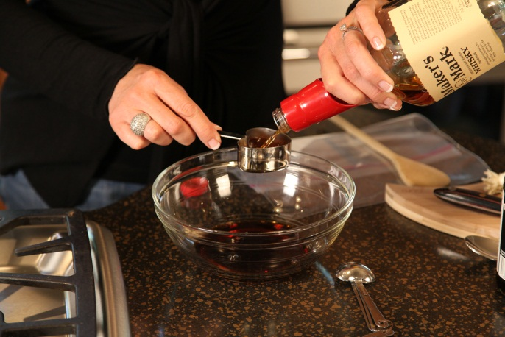

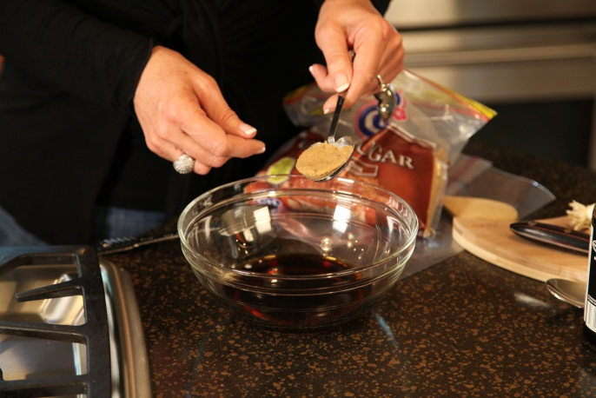

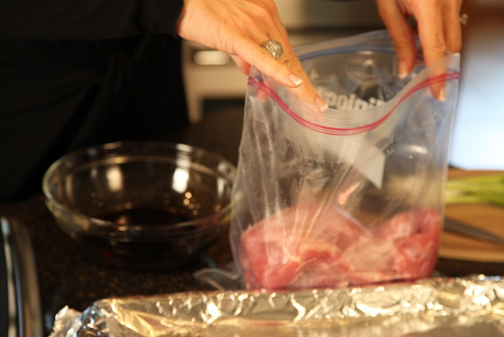

Remove from marinade; discard marinade. Place on a rack in a shallow roasting pan. Bake at 325° for 55 minutes. ( I like to cook pork until it reaches 160 to 165 degrees on an instant read thermometer )

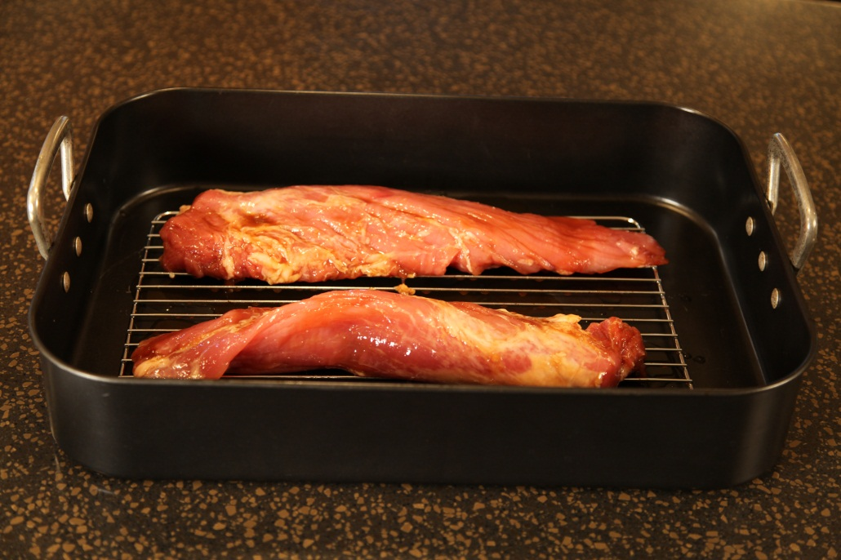

While tenderloins bake, prepare Mustard Sauce. ( or prepare a day ahead so the flavors can develop)
Note: The flavor is pretty intense, so if you want to tone it down a bit, just use a little less dry mustard.
I love the flavor of this sauce, I make the recipe exactly as I have given it here.

.
Mustard Sauce:
Combine 2/3 cup sour cream, 2/3 cup mayonnaise, 2 tbs. dry mustard and 4 chopped green onions. Cover and chill.

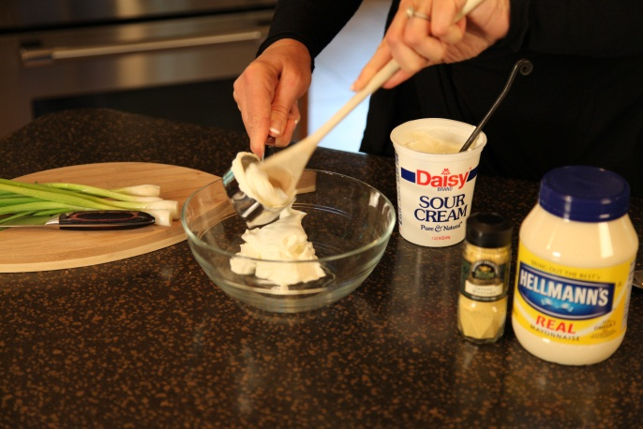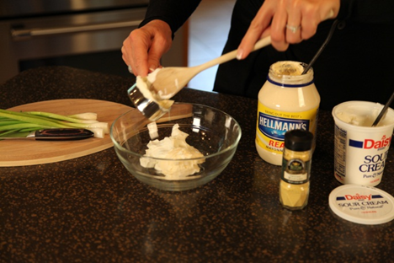

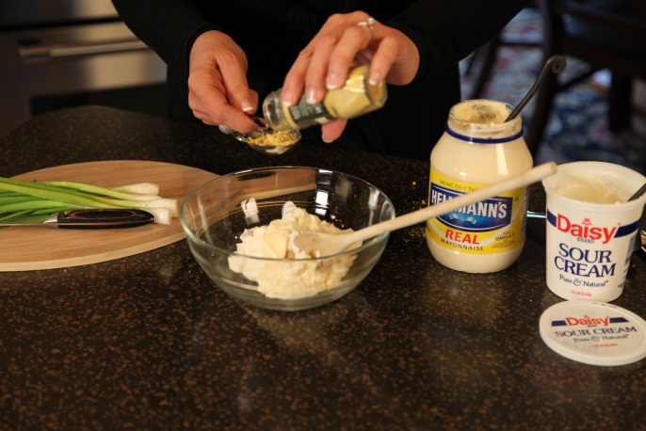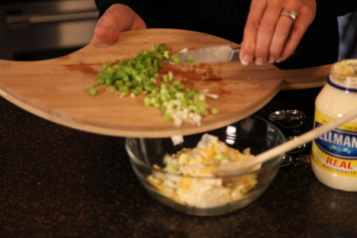

Serve with mustard sauce.

Let’s make life special by sharing great food with our family and friends! Enjoy!

