Disappearing Ice Cream Dessert
This is a great summertime dessert to have on hand in your freezer. Everyone loves it and no one will ever guess how simple this is to make. You can have this ready for the freezer in 5 minutes!

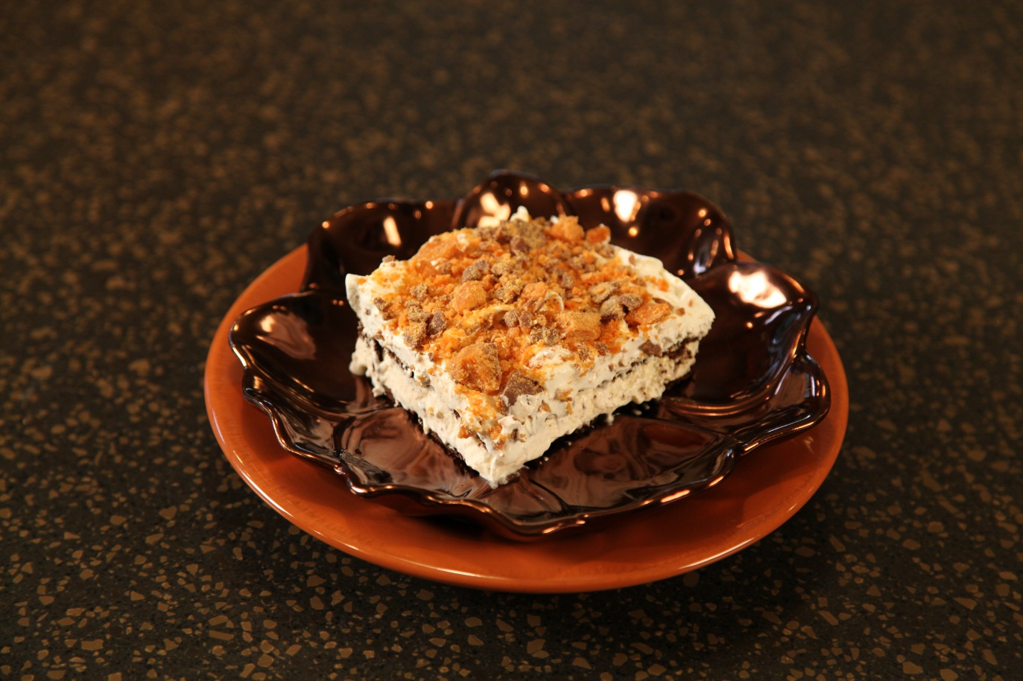

12 |  | ice cream sandwiches
1 | tub | Cool Whip, thawed
3 | large | Butterfinger candy bars, crushed

Line the bottom of a 9 X 13 baking dish with ice cream sandwiches.
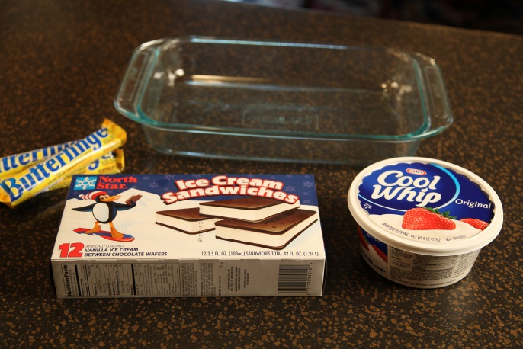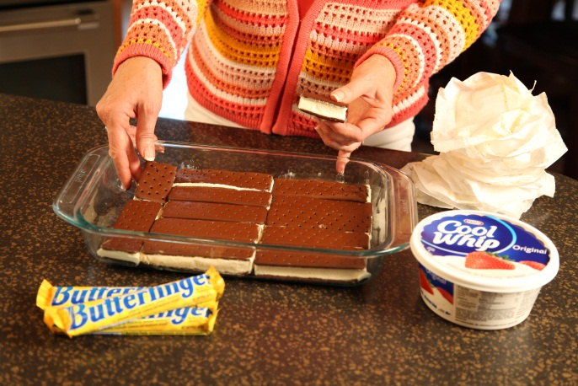
Spread whipped topping thickly and evenly over sandwiches.

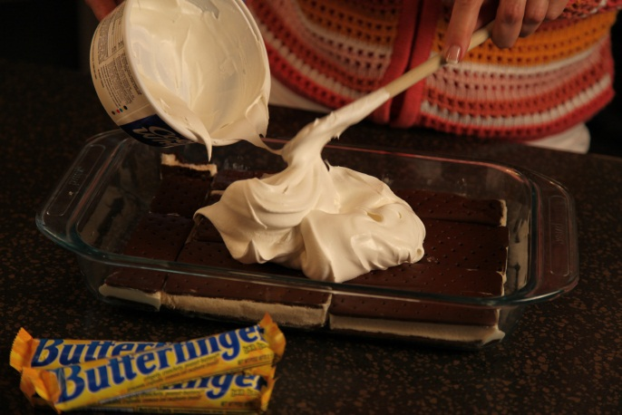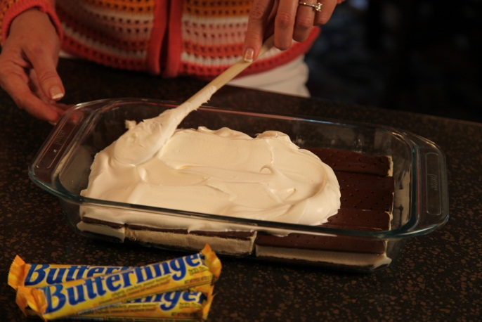

Place candy bars in a zip lock bag and pound with a mallet to crush. Sprinkle the Butterfinger crumbs over top.

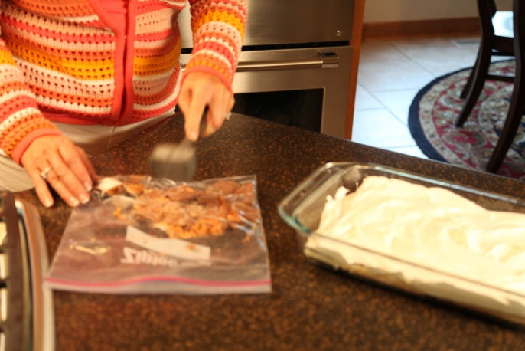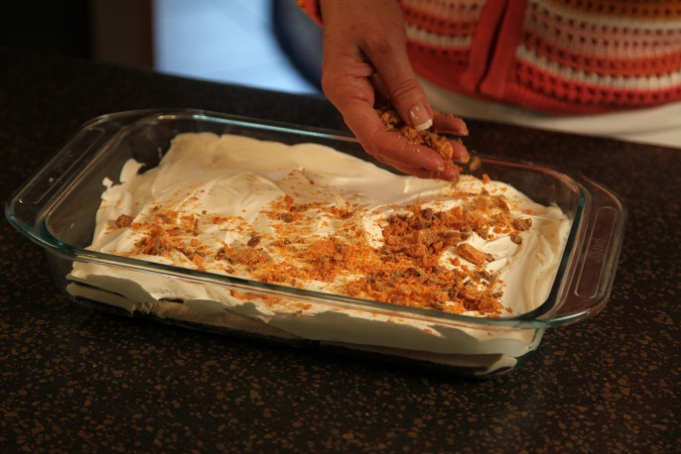

Cover with plastic wrap and then with aluminum foil and freeze until ready to serve.

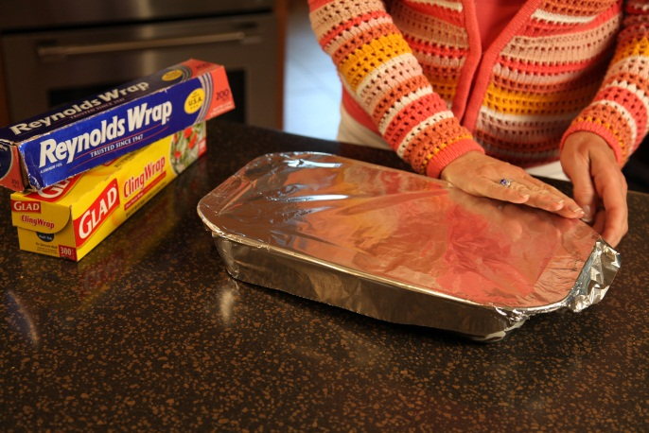

Let’s make life special by sharing great food with our family and friends! Enjoy!

