Gooey Coconut Chocolate Brownie Pie
One of my all-time favorite pies. You can see the gooey goodness in this pie.
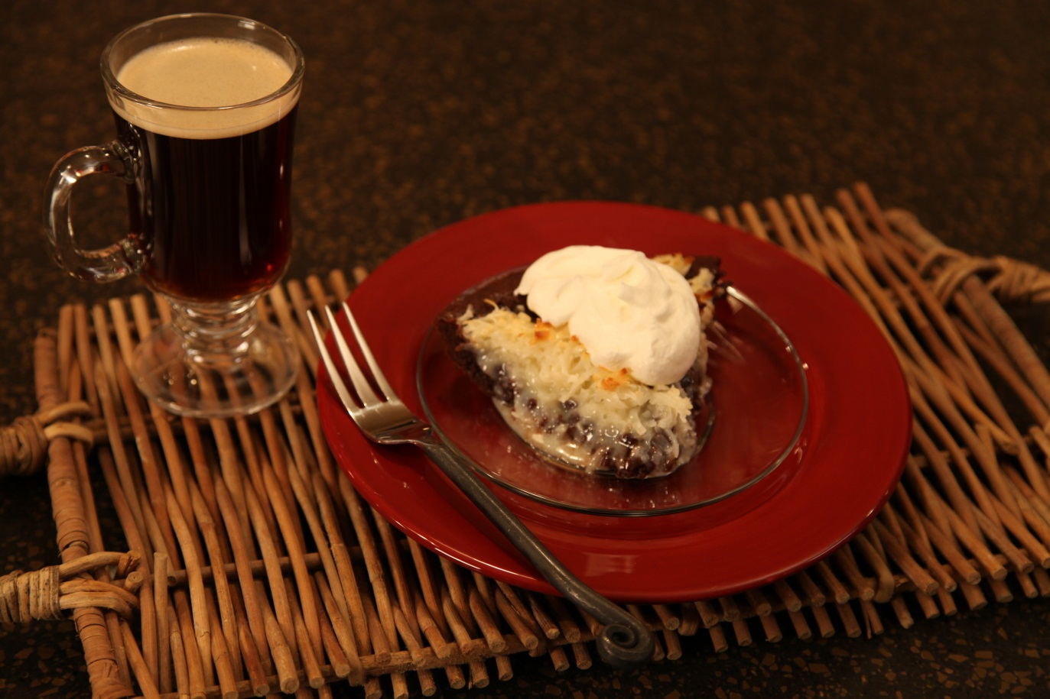
Pie:
2 2/3 cups coconut
1 can sweetened condensed milk
1 stick margarine
3 squares unsweetened chocolate
3/4 cup sugar
1/2 cup all purpose flour
3 eggs
1 tbs vanilla
Whipping Cream:
1 8 oz carton whipping cream
1/4 cup sugar
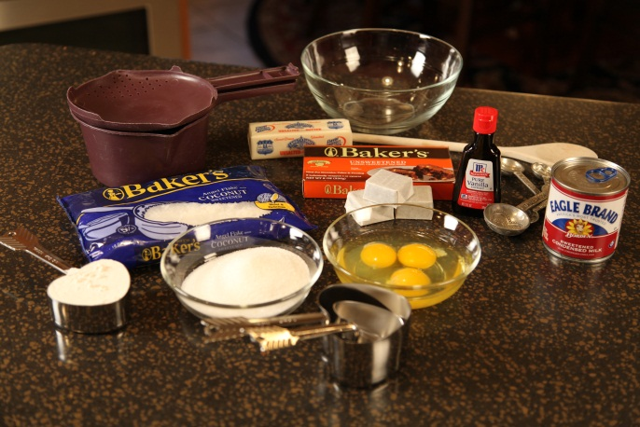

Mix together coconut and sweetened condensed milk; set aside.
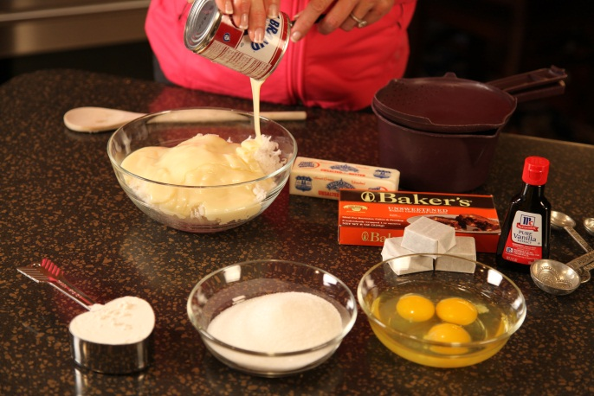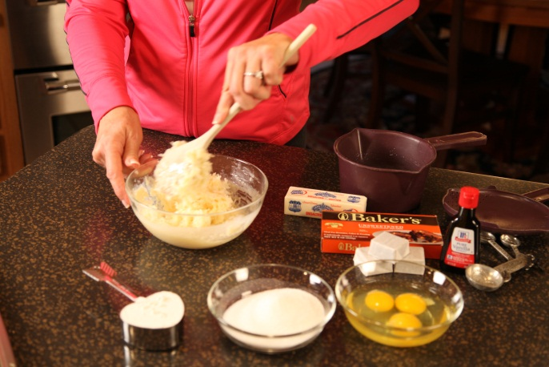

Microwave margarine and chocolate together for 3 minutes in a microwave bowl. Remove from microwave and add the sugar and flour to the hot mixture. Stir well. Gradually add the eggs, one at a time and stir until the chocolate mixture is smooth.

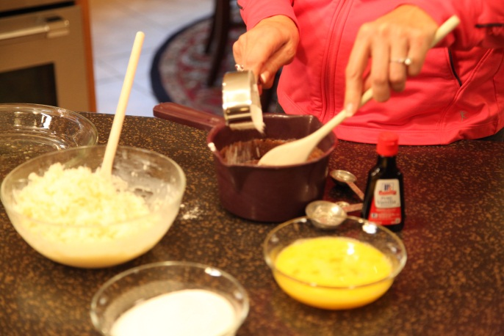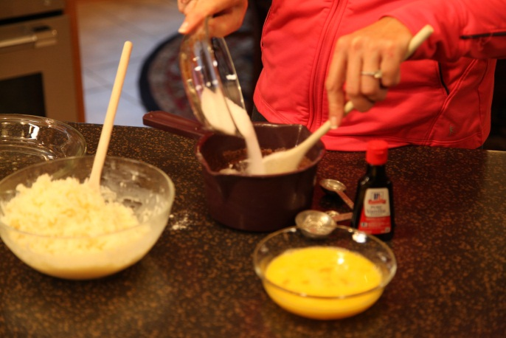

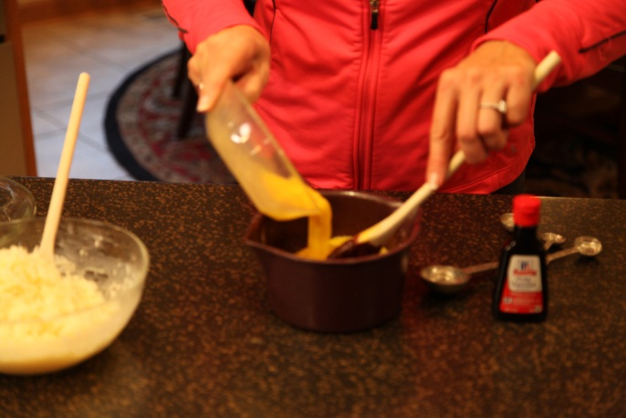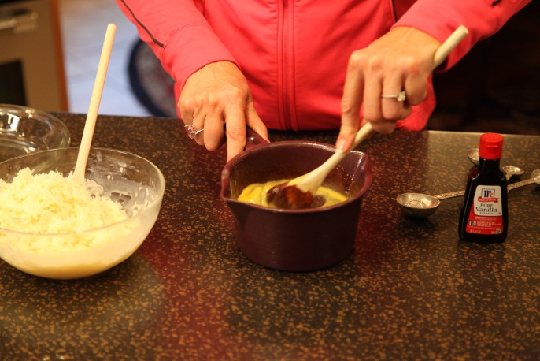

Add vanilla and stir.

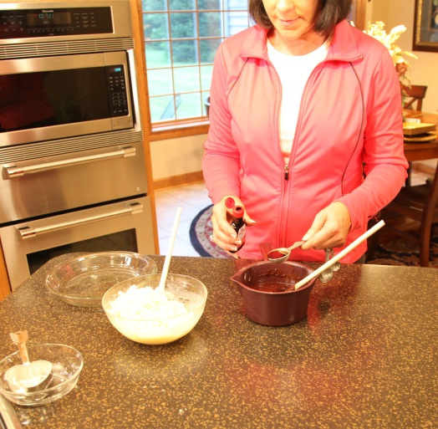

Stir well to blend. Pour mixture into a greased pie pan.

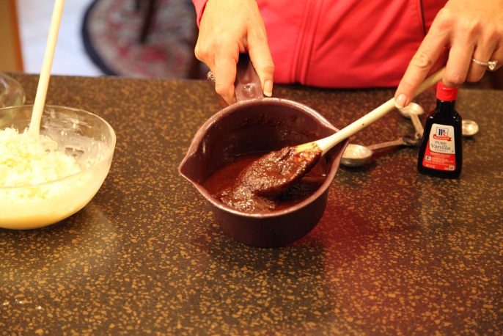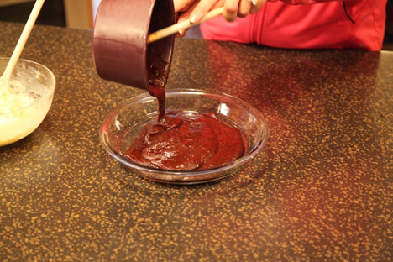

Put coconut mix around top.

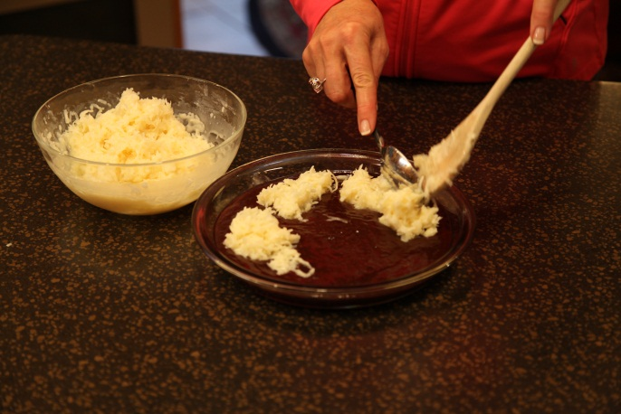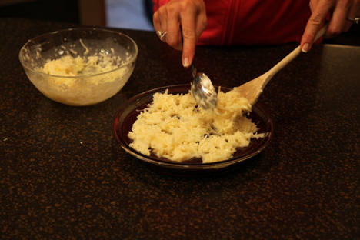

Bake in a 325° oven for 25 minutes. Cool pie on wire rack.

Tips
Serve with sweetened homemade whipped cream.

Let’s make life special by sharing great food with our family and friends! Enjoy!

