Great Strawberry Shortcakes
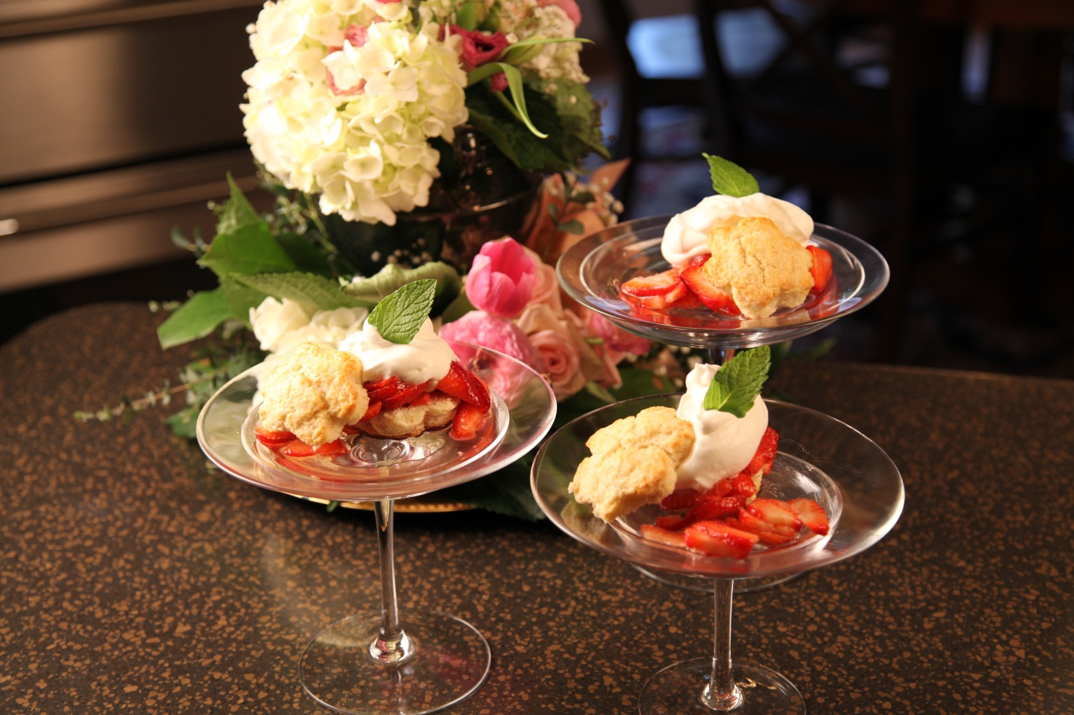

6 to 8 | cups | sliced strawberries
1/2 | cup | plus 1/3 cup sugar, plus more for sprinkling
2 1/2 | cups | All- purpose flour
3/4 | cup | cake flour
2 | tbs | baking powder
3/4 | tsp | salt
1 | cup | butter, chilled and cut into pieces
1 | cup | milk
1 |  | egg
1 | tbs | water
 |  | Whipped cream

Combine strawberries and 1/2 cup sugar. Toss and let stand at room temperature 2 hours.
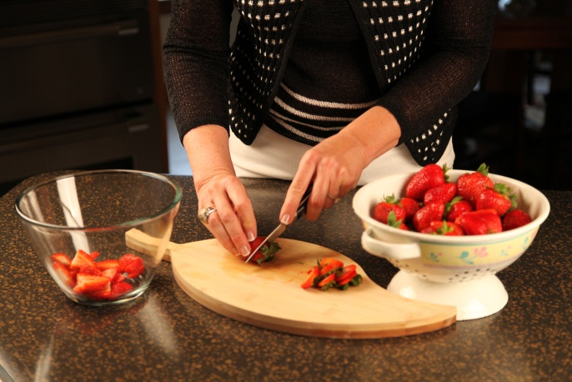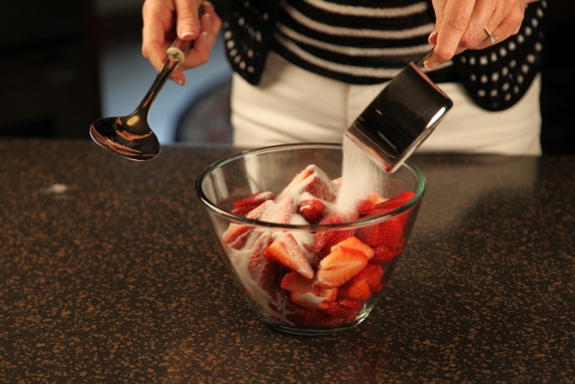

Preheat oven to 425°. Combine 1/3 cup sugar with the next 4 ingredients in a large bowl; cut in butter with a pastry blender until mixture resembles coarse meal.

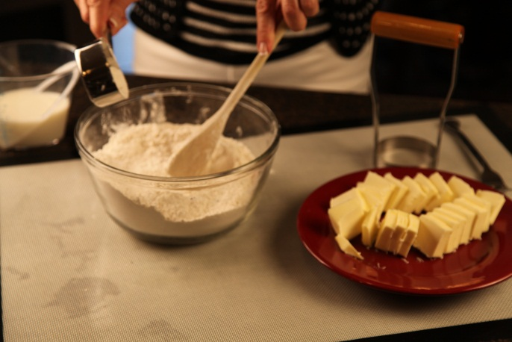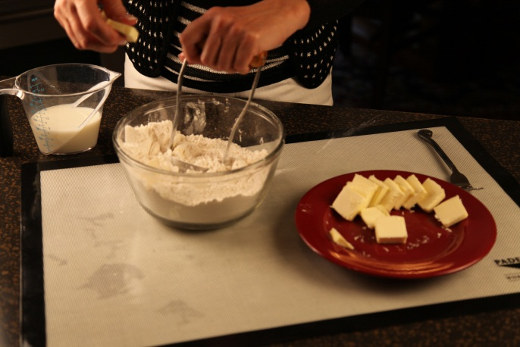
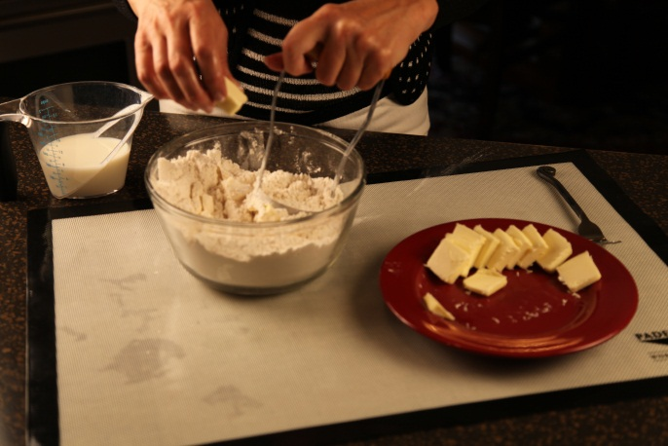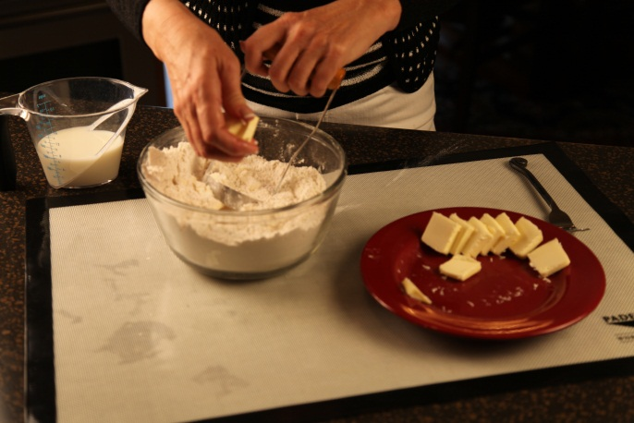

Add 3/4 cup milk and mix with a fork just until dough holds together, adding more milk if needed. Dough should be soft.
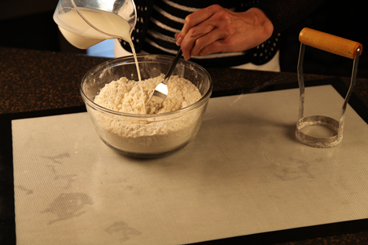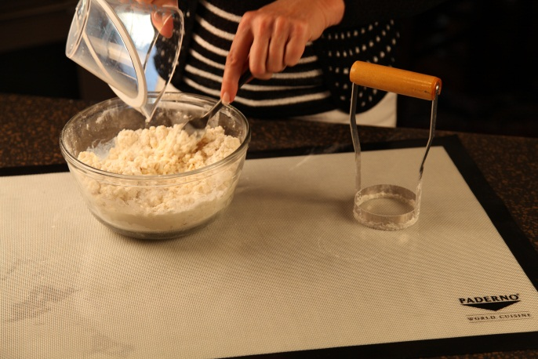

Turn dough out onto a floured surface and knead gently 8 to 10 times.

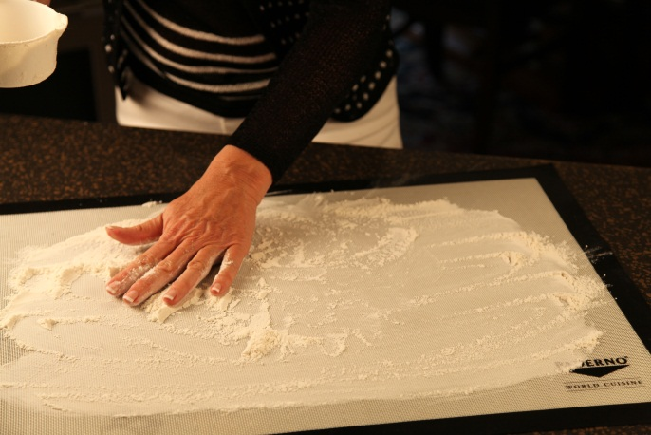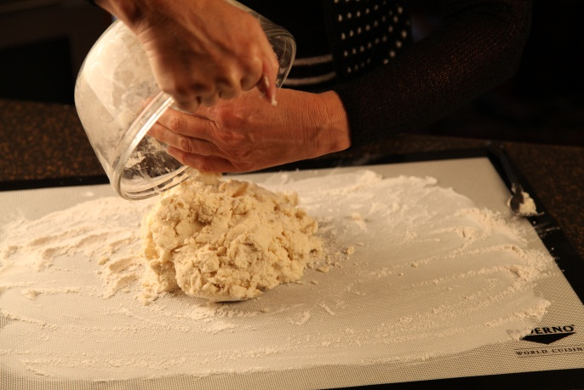

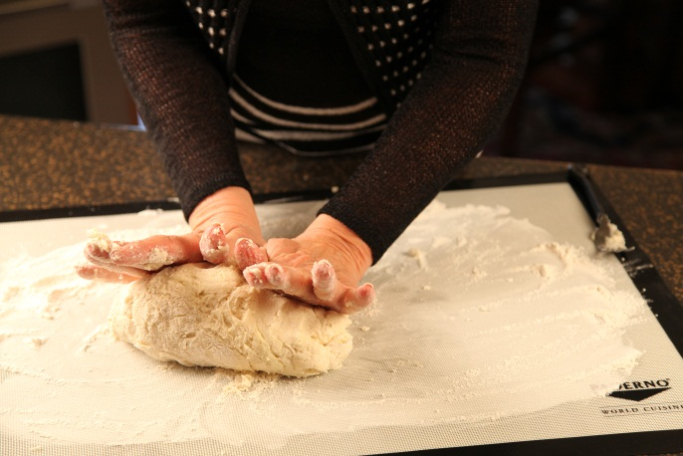

Pat it out 3/4 inch thick and cut into rounds, using a 2 1/2 inch biscuit cutter.
Place on a greased shiny baking sheet.

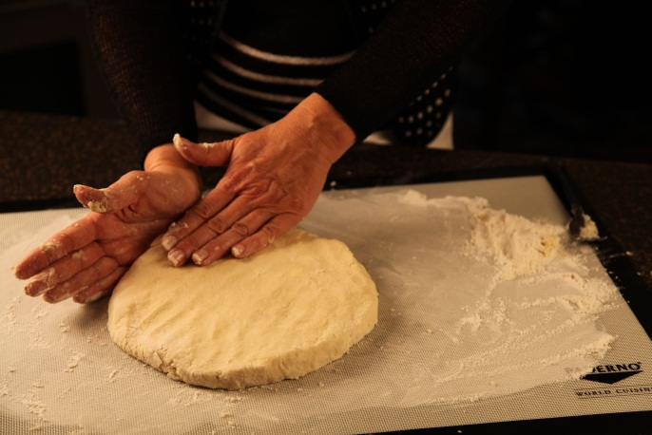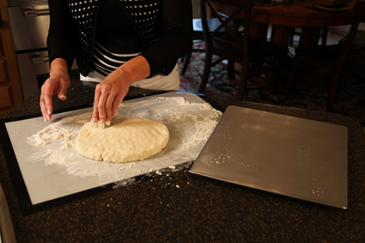

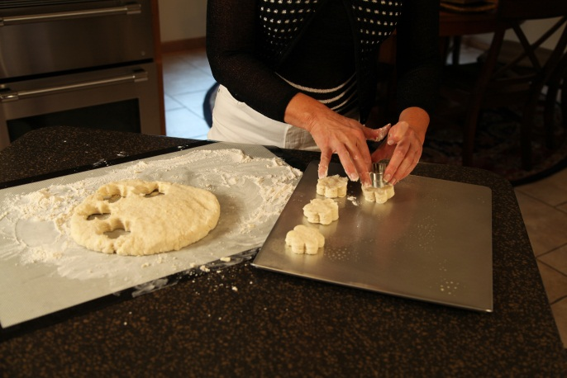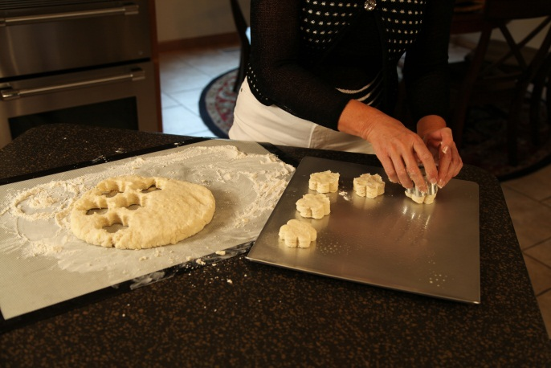

Combine egg and water, beating well; brush on tops of biscuits. Sprinkle with sugar.

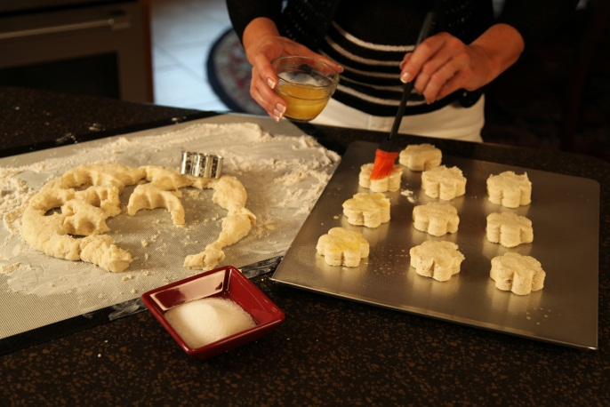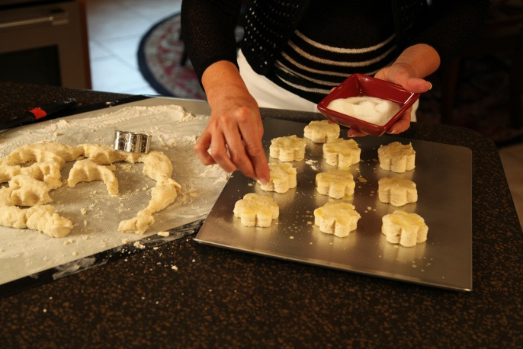

Bake for 12 minutes, or until lightly browned. Cool on a wire rack.

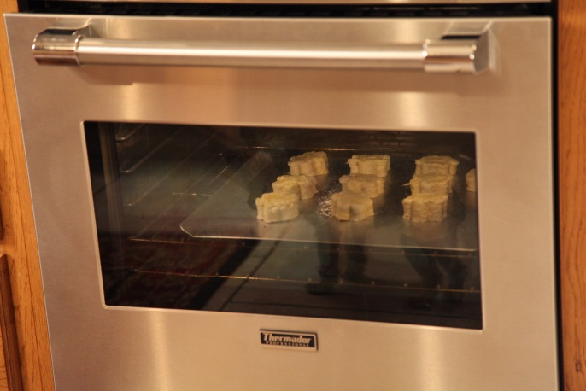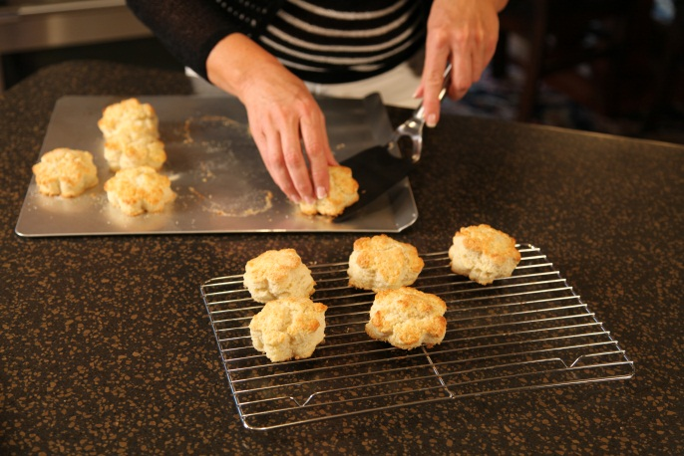

Split and serve with strawberries and whipped cream.

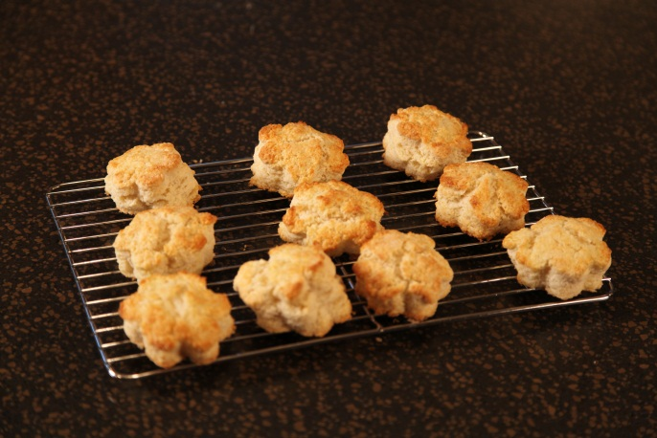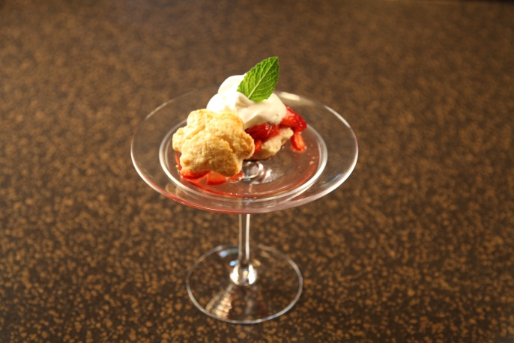

Yield: 10 servings

Let’s make life special by sharing great food with our family and friends! Enjoy!

