Homemade Whipped Cream
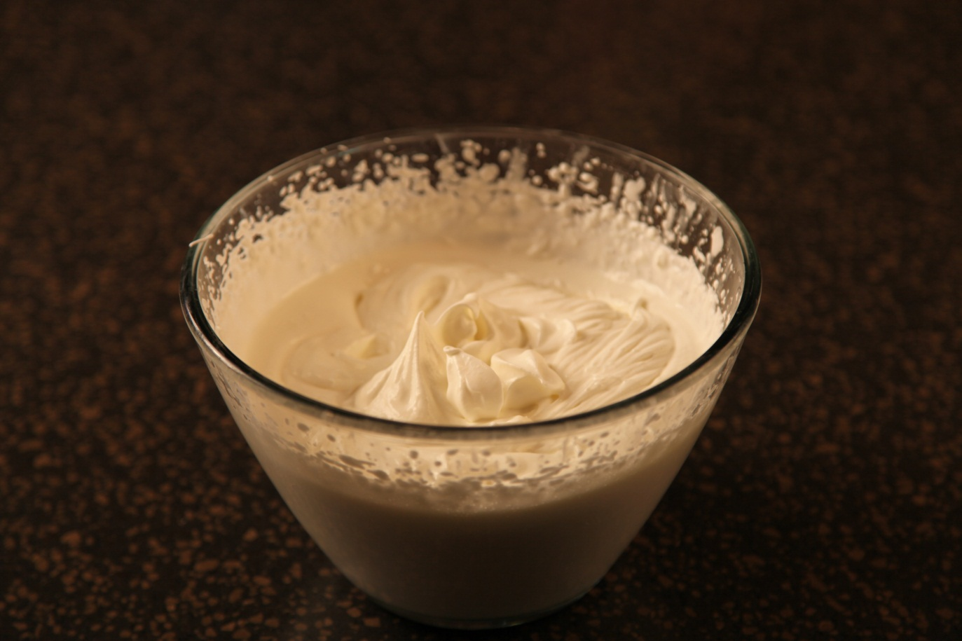

16 | oz | Heavy cream
1/2 | cup | sugar

Chill mixing bowl and beaters in freezer for about 30 minutes. Whip 16 ounces of whipping cream until soft peaks form.

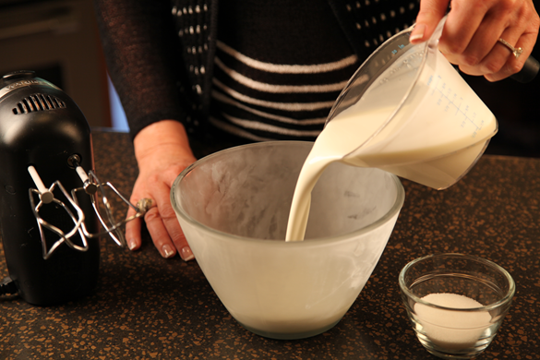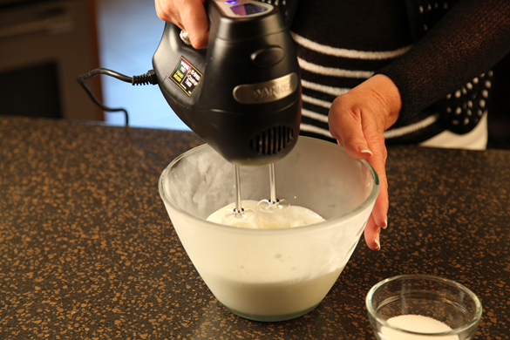

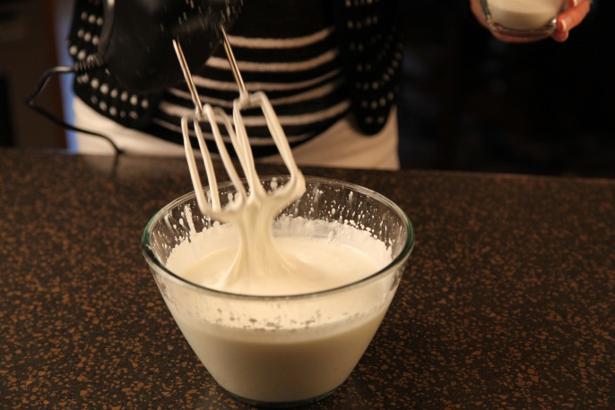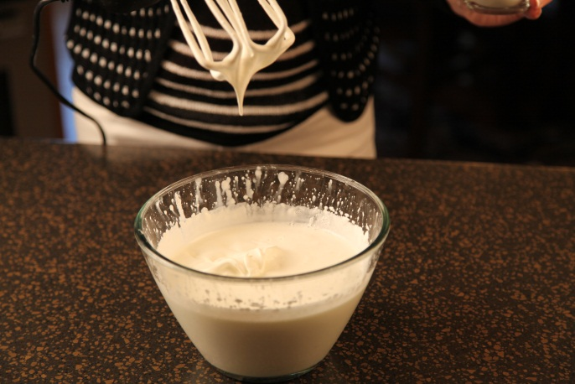

Slowly add ½ cup sugar and continue beating until stiff peaks form.

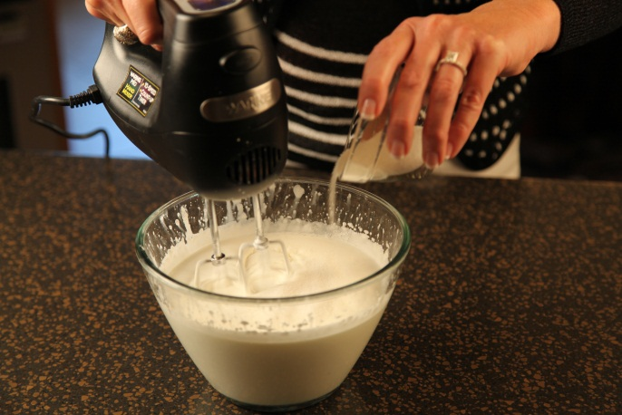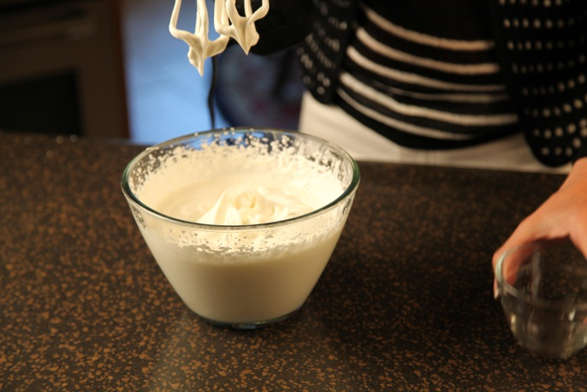

Let’s make life special by sharing great food with our family and friends! Enjoy!

