Meal In One Salad
This is really good! It is a great summertime lunch.

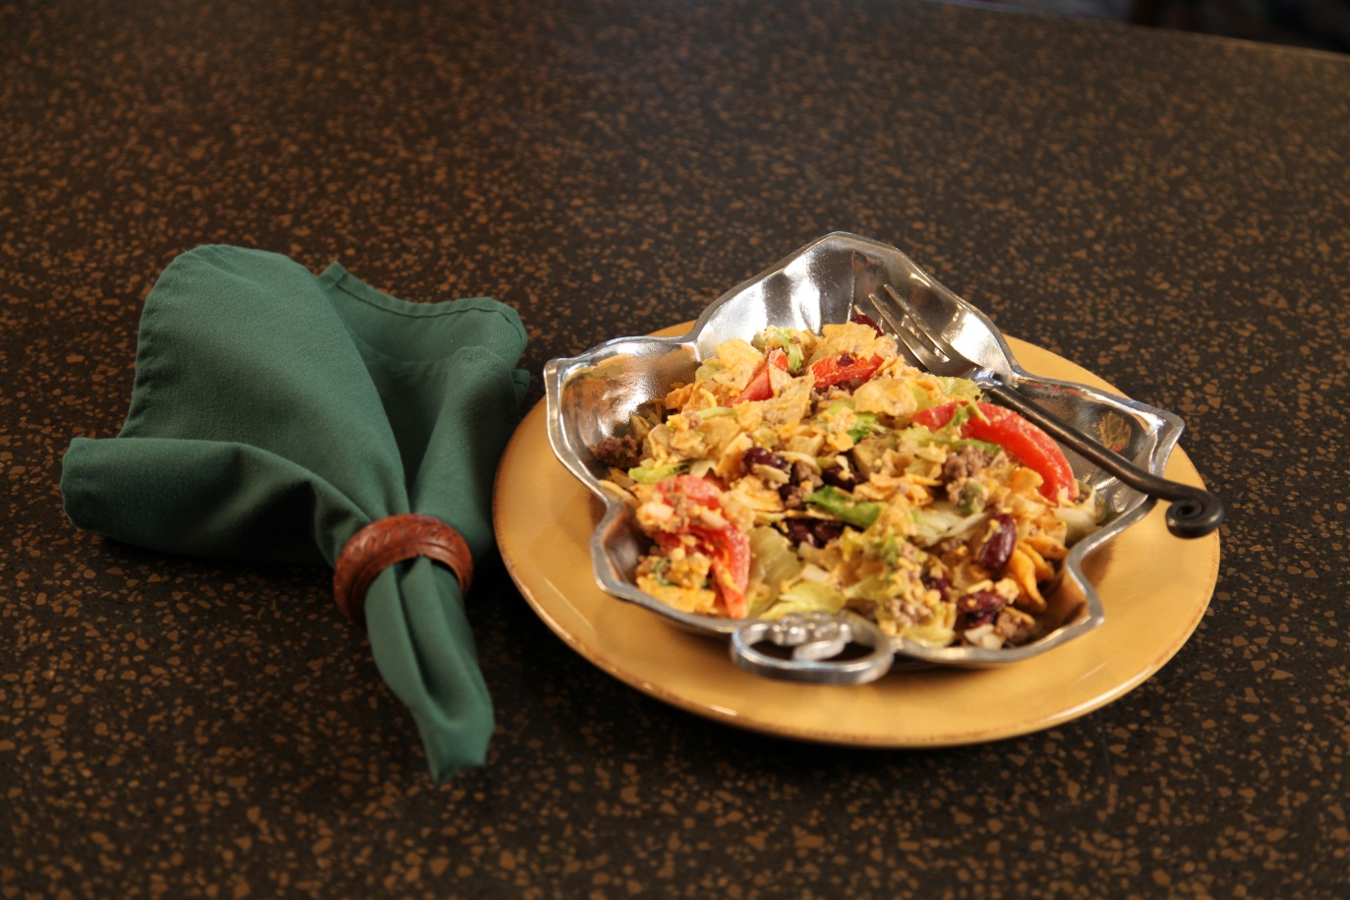

1/2 | cup | chopped onion
1 | head | lettuce, chopped
2 |  | tomatoes, cut in wedges
1 |  | avocado, diced
4 | oz. | grated Cheddar cheese
1 | lb. | ground beef
1 | 15 oz | Dark red kidney beans, drained
1 | tsp | salt
1 | small bag | tortilla chips
16 oz |  | Thousand Island dressing
Crumble and cook ground beef in skillet until done. Add drained dark red kidney beans and salt.
Simmer 10 minutes, Drain any excess fat and refrigerate until you are ready to assemble the salad.

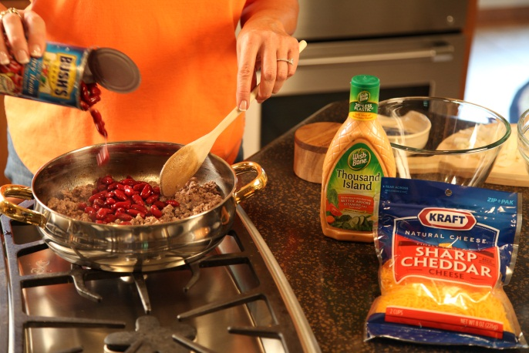

Toss together the chopped onion, chopped lettuce, tomato wedges, diced avocado and shredded
Cheddar cheese. Refrigerate until you are ready to assemble the salad.

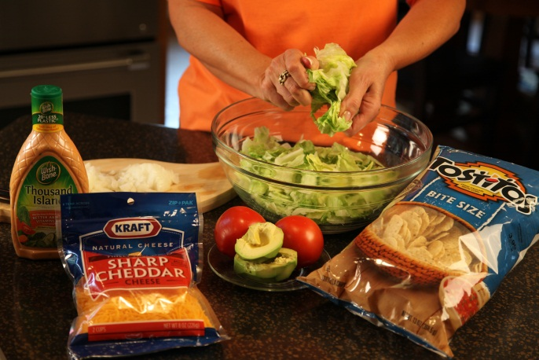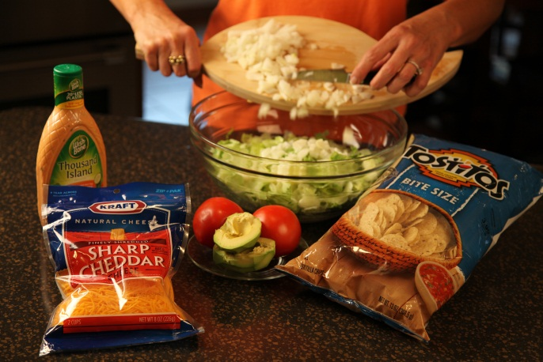

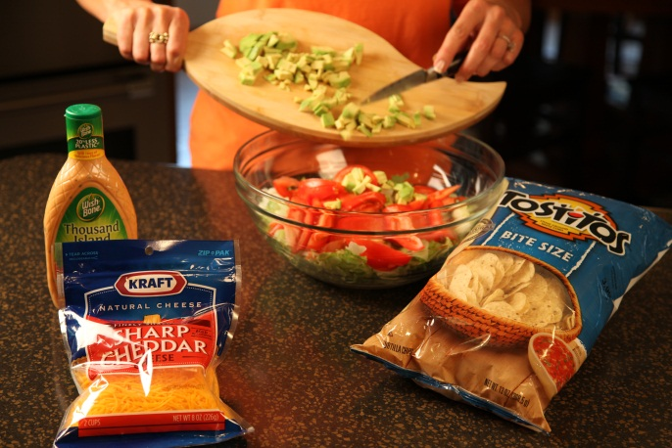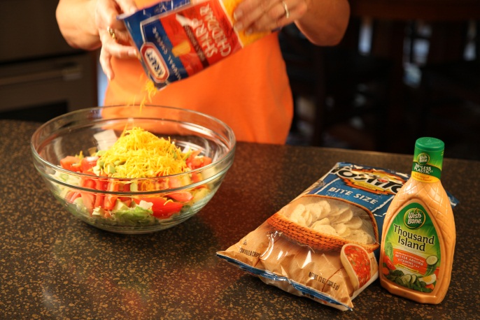

Crush small bag of tortilla chips.

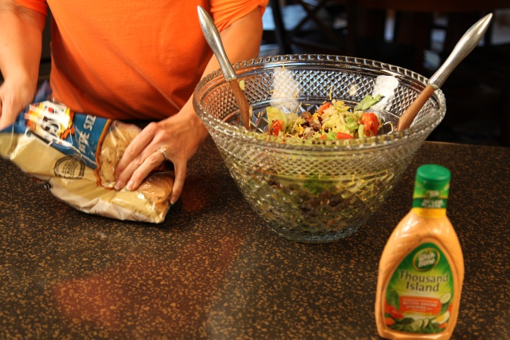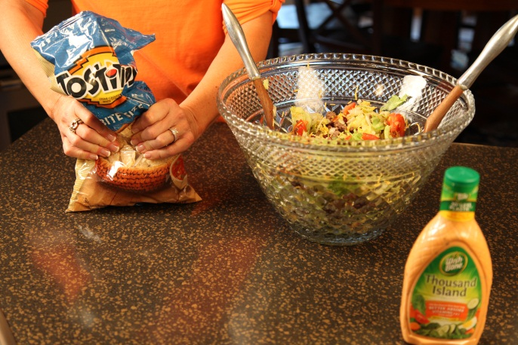

At serving time, toss together the meat and bean mixture, the lettuce mixture and the Thousand Island Dressing.
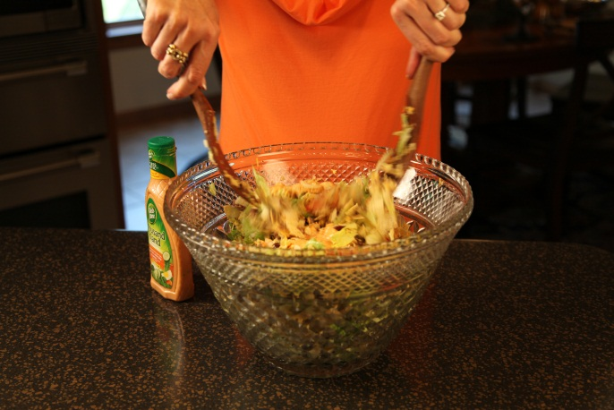

Let’s make life special by sharing great food with our family and friends! Enjoy!

