|  |
| --- |
| Sour Cream Banana Pie |
| C:\Users\Owner\Pictures\Food\Sour Cream Banana Pie\IMG_0305.JPG   |  |  |  | | --- | --- | --- | | 1 |  | Refrigerated pre-made pie crust | | 3 |  | bananas | | 1 | cup | milk | | 1 | large box | instant vanilla pudding | | 16 oz |  | sour cream | | 8 oz |  | Cool Whip | |  |  | Bananas and Maraschino cherries for garnish |   C:\Users\Owner\Pictures\Food\Sour Cream Banana Pie\IMG_0276.JPG |
| Place pie crust inot pie dish, flute edges and prick inside of crust with a fork. Bake as directed on package.  C:\Users\Owner\Pictures\Food\Sour Cream Banana Pie\IMG_0269.JPG C:\Users\Owner\Pictures\Food\Sour Cream Banana Pie\IMG_0271.JPG  Slice bananas into baked pie crust.  C:\Users\Owner\Pictures\Food\Sour Cream Banana Pie\IMG_0291.JPG C:\Users\Owner\Pictures\Food\Sour Cream Banana Pie\IMG_0293.JPG  In large bowl, mix together by hand the instant pudding, 1 cup milk and 2 cups sour cream. Pour into pie crust over sliced bananas.  C:\Users\Owner\Pictures\Food\Sour Cream Banana Pie\IMG_0279.JPG C:\Users\Owner\Pictures\Food\Sour Cream Banana Pie\IMG_0282.JPG  C:\Users\Owner\Pictures\Food\Sour Cream Banana Pie\IMG_0286.JPG C:\Users\Owner\Pictures\Food\Sour Cream Banana Pie\IMG_0299.JPG  Top with Cool Whip.  C:\Users\Owner\Pictures\Food\Sour Cream Banana Pie\IMG_0300.JPG C:\Users\Owner\Pictures\Food\Sour Cream Banana Pie\IMG_0301.JPG  Garnish with sliced bananas and maraschino cherries at serving time. |

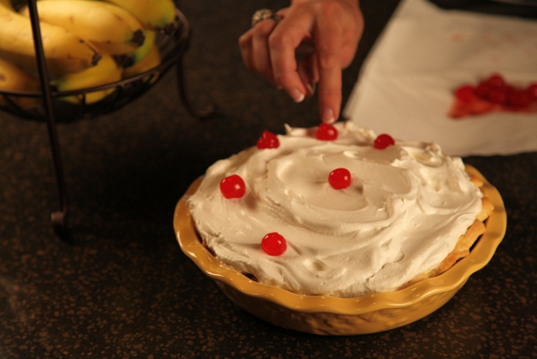 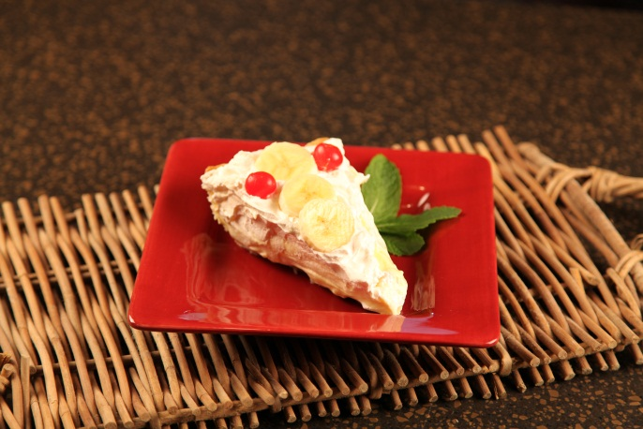

Let’s make life special by sharing great food with our family and friends! Enjoy!