Southern Peach Tea
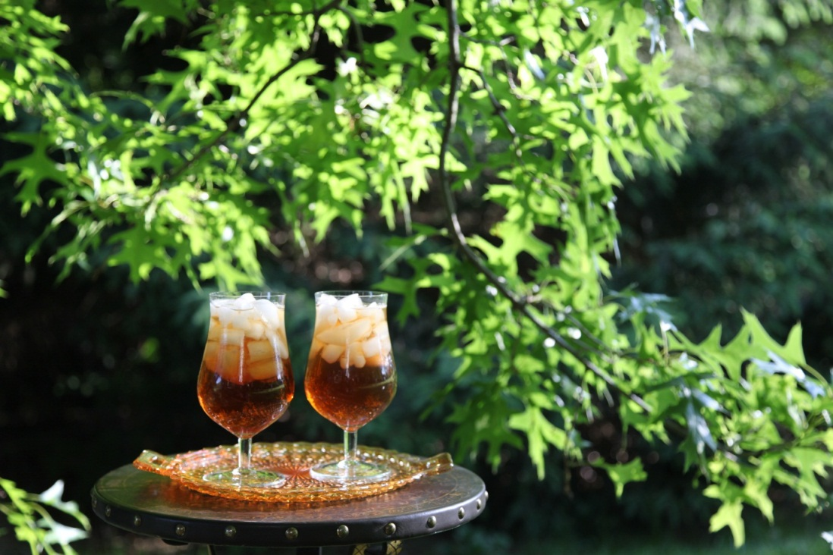
5 Regular Size Tea Bags
1 Bigelow Perfect Peach Herb Tea Bag
1 Cup of sugar ( yes, that’s right)

Microwave water in glass jar for 5 minutes, or until boiling.
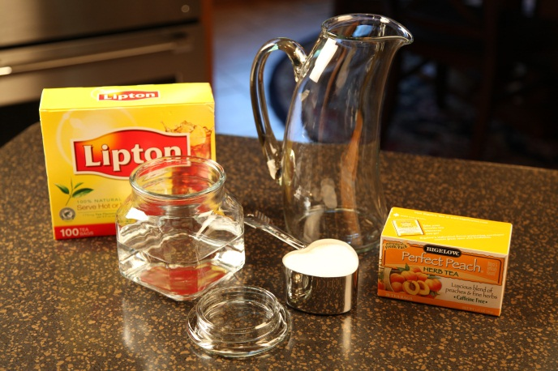

Steep the tea bags in hot water for 5 minutes.

Place a spoon into a glass pitcher. Add the sugar. Pour the hot tea brew into the pitcher.

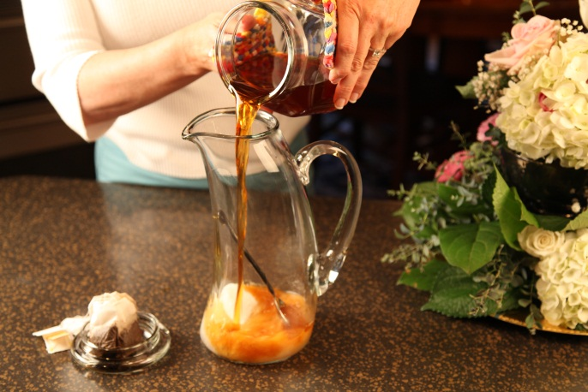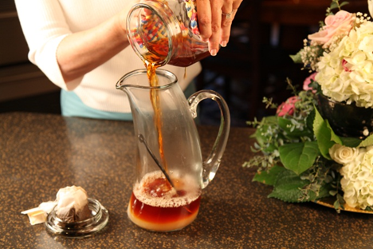

Fill pitcher with cool water.
Serve over crushed ice.

Let’s make life special by sharing great food with our family and friends! Enjoy!

