Vickie's Cheese Ball
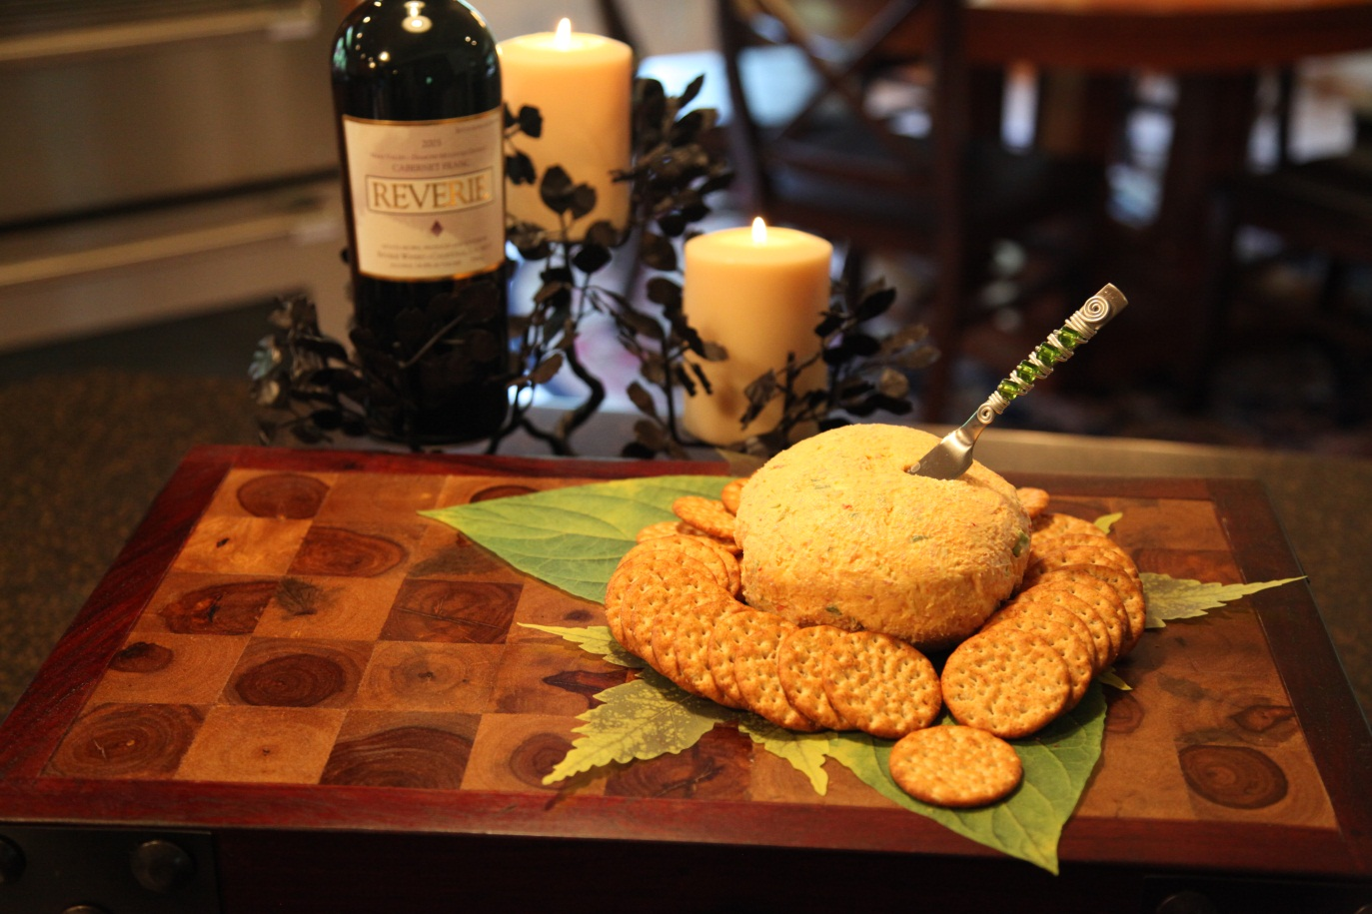

8 | oz | Cream cheese
8 | oz | Pimiento cheese spread
 |  | Green onions, chopped
1 | sm pkg | Honey ham

Add the cream cheese and pimiento cheese spread to the mixing bowl .

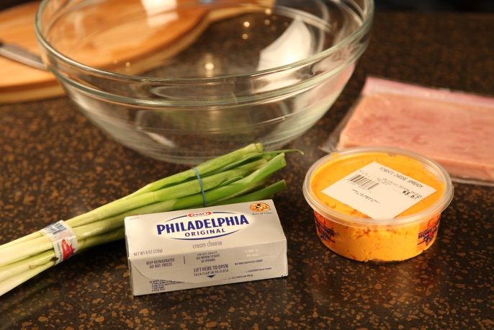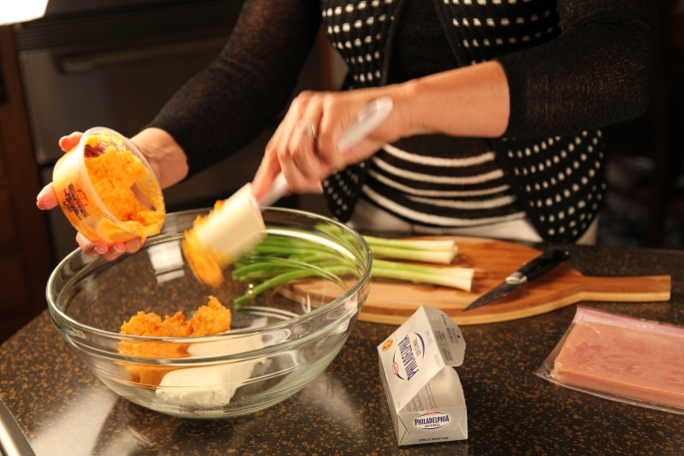

Chop the onion and add to the mixture.

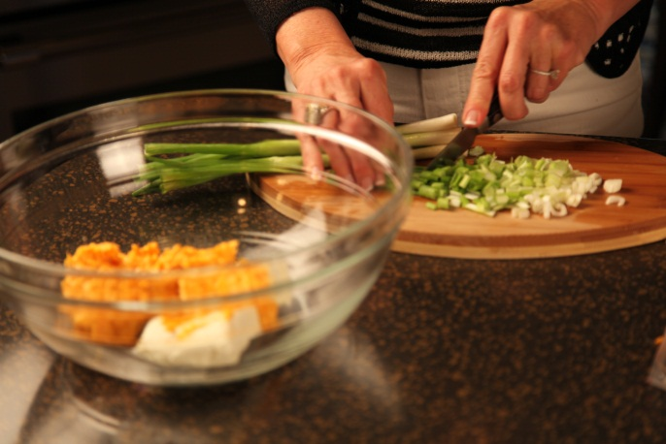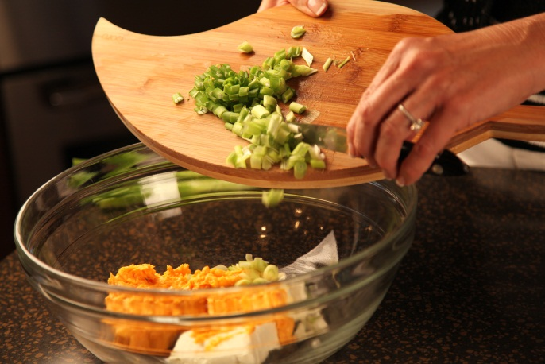

Chop ham in food processor and add to the cheese mixture. Mix with electric mixer..

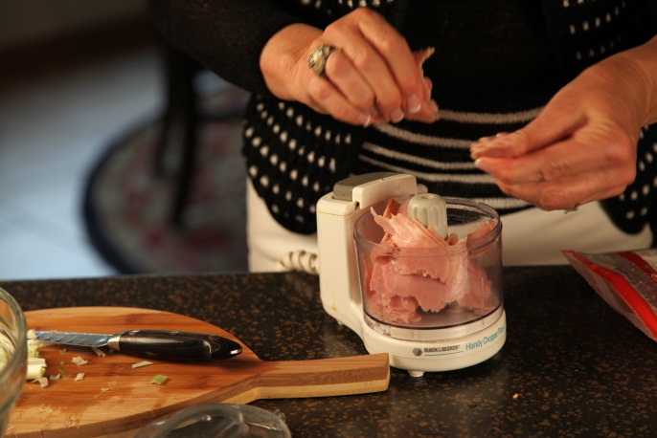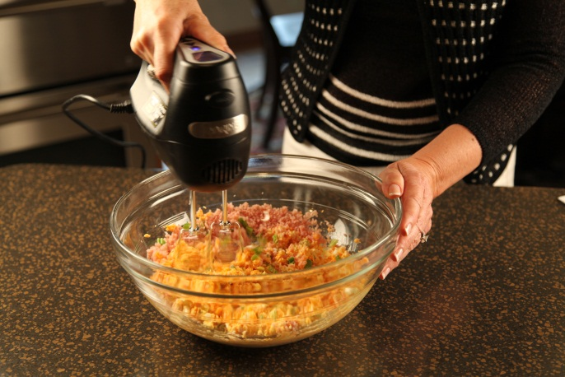

Scrape cheese ball mixture onto a sheet of waxed paper. Shape into one large or two small cheese balls.

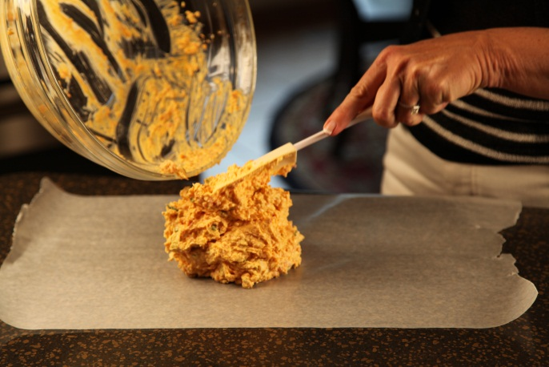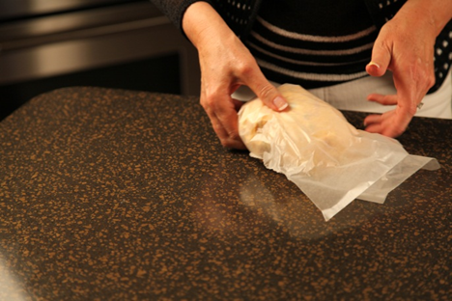

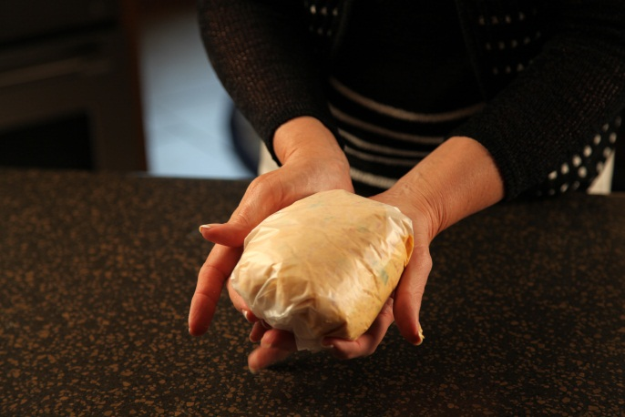

Pl

Refrigerate several hours before serving.

Let’s make life special by sharing great food with our family and friends! Enjoy!

