|  |
| --- |
| Vickie's French Onion Drop Biscuits |
| These tasty morsels are great to serve with dinner or an appetizer cheese tray. They are so quick and easy to make too!  C:\Users\Owner\Pictures\Food\French Onion Drop Biscuits\IMG_0919.JPG   |  |  |  | | --- | --- | --- | | 2 | cups | Biscuit mix | | 1/4 | cup | Milk | | 8 oz |  | French onion dip | | 2 | tbs | Green onion, finely minced | |
| Preheat oven to 400°.  Combine all ingredients in a bowl.  C:\Users\Owner\Pictures\Food\French Onion Drop Biscuits\IMG_0878.JPG C:\Users\Owner\Pictures\Food\French Onion Drop Biscuits\IMG_0881.JPG  C:\Users\Owner\Pictures\Food\French Onion Drop Biscuits\IMG_0884.JPG C:\Users\Owner\Pictures\Food\French Onion Drop Biscuits\IMG_0886.JPG  Stir with a wooden spoon until a soft dough forms.  C:\Users\Owner\Pictures\Food\French Onion Drop Biscuits\IMG_0892.JPG C:\Users\Owner\Pictures\Food\French Onion Drop Biscuits\IMG_0895.JPG  Drop by tablespoonfuls onto sprayed baking sheet.  C:\Users\Owner\Pictures\Food\French Onion Drop Biscuits\IMG_0902.JPG C:\Users\Owner\Pictures\Food\French Onion Drop Biscuits\IMG_0905.JPG  Bake for 10 minutes or until light golden brown.  C:\Users\Owner\Pictures\Food\French Onion Drop Biscuits\IMG_0911.JPG C:\Users\Owner\Pictures\Food\French Onion Drop Biscuits\IMG_0914.JPG  Serves 6 to 8, |

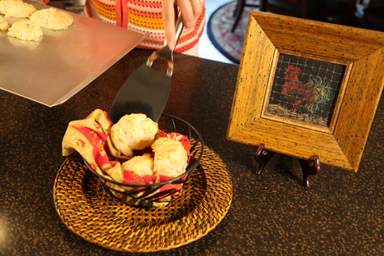 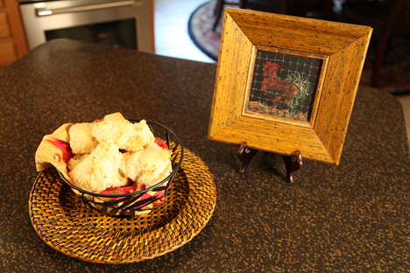

**Let’s make life special by sharing great food with our family and friends! Enjoy!**