Vickie's Homemade Crackers
These homemade crackers are so good served with cheese balls, spreads, salads and soups. For a special touch, instead of cutting these into strips, use a cookie cutter to cut the tortilla into festive shapes before brushing with butter.
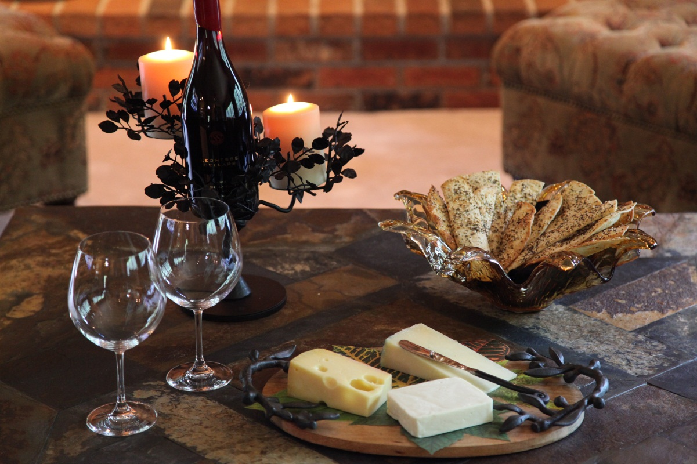
1/4 | cup | butter, melted
4 | 10 inch | flour tortillas
3/4 | cup | grated parmesan cheese
1 |  | egg white, beaten
 |  | Garnishes:
 |  | sesame, poppy and/or caraway seed ( I use all three)
onion powder, cayenne pepper or dried cumin to taste
sea salt ( optional)

Grate the parmesan cheese.
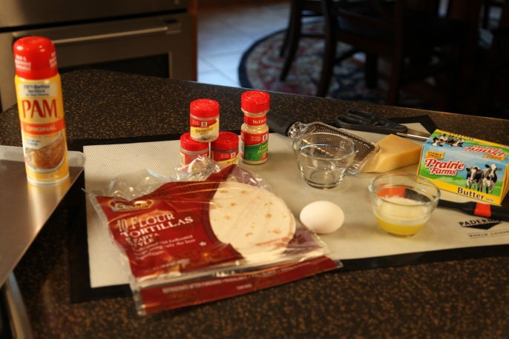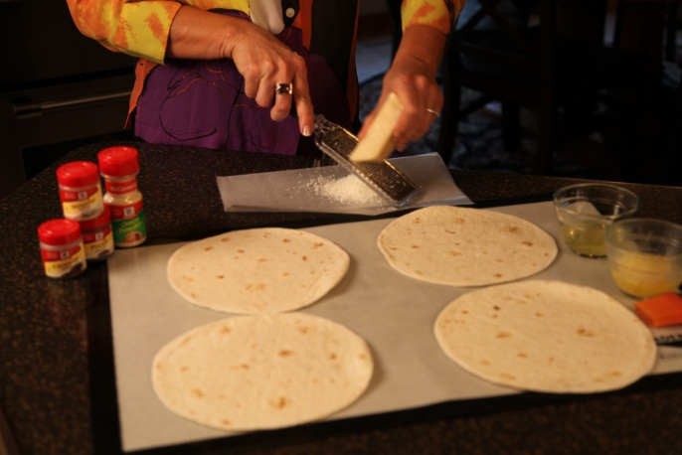
Brush butter lightly over one side of each tortilla; sprinkle evenly with cheese and press down lightly.
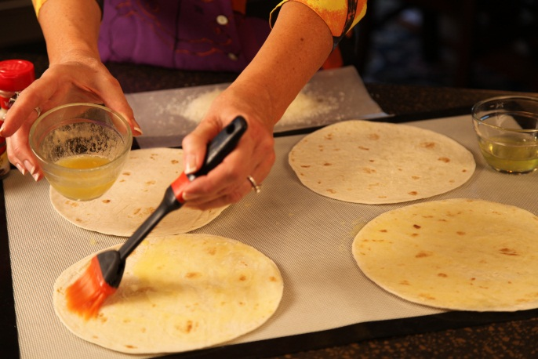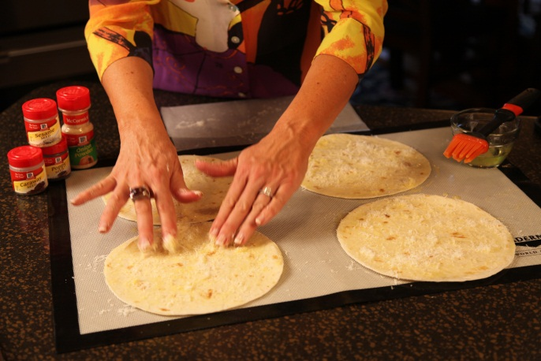

Carefully turn tortillas over. Brush other side with egg white and sprinkle with desired seeds and seasonings.

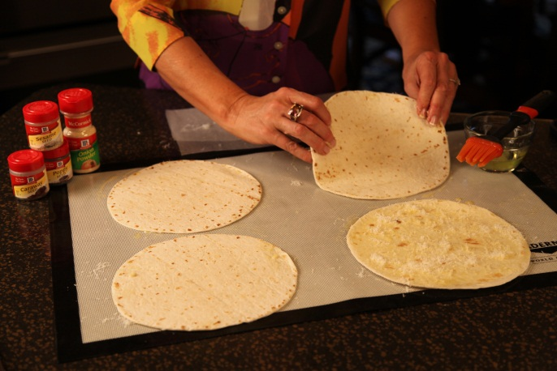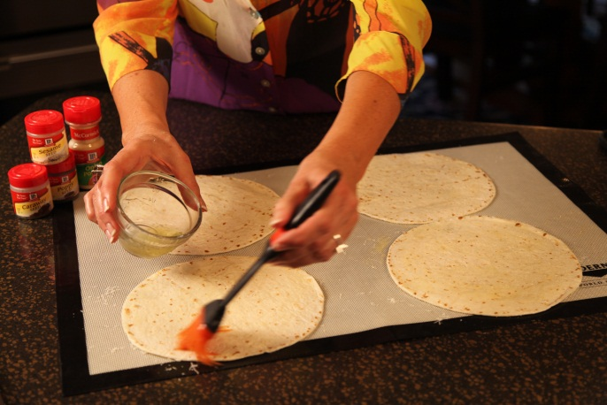

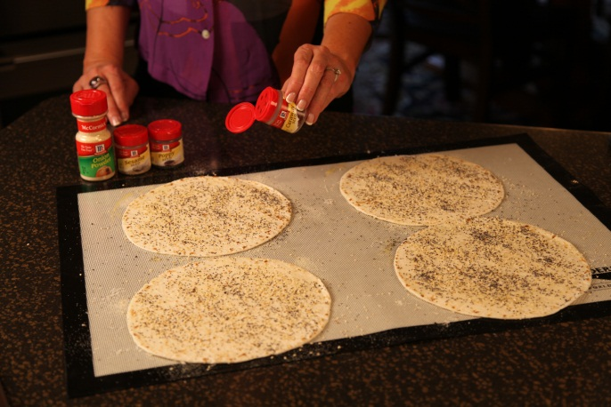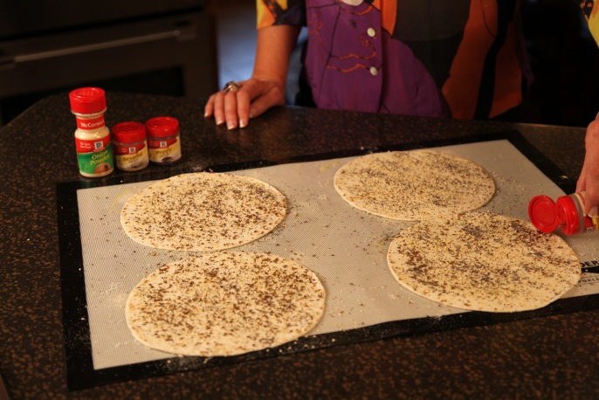

Cut each tortilla into 4 strips with kitchen scissors. Place strips cheese-side down on a baking
sheet sprayed with non-stick vegetable spray. Note: For best results, use a shiny baking sheet –
not a dark baking sheet.

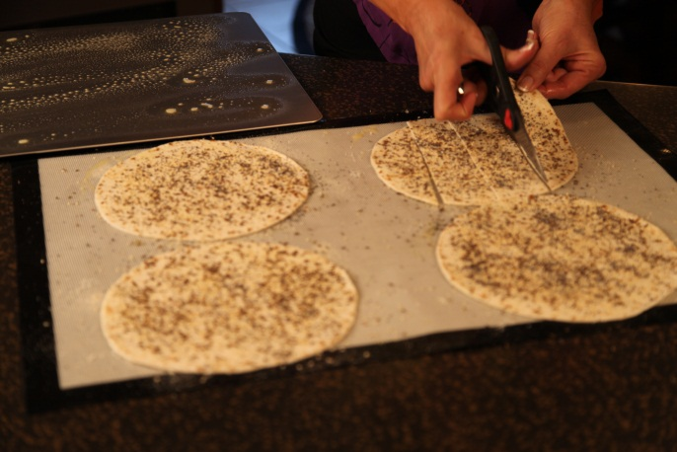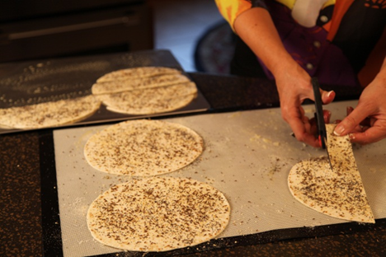

Bake at 400° on middle rack of oven for 8 to 9 minutes, until crisp and golden. Watch carefully because these will burn easily.
Cool 10 minutes on a wire rack. Makes 16 cracker strips.
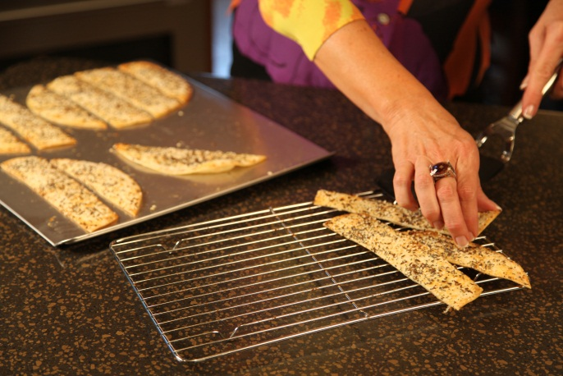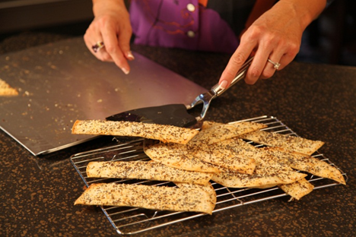

Let’s make life special by sharing great food with our family and friends! Enjoy!

