Vickie's Meat Loaf
This recipe is good to make ahead and freeze. Just freeze the loaf and then thaw and bake. Add the sauce when you bake it. For smaller loaves, just shape into 2 small loaves, cook one and freeze one.
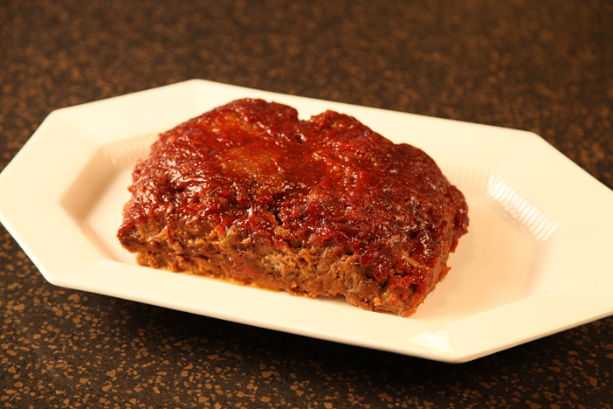

2 lb ground chuck
1 env. dry onion soup mix
2 eggs, beaten
1/4 cup water
2/3 cup ketchup
3/4 cup dry breadcrumbs, plain
3/4 cup chopped green pepper
Topping:
3/4 cup brown sugar
1 cup catsup
1 tsp nutmeg
4 tsp dry mustard

Mix all meatloaf ingredients together and shape and put into pan. I use a meatloaf pan, which drains the fat off the meatloaf as it bakes. Be sure to spray the meatloaf pan with Pam before putting the meatloaf into the pan.
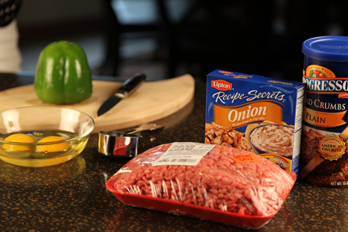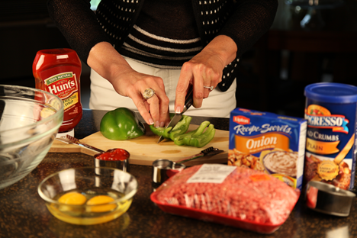
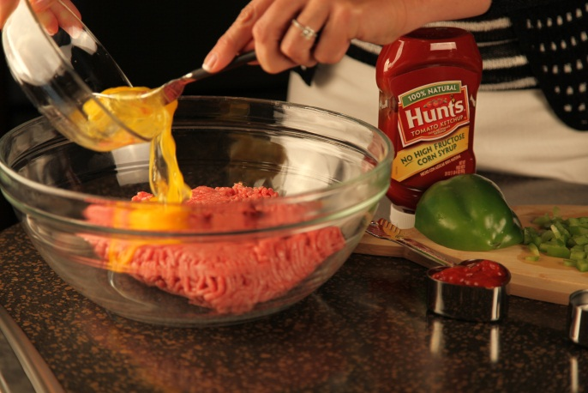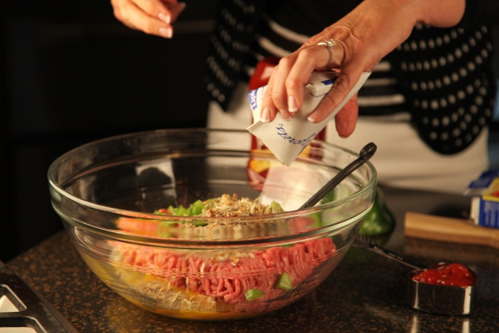
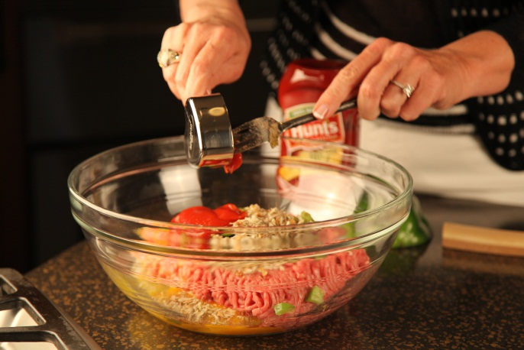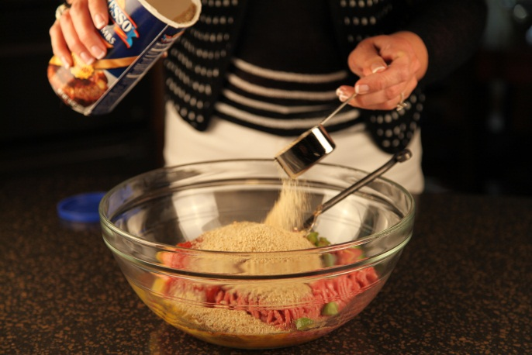

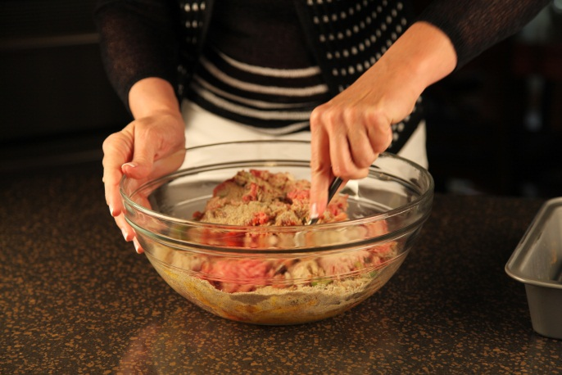
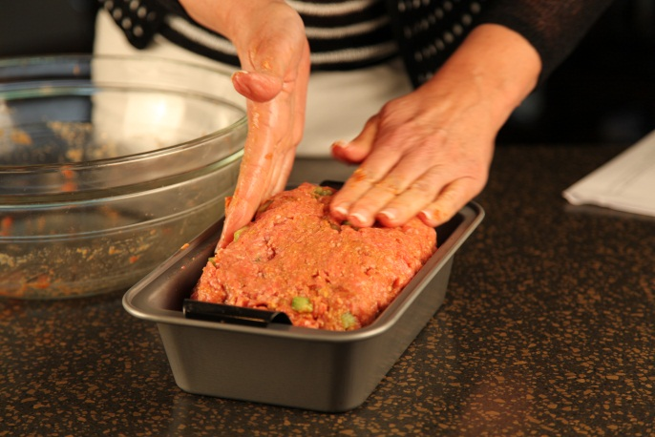

Bake 350° for 45 minutes

Mix topping, put on meat loaf after it has baked 45 minutes.

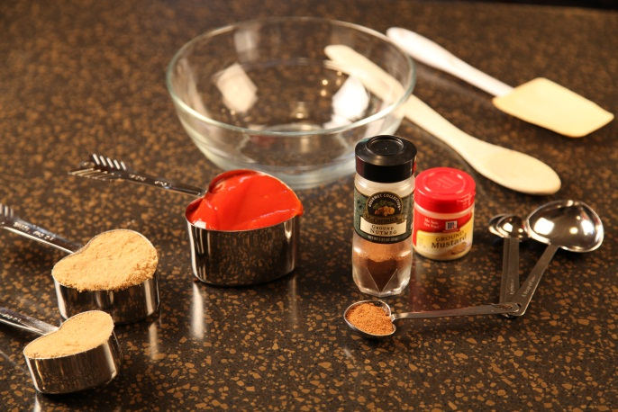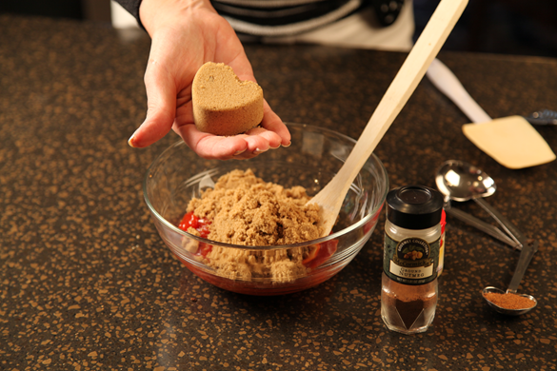

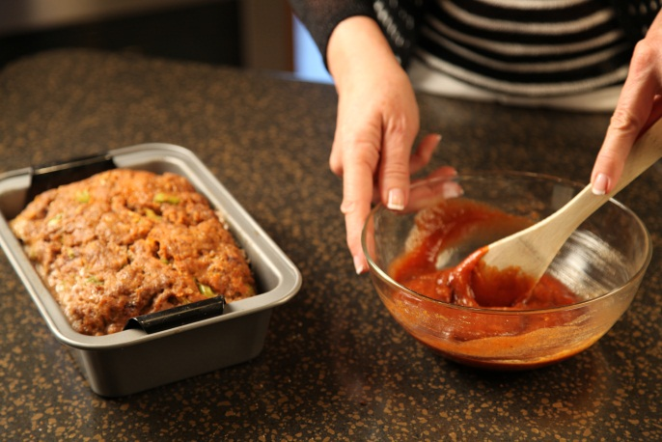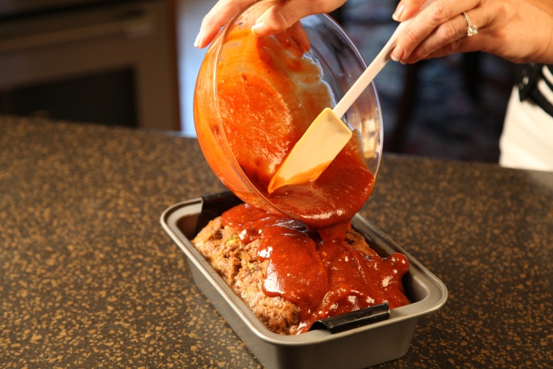

Place it back in the oven and continue baking another 45 minutes. (Baking time for full recipe)
I serve this with Cream Cheese Whipped Potatoes.

Success Secret:

Here’s my tip for baking a great meatloaf: Use a meatloaf pan. The meatloaf pan allows the fat to drain off of the meatloaf as it cooks, circulates the heat and cooks evenly. It also makes it so EASY to remove the meatloaf from the baking pan!

