Cherry Cheesecake Salad
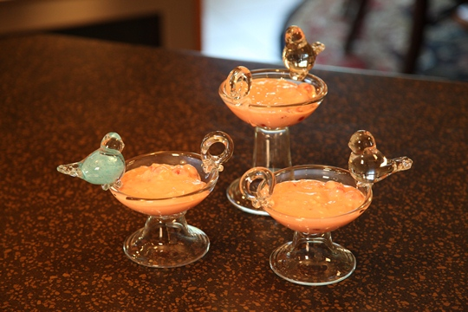
1 can sweetened condensed milk
3 ounces cream cheese
21 ounce can cherry pie filling
8 ounce can crushed pineapple, well drained
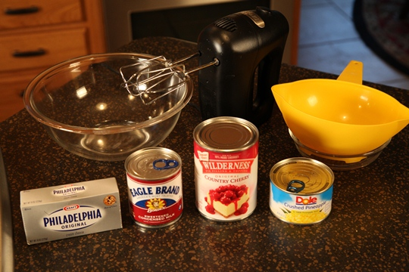

Directions:
Cream together the sweetened condensed milk and cream cheese. Fold in the pie filling and pineapple.
Chill. Enjoy!

