Chicken Piccata
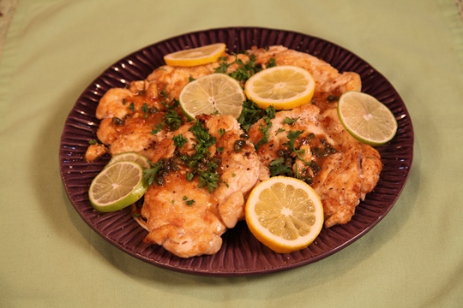
4 boneless skinless chicken breasts, about 2 pounds
¼ cup flour
2 tablespoons each oil and butter
½ teaspoon salt and ¼ teaspoon pepper
¼ cup dry white wine
2 tablespoons capers, drained
¼ cup lemon juice (fresh squeezed if possible)
3 tablespoons chopped fresh parsley (for garnish)
4 thin slices each lemon and lime (for garnish)

Directions:
Cut one side on 4 large zip lock bags. Place one chicken breast inside each bag. Using the flat side of a meat mallet, pound each chicken breast to ¼ inch thickness.
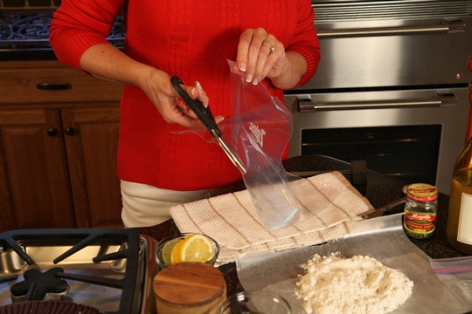

Coat chicken with flour. Heat the oil and butter in a large skillet. Add the chicken and brown quickly on both sides – about one minute per side. Remove to a platter and sprinkle with salt and pepper.
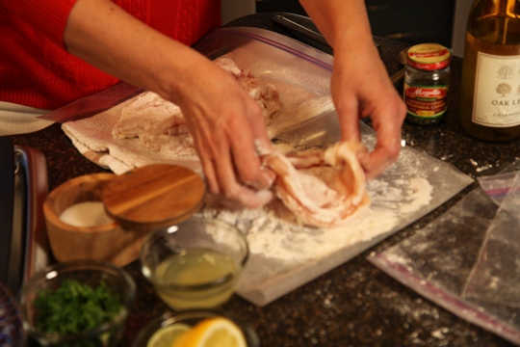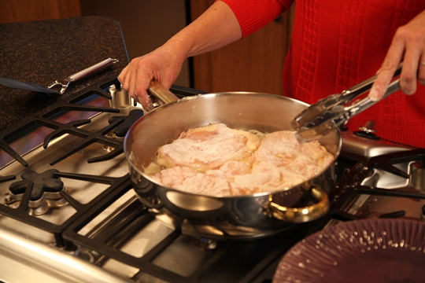
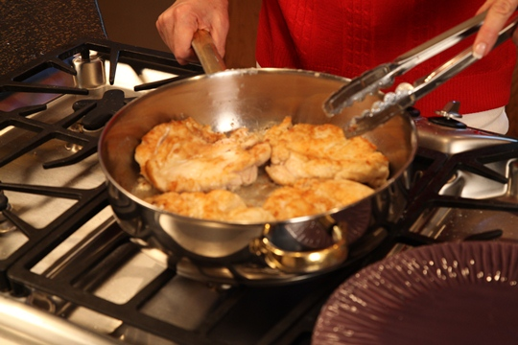

Add wine, capers and lemon juice to the skillet. Heat to a boil , scraping sides and bottom of the pan. When 4 tablespoons of liquid remains, pour over the chicken.
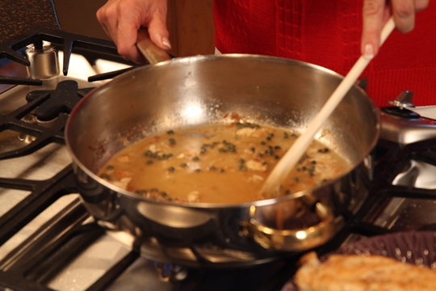
Garnish with chopped fresh parsley and lemon and lime slices. Enjoy!
