Coconut Cream Cheese Pie
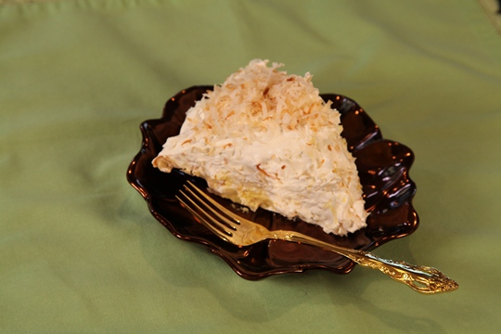
1 refrigerated pie crust, rolled to fit a 9 ½ inch pie pan
8 ounces cream cheese, room temperature
2 cups milk
15 ounce can Sweetened Coconut Cream ( found in the mixed drink section of the grocery store)
4 packages ( 3 ½ ounces each) vanilla instatnt pudding mix
¾ teaspoon coconut extract
16 ounces Cool Whip
7 ounces shredded sweetened coconut
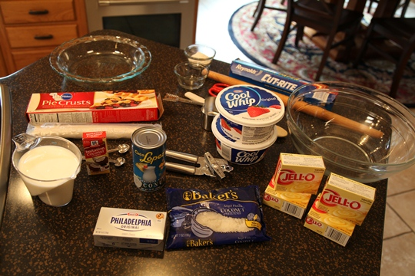

Directions:
Roll pie crust and fit into a 9 ½ inch pie pan. Prick with a fork and bake as directed on the package for an unfilled pie. Set aside to cool while you make the pie filling. Reduce the oven temperature to 350 degrees.
Combine the softened cream cheese, milk and coconut cream in a large mixing bowl. Beat with an electric mixer for about 4 minutes, until smooth.
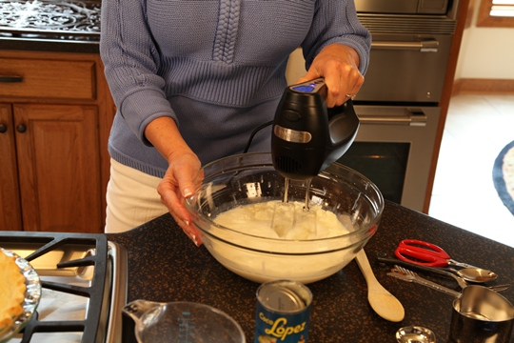

Add the pudding mix and coconut extract and beat until blended.
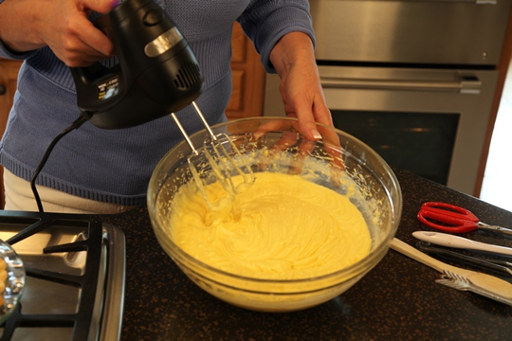
Fold in 1 cup of the Cool Whip into the cream cheese mixture. Spoon cream cheese mixture into the pie crust.
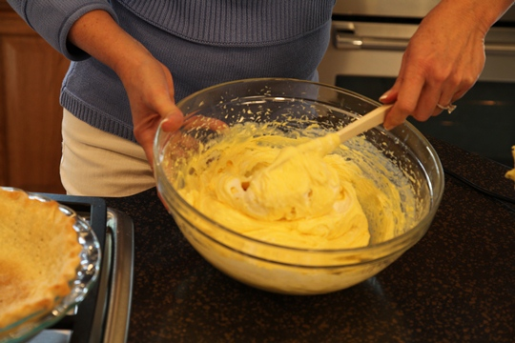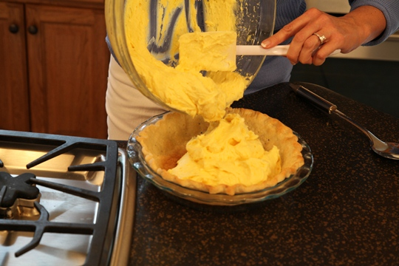
Spread the remaining Cool Whip on top of the filling.

Spread the coconut on a baking sheet and bake at 350 degrees until lightly browned, stirring occasionally – about 8 minutes.
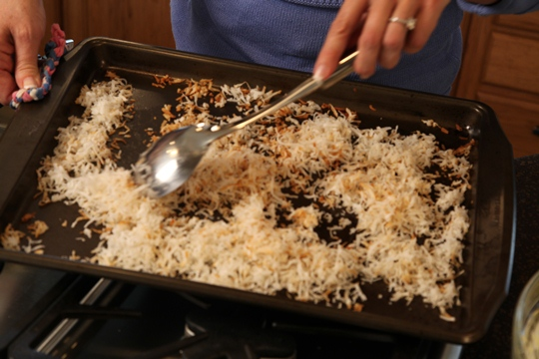

Sprinkle the toasted coconut on top of the pie and chill until ready to serve.

