Eggs in Toast Nests

6 slices of bread
1 stick of butter, melted
6 medium eggs
1 tablespoon butter
Salt and pepper

Note: To make 12, double the ingredients and use a 12 cup muffin tin.
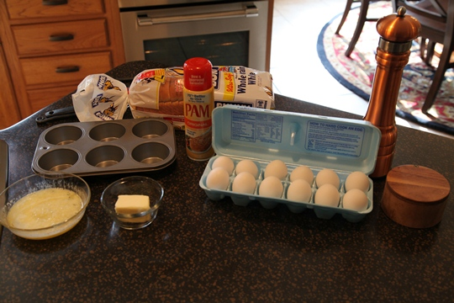
Directions:
Step 1:
I usually do Step 1 the night before I plan on serving the Eggs in Toast Nests.
Trim the crusts off of 6 slices of bread. Brush both sides with melted butter.
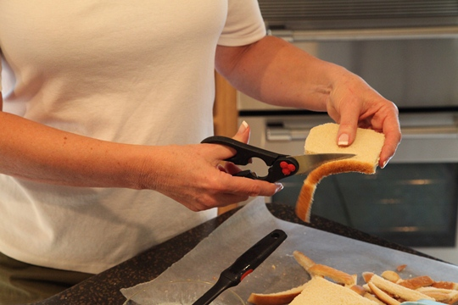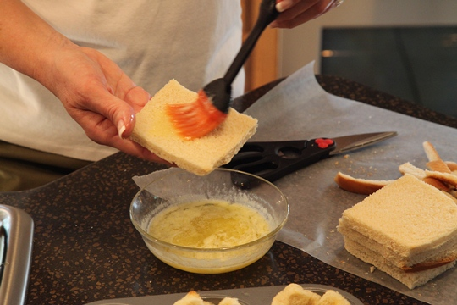
Fit into large muffin cups or custard cups. Press down slightly with your fingers so the bread will fit in the cup. Bake at 325 degrees for 15 minutes until lightly toasted.
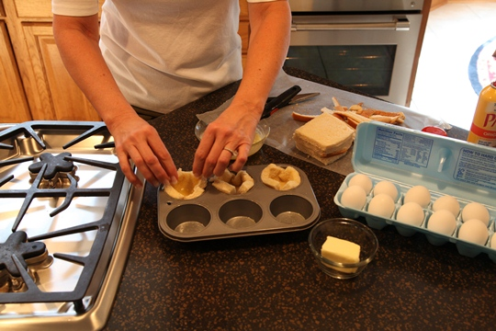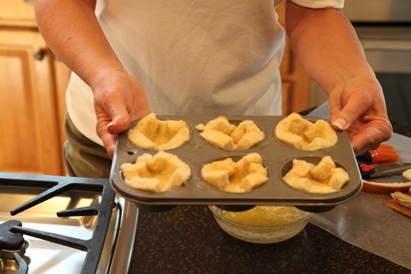

If doing Step 1 the night before, remove the toast cups from the oven, cool slightly, cover with aluminum foil and continue with step 2 the next morning.
Step 2:
Set oven temperature to 350 degrees.
Break a medium size egg into each toast cup.
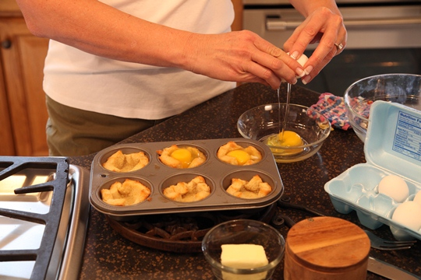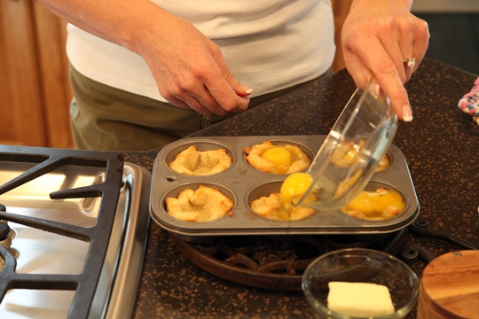
Add salt and pepper and dot with butter. Poke each egg with a fork to break the yolk. Cover lightly with foil and bake at 350 degrees for 18 minutes or until done.
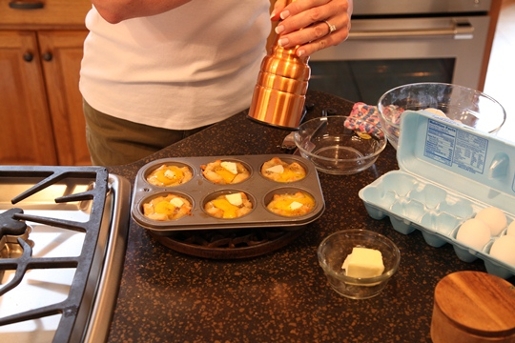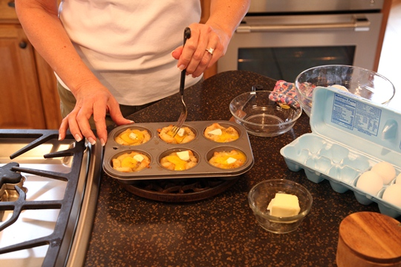
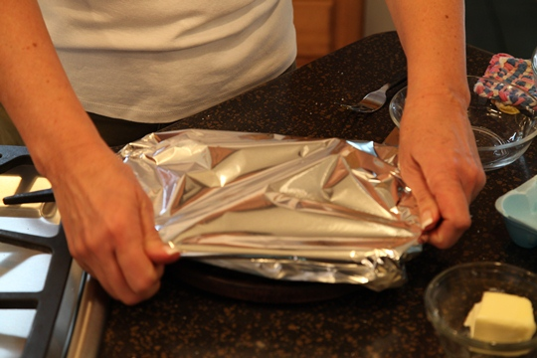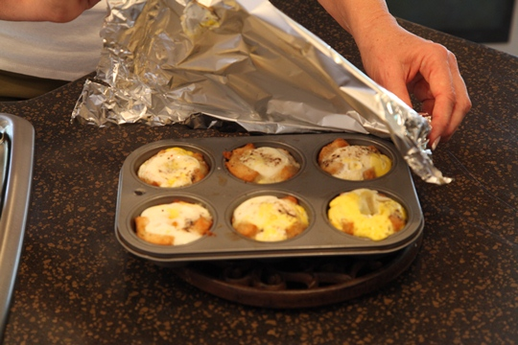
Loosen cups with a fork and place on a serving platter. Serve Eggs in Toast Nests hot on a platter with bacon or sausage links and garnish with fresh parsley.

