Fabulous Fish
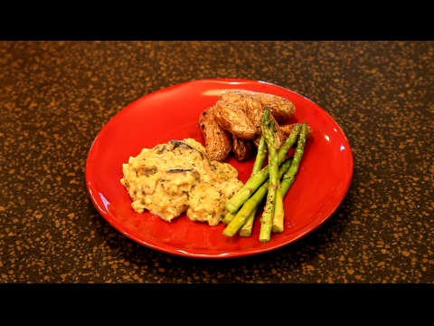

1 pound fillets of white fish, thawed
4 tablespoons melted butter
2 green onions, sliced
8 ounce package fresh mushroom slices
1 can Cream of Celery soup
½ teaspoon Italian Seasoning
½ cup Italian or plain breadcrumbs
Directions:
Arrange the fish fillets in a 12 X 8 X 2 oblong baking dish.
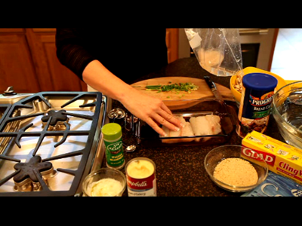

Top with butter, onions, mushrooms, soup and seasonings. Cover with plastic wrap and microwave for 10 minutes.
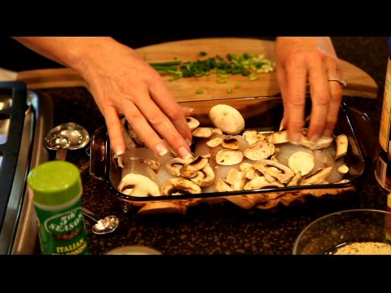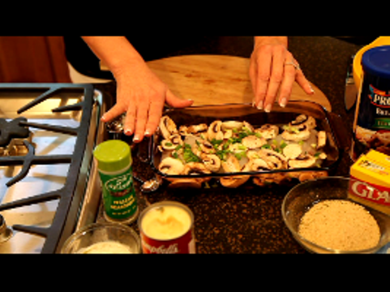
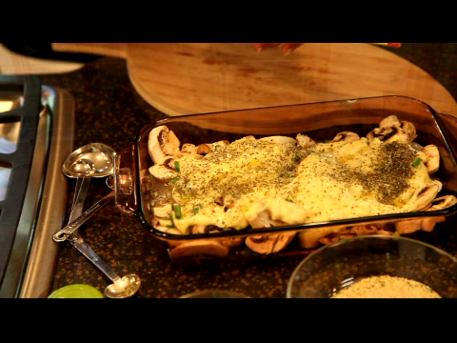

Remove from microwave and uncover.
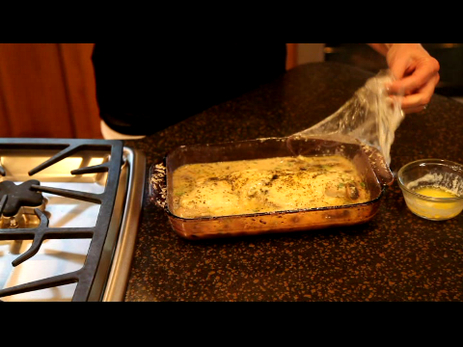
Mix the remaining melted butter into the breadcrumbs. Sprinkle buttered breadcrumbs over the top of the fish. Enjoy!
