Glazed Strawberry Pie
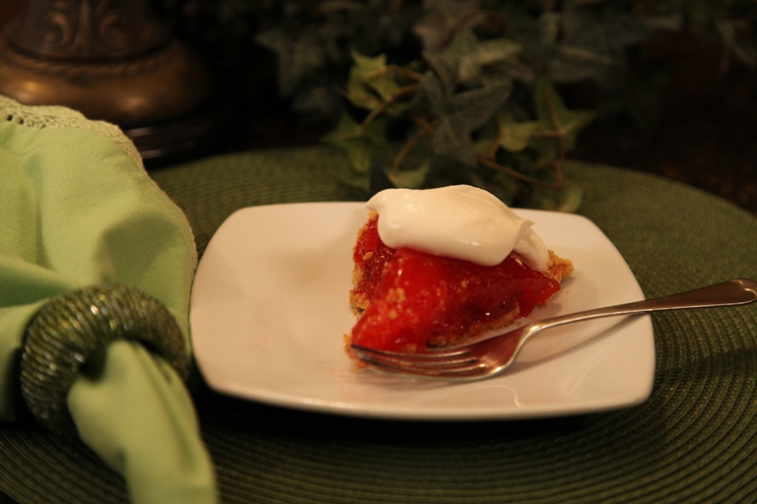
1 quart whole strawberries
½ cup confectioners ( powdered) sugar
1 cup water
1 cup sugar
Dash of salt
3 tablespoons cornstarch
3 tablespoons strawberry Jello powder
Graham cracker pie crust or baked pie shell
Homemade whipped cream
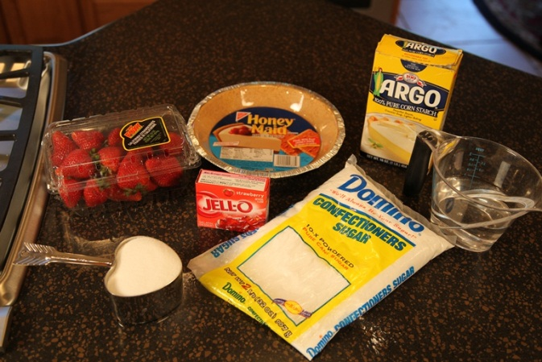

Wash and hull 1 quart of whole fresh strawberries. Add ½ cup of confectioners (powdered) sugar. Set aside.
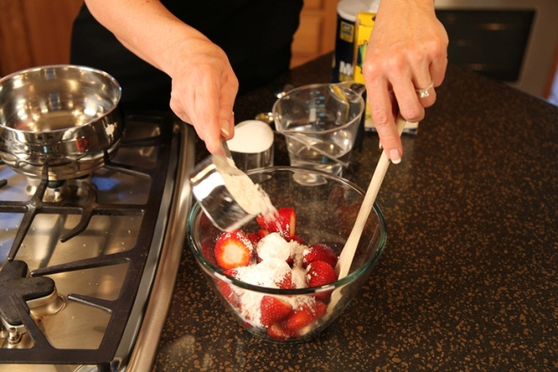
Put 1 cup of water, 1 cup of sugar, dash of salt and 3 tablespoons of cornstarch in a saucepan and boil until thick and clear.
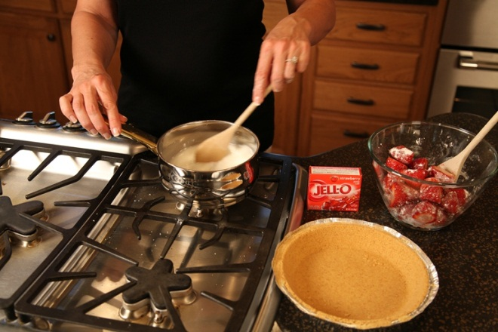

Add 3 tablespoons Strawberry gelatin. Stir well and set aside to cool.
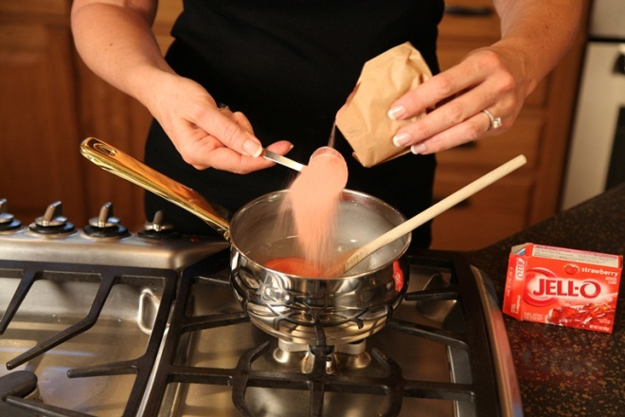
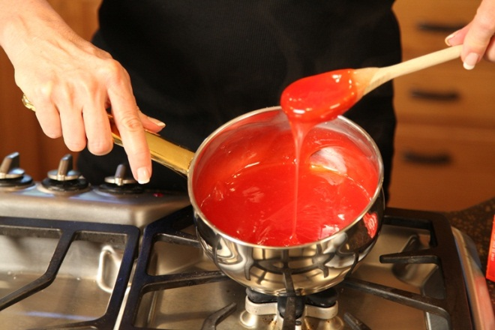
Place whole strawberries into pie shell. Pour the cooled filling over the strawberries and chill. Top with homemade whipped cream at serving time. Enjoy!
