Hamburger Quiche
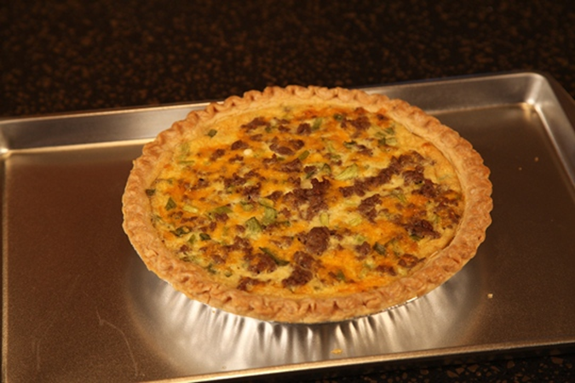
9” frozen deep dish pie crust
½ pound ground hamburger
½ cup Mayonnaise
½ cup milk
2 eggs, beaten
1 tablespoon cornstarch
¼ cup chopped green pepper
¼ cup chopped green onion
1 1/2 cups grated cheddar or Swiss cheese
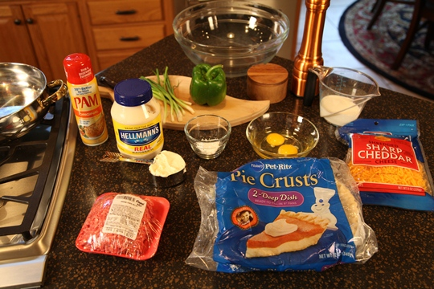

Directions:
Brown the ground beef and drain. Mix mayonnaise, milk, cornstarch and eggs. Stir in the meat, cheese, chopped green onion and chopped green pepper. Add 1 teaspoon salt and ½ teaspoon black pepper.
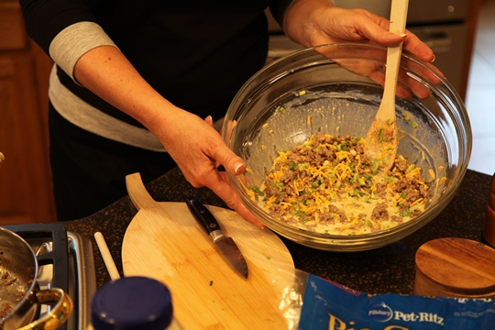
Pour into the unbaked pie shell. Place on a cookie sheet and bake at 350 degrees for 35 to 45 minutes, or until the center of the quiche is set.
Serves 4 to 6
