Italian Roasted Fingerling Potatoes with Herbs
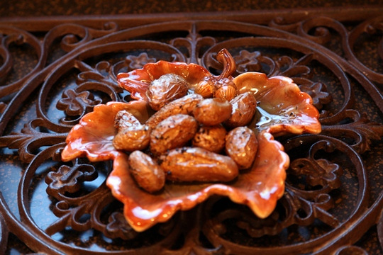
2 Servings
1 pound fingerling potatoes
1 tablespoon Herbs de Provence, plus extra for garnish
3 cloves garlic, minced
¼ cup extra virgin olive oil, plus extra for drizzling
Salt and pepper
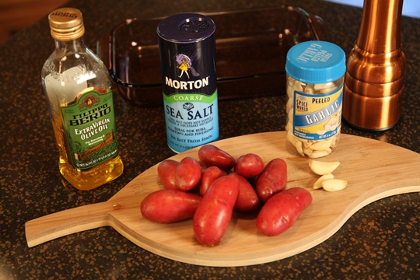
Directions:
Put the potatoes in a large bowl. In a small bowl, whisk together the herbs, garlic and oil until blended and then pour over the potatoes.
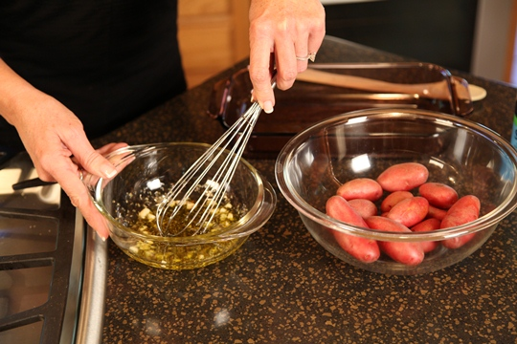
Sprinkle generously with salt and pepper and toss to coat. Transfer the potatoes to a large baking dish, spacing them evenly apart.
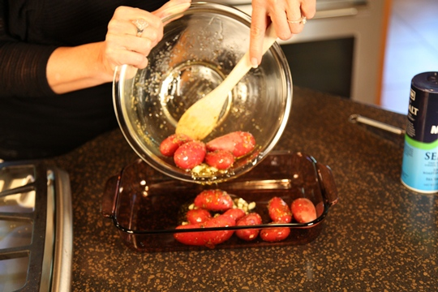
Roast the potatoes until they are tender and golden, about an hour, turning them occasionaly while roasting.
Transfer the roasted potatoes to a platter and drizzle with extra virgin olive oil and sprinkle with additional Herbs de Provence, if desired.
Enjoy!

