Moms’ Sunday Pot Roast Dinner
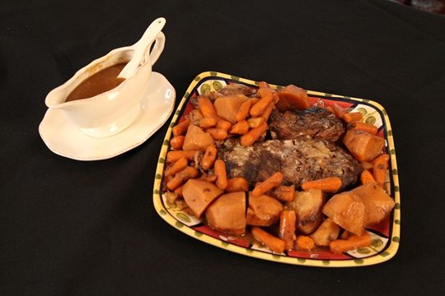

3 cups baby carrots
6 to 7 potatoes, peeled and cut in half
3 pound chuck roast
1 can Cream of Mushroom soup
1 can French Onion soup
2 onions, peeled and cut in half
Salt and pepper

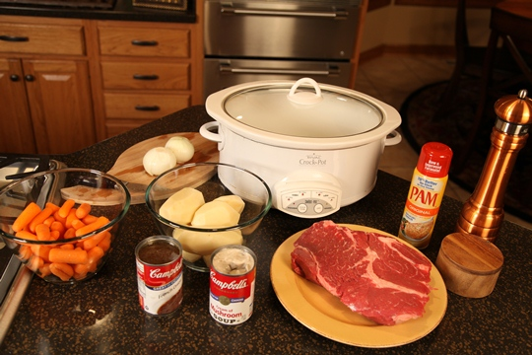

Directions:
Spray the crock pot with cooking spray. Put the carrots and potatoes into the bottom of the crock pot and season with salt and pepper. Lay the chuck roast on top and sprinkle with salt and pepper.
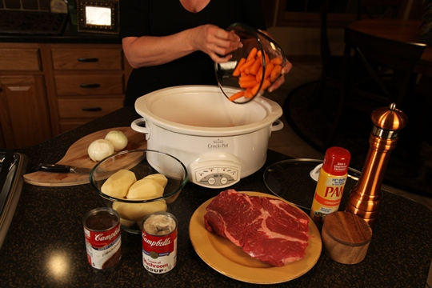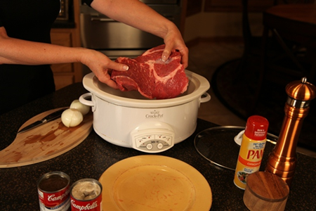
Pour the Cream of Mushroom soup and French Onion soup on top of the roast. Lay the onions on top.
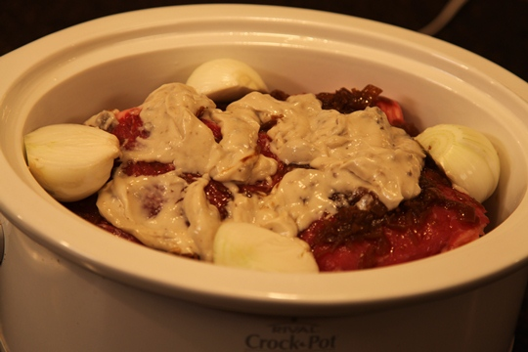
Cover and cook on LOW for 10 hours. When ready to serve, remove roast and vegetables onto a platter. To make the gravy, turn the crock pot to HIGH and sprinkle Wondra instant flour into the liquid. Whisk until thickened , about 1 minute.

