Roasted Cauliflower

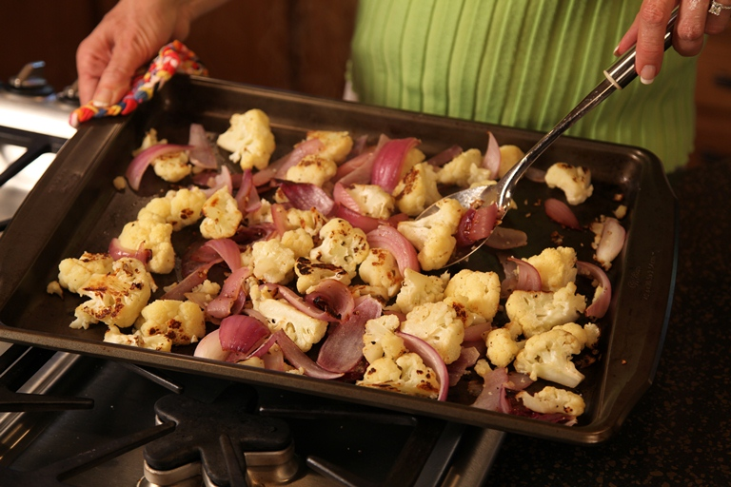

Roasted Cauliflower
1 tbs Olive oil
½ tsp Garlic powder
¼ tsp Salt
¼ tsp Black pepper
1 Head cauliflower, cut into flowerets
1 Red onion, cut into 1/2 inch thick wedges

Place a large jelly-roll pan in a 500° oven for 5 minutes or until hot.
Meanwhile, combine oil and next 3 ingredients in a large bowl. Add cauliflower and onion; stir well until coated. Pour vegetables onto hot jelly-roll pan and spread into a single layer.
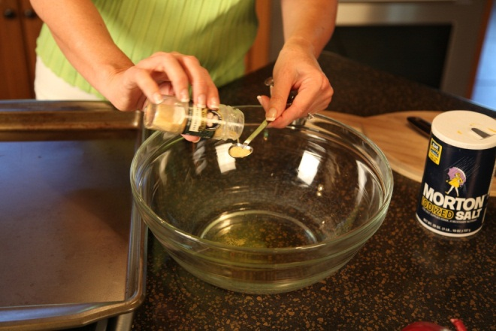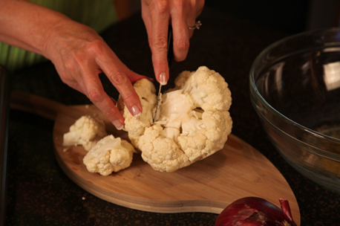

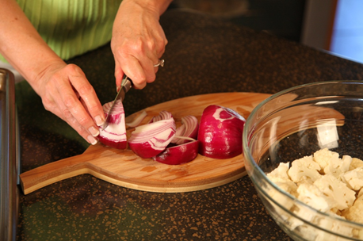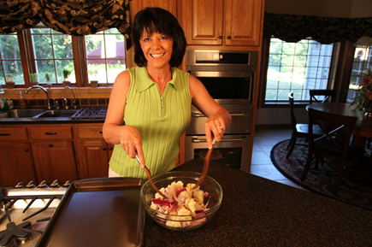
Bake at 500° for 15 minutes or until browned, stirring occasionally. Serves 4 to 5.
