Baked Ravioli Casserole
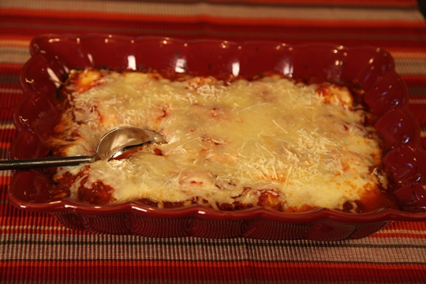
Get set for the ultimate comfort food casserole! Layers of frozen ravioli make this lasagna-type recipe easy and delicious. You can assemble this in less than 5 minutes and it takes about 30 minutes to bake. This recipe meets all of the Make Life Special requirements – it is quick to make, it has only a few ingredients that are readily available, and it is yummy! Casseroles are typically made with meat, vegetables, cheese and a sauce. This casserole can be made without meat – as I have done here using the cheese ravioli; or you can substitute beef filled frozen ravioli if you prefer to add the meat.
I love this recipe because you can make it ahead of time and either freeze or refrigerate the ravioli casserole until you are ready to bake it.
Don’t omit the spinach…trust me on this one. It really adds great flavor to this dish and it’s a great way to get your family to eat vegetables. Remember…Let’s Make Life Special by sharing great food with our family and friends! Enjoy!
Ingredients:
28 ounce jar spaghetti sauce
30 ounces frozen cheese filled ravioli, unthawed
10 ounce box frozen chopped spinach, thawed and squeezed dry
8 ounce bag shredded mozzarella cheese
½ cup shredded Parmesan cheese
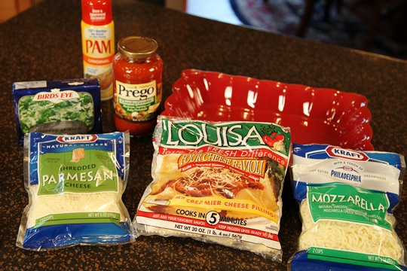
Preheat the oven to 350 degrees. Coat a 9 X 13 baking dish with cooking spray and spoon 1/3 of the sauce in the dish. Arrange a layer of frozen ravioli on top of the sauce.
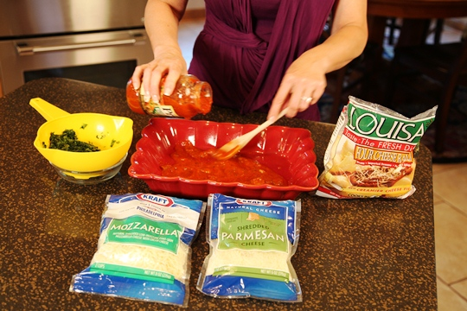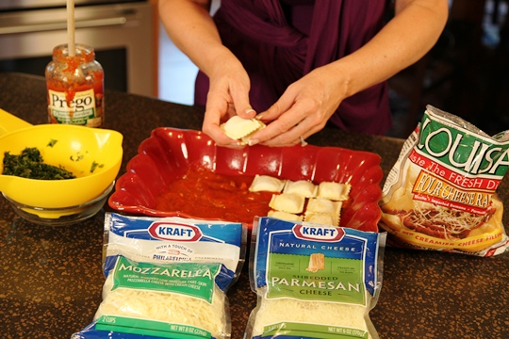

Squeeze the liquid out of the thawed spinach. Scatter all of the spinach over the ravioli layer.
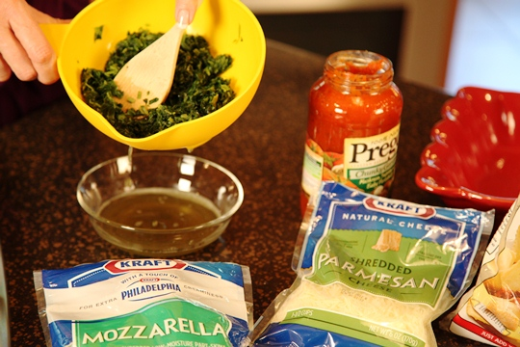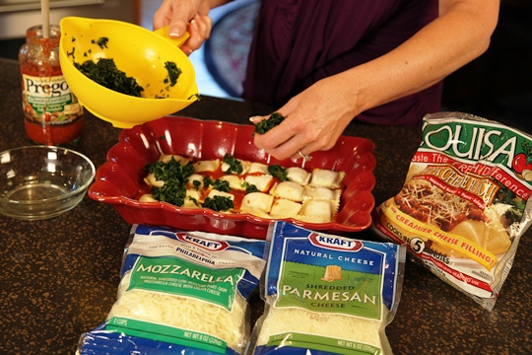
Top with half of each cheese.
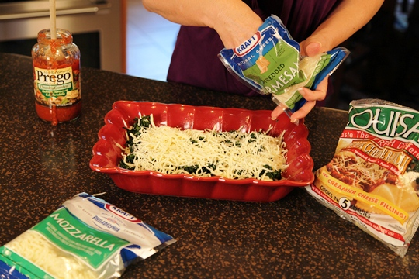
Cover with another layer of ravioli and the remaining sauce and cheese. Cover with aluminum foil and bake 25 minutes.
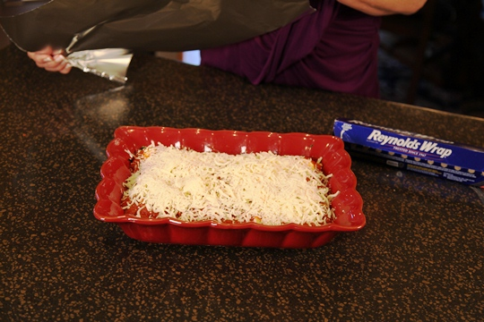
Uncover and bake 5 to 10 minutes more or until bubbly.
Just add a salad and some garlic bread and you have great family meal!
