Quick Chicken Corn Chowder
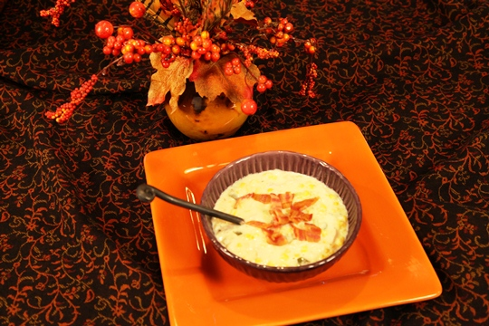
You can have this on the table in less than 30 minutes!
Ingredients:
2 Tablespoons butter
¼ cup chopped onions
¼ cup chopped celery
1 Jalapeno pepper, seeded and chopped OR 2 tablespoons canned chopped jalapeno pepper (not pickled)
2 tablespoons flour
3 cups milk (or combination of milk and half and half)
2 cups chopped skinless deli rotisserie chicken
1 ½ cups frozen corn
1 can cream style corn
1 teaspoon thyme
¼ teaspoon ground red pepper
1/8 teaspoon salt
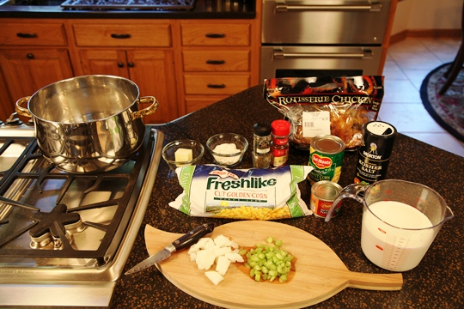

Melt butter in a large soup pot over medium heat. Add onion, celery and jalapeno pepper and cook for 3 minutes, stirring frequently.
Add flour; cook 1 minute, stirring constantly. Stir in milk and remaining ingredients. Bring to a simmer and cook until thick – about 5 minutes.
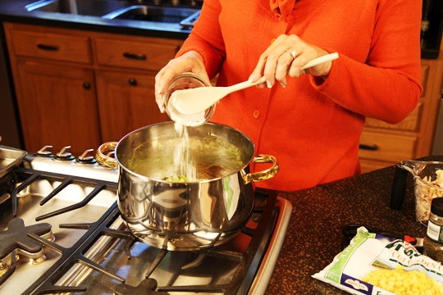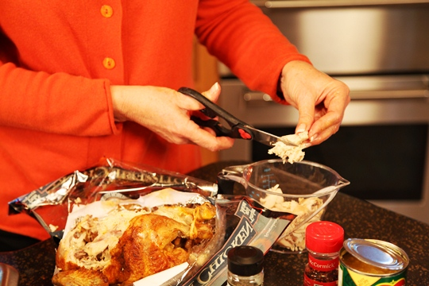
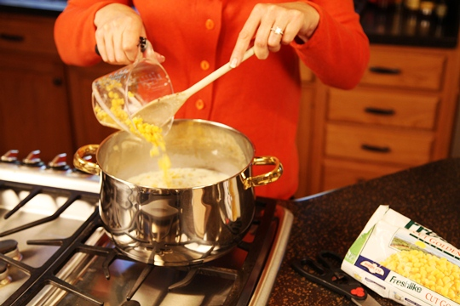
Serve big bowls of this chowder topped with Microwaved Bacon Bits.

Happy Fall Y’all!!!!!

