Yellow Bird Cocktail
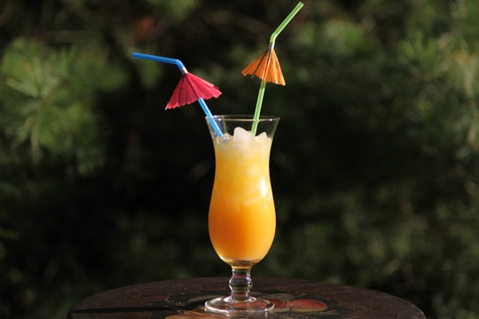
I’m dreaming of the beach today……so grab a cocktail glass and I’ll show you how to make the famous Bahamas Yellow Bird! This is the authentic Yellow Bird recipe. A bartender in the Bahamas wrote this recipe on a napkin and handed it to me when I told hi9m how much I LOVED this drink. It’s perfect on a hot summer day…..or anytime you want to escape to the islands!
Ingredients:
1 cup light rum
½ cup Crème de Banana
¼ cup Tia Maria
3 cups orange juice
¼ cup pineapple juice
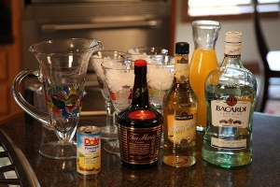
Stir together and serve over ice.

